5 For 5 Unit 1 Key Human Geography Concepts

In This Section
Summary: The AP Human Geography course is divided into seven broad content areas:
- Geography’s nature and perspectives
- Population
- Cultures
- Political organization of space
- Agricultural and rural land use
- Industrialization and economic development
- Cities and urban land use
This section reviews geography’s nature and perspectives by examining the core concepts of human geography (space, place, location, scales, and regions), as well as the necessary skills essential for success in the AP course and on the AP Human Geography exam. In addition, this section briefly reviews the new technologies that geographers use to explore the questions of who lives where, how they live, and why they live there. Spatial behavior and interaction are also covered in this section.

Introduction
What exactly is human geography? Human geography is the study of why people choose to live where they do. Human geographers seek to discover who lives where, how they live, and why they live there.

Geography as a Field of Inquiry
The study of geography explores where, how, and why different places, people, and environments came to exist and the various effects each has on the other. Geographers examine these places, people, and environments in spatial terms. Their position “in space” can spark as many new questions as it answers, however, so geographers are constantly asking questions such as: Where is it? Why is it located there? How do the people there adapt to their environment? Why do they build dwellings like this? Where do they come from and how do they survive?
We must thank the wisdom of the ancients for starting us off on human geography! The “father of geography,” a Greek scholar and mathematician named Eratosthenes, defined the word “geography” calling it geo (earth) graphos (to write). He is credited with many “firsts.” He was the first person to compute the circumference of the Earth, which he accomplished using a measurement called stades, or the length of stadiums at that time. He was incredibly accurate. He also used his mathematical genius to invent pi and was the first to accurately calculate the tilt of the Earth’s axis. He invented the system of latitude and longitude in his spare time, too, and was the first to measure the equator (25,000 miles).
Another ancient Greek scholar, Herodotus, drew the first map of the known world of his time in 450 B.C.E as part of his study of the Greco-Persian Wars. The extent of the known world at that time was the Mediterranean Sea and immediate surroundings.

Core Geographic Concepts
Key Idea:
The basic building blocks of human geography are space, place, location, scale, and regions. Since geography is a spatial science, let’s begin by talking about what “space” is.
Space is the extent of area that is occupied by something. It can refer to physical and cultural objects on the surface of the Earth. Relative space is concerned with where something is in relation to something else and changes constantly as interrelationships between people, places, and things change. Absolute space is a measurable area with definite boundaries. Absolute space is an essential ingredient in mapmaking (cartography) and spatial analysis of any type. Siteis the physical location of a place, and situation refers to the location of a place based on its relation to other places. For example, the site of Foxburg is on the banks of the Allegheny River in northwestern Pennsylvania. The situation of Foxburg is that it lies equidistant between Erie and Pittsburgh and is 3 miles upstream from the town of Emlenton.
Place is another word for location. We examine place very carefully in human geography to determine the values and attributes that a location possesses. We often refer to a location’s sense of place and are talking about all the attributes—physical, cultural, emotional—that a location has to us personally. Conversely, placelessness refers to the condition in which a place actually loses its sense of being “special.” The unique urban or regional flavor of a location becomes diminished or lost as mass merchandising outlets, fast-food restaurants, and brand-name retail stores erase its sense of place.
Places share similar attributes and some of them are listed below. All places:
- Have location, direction, and distance from other places
- Change over time
- Interrelate with all other places in some way
- Have size and scale
- Possess a physical aspect and a cultural aspect
- Can be grouped into regions based on how they are alike and how they are dissimilar
Location is also important in the study of human geography. Absolute location is the actual space a place occupies on the Earth’s surface. It is usually referred to in mathematical form using degrees, minutes, and seconds (latitude and longitude coordinates) or even simply a street address for a house or building. The system of describing locations of US places using the township, range, or section is another method of describing absolute location.
Relative location refers to the location of a place in relation to the location of other places. Relative locations vary greatly and depend on your perspective. The phrases, “down South,” “up North,” “back East,” and “out West,” are examples of how history and tradition still flavor our speech in the United States. An example of relative location would be “Pittsburgh is located at the confluence of the Monongahela and Allegheny Rivers approximately 90 miles north of Morgantown, West Virginia.”
Location is related to the global grid system of latitude and longitude. Latitude is the distance north and south of the equator and is measured in equidistant lines called parallels, which decrease in length as they get closer to the north and south poles. Longitude is the distance east and west of the Prime Meridian in meridians, or lines of equal length that meet at the north and south poles.
Scale, or the degree of generalization on a map, is used in two very important ways in geography. First, scale can mean the frame of reference for studying something—the agricultural practices of the world (global scale), a region (regional scale), or a community (local scale). Scale also can mean the size of a unit on a map as a ratio of its size on the map to the same units on the Earth’s surface. It is important to know which meaning you are talking about when using the term. For example, reference to your study of large-scale desertification using a small-scale map can be confusing! (A small-scale map shows a smaller amount of detail for a larger area. A large-scale map shows a larger amount of detail for a smaller area.) In the example above, your study of large-scale desertification refers to desertification on a global or multiregional scale.
Two Examples of How Scale Is Shown on a Map
Representative fraction (RF): | 1:250,000
Verbal scale: | 012miles
Regions are an important concept because they allow us to study space, place, and locations in better detail by allowing us to generalize about a common characteristic and thus group them. A region is an area that displays a common trait such as culture, government, language, landform, etc. Regions can be mapped and analyzed. Just as historians group events in a specific era as “periods,” geographers group area spatially into “regions.” Examples of this type of grouping result in the Sunbelt, Silicon Valley, the Bible Belt, the Heartland, etc. The table below defines and gives examples of some important regions you should know.
TYPE OF REGION | DEFINITION | EXAMPLES
Formal (uniform) | A region with a high level of consistency in a certain cultural or physical attribute | French-speaking region of Canada  Dairying region of North America  Political boundaries demarcating states (such as Poland, Thailand, etc.) or their subdivisions (Iowa, Manitoba, etc.)  Tropical region, Desert region
Functional (nodal) | A region with a node, or center hub, surrounded by interconnecting linkages. Usually connections relate to trade, communications, transportation, etc. | Metropolitan Area of Chicago  Bank of America  Port of New Orleans and its hinterlands  Mall of America’s surrounding area
Perceptual (vernacular) | A region defined by feelings and prejudices that may or may not be true. A construct of one’s mental map. | Dixie, Bible Belt, Rust Belt,  Hillbilly region, Society Hill  Urban street gang’s turf  Chinatown

Key Geographic Skills
Key Idea:
In AP Human Geography, we use several key geographic skills. The five main skills involve analyzing human actions as they relate to their environment. Since geography is a spatial discipline, these key skills revolve around learning to interpret, analyze, and apply data spatially in the form of maps, graphs, and charts. Information can be displayed and problems solved by applying the concepts learned in AP Human Geography!
The five key geographic skills presented in AP Human Geography class are:
- The ability to interpret maps, graphs, tables, charts, and other spatial data. Since it is impossible to represent a globe accurately on a flat piece of paper, a map always distorts, or misrepresents, some item of information. The type of information you want to find on a map will tell you which projection, or type of map you need to use.
- How to understand and interpret the implications of relationships among observable facts (phenomena) in places. Geographers study the interaction of the major elements that give character to a place. When you are engaged in geography, you are trying to understand the value of places!
- How to recognize and interpret relationships among patterns and processes at different scales. Patterns of vegetation, fauna, precipitation, house types, or agricultural activities are all the result of various processes. Geographers figure out how these different processes relate to each other at various scales.
- How to define regions and evaluate the regionalization process. It has been said that making regions is the highest form of a geographer’s art.
- How to characterize and analyze changing interconnections among places. One of the most important aspects of geography is the effort to understand how places are interconnected and how these interconnections change with technology and over time.

Maps and Models
Maps and models are essential to the study of human geography (see Figure. 1). Maps usually display data spatially in a flat, two-dimensional manner, which means all maps are flawed in some way. Projections are versions of maps that try to minimize one attribute of the map but do so at the expense of the other attributes. Distortions in conformality (location), distance, direction, scale, and area always result from this process. The type of projection you should choose is the one that shows what you most need to know about an area (see Figure. 2).
When relationships between points based on angles are needed, as in navigational or meteorological charts, a conformal projection such as the Mercator projection or the Lambert Conformal Conic projection, is used. Equidistant projections, such as the Equidistant Conic projection or the Equirectangular projection are used when accurate distances from the center of a map are required. When directional relationships from a given central point, or azimuth, are important, the Lambert Azimuthal Equal-Area projection is often chosen. All projections require a compromise in one or more of the following map attributes—shape, area, distance, or direction. World maps, such as the Winkel Tripel projection and the Robinson projection, display a compromise in one or more of these characteristics.
Some maps, however, are in our minds—mental maps. They are mental images in our heads that enable us to get to our friend’s house without getting lost or help us get from one class to another at school. These maps are as real as a highway map of Ohio and just as useful! Besides helping us navigate our daily lives and get from one place to another, mental maps also contain perceptions about safety, pleasure, or neighborhood, as well as other emotional variables. The mental map shown is a sketch map drawn by an AP Human Geography student of his neighborhood (see Figure 3).
Different types of maps show different types of information. All maps are biased in some way so be sure to recognize the map author’s purpose and intention and take that into account when studying the spatial display of data on the map.
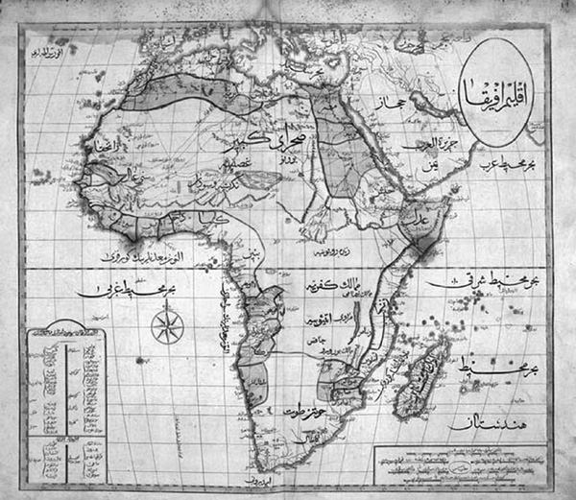
Figure 1 Ottoman map of Africa.
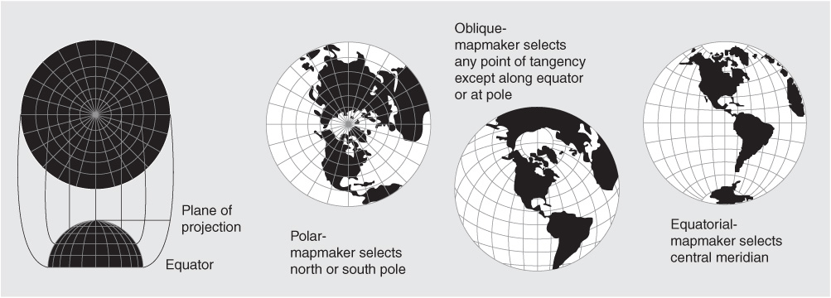
Figure 2 Azimuthal map projection of the United States. Source: United States Geological Survey.
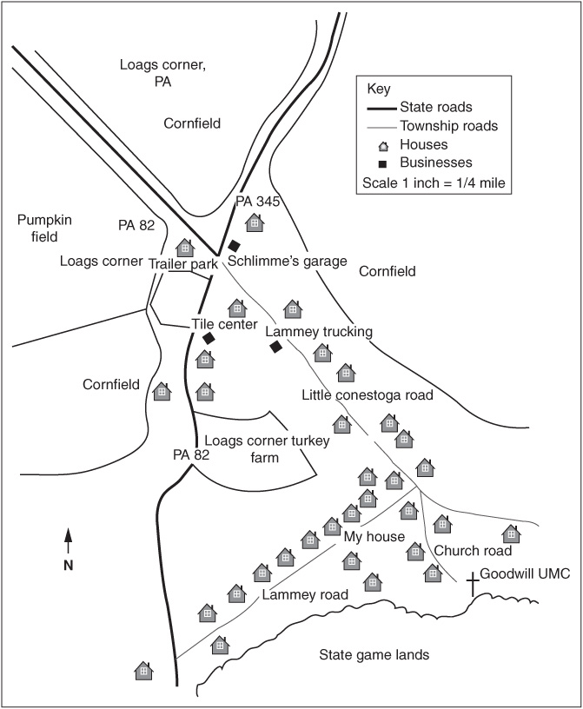
Figure 3 Mental map of a neighborhood.
Check out the table to see some kinds of maps geographers use and the best purpose for each type.
TYPE OF MAP | WHAT IT DOES | EXAMPLE
General-purpose or Reference Map | Displays general features of an area | Topographic, highway, atlas
Thematic Map (types of thematic maps are listed below)  - Graduated Circle  - Dot  - Choropleth | Displays a single type of information  Size of circle conveys number of occurrences of event in an area  Displays pattern, distribution, dispersion of data in an area  Displays an average value of data in an area | Population, median income, annual beef production  (see example below)  (see example below)
The two maps in Figures 4 and 5 are both examples of thematic maps displaying the same data but in two different ways. The first is a choropleth map and the second is a dot map. Compare them and see which one makes better sense to you.
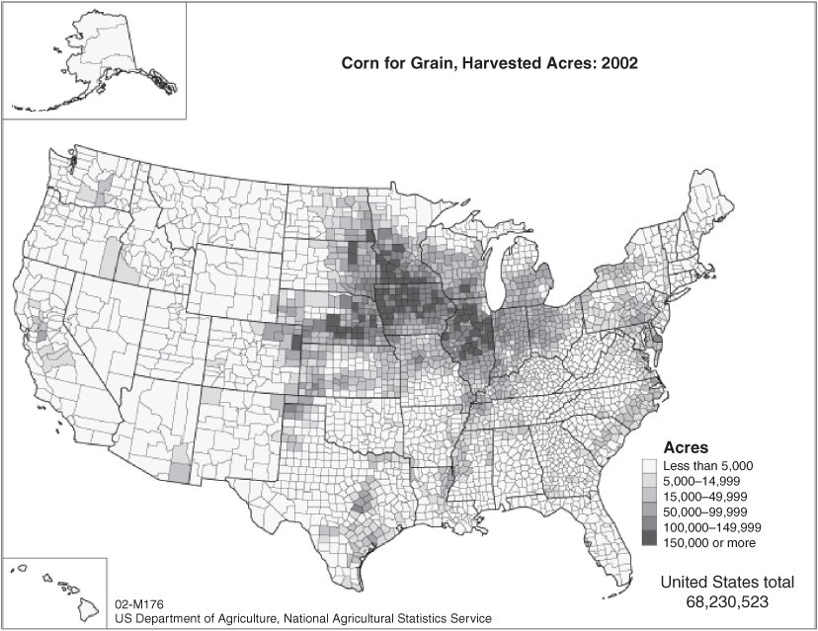
Figure 4 Example of a choropleth map.
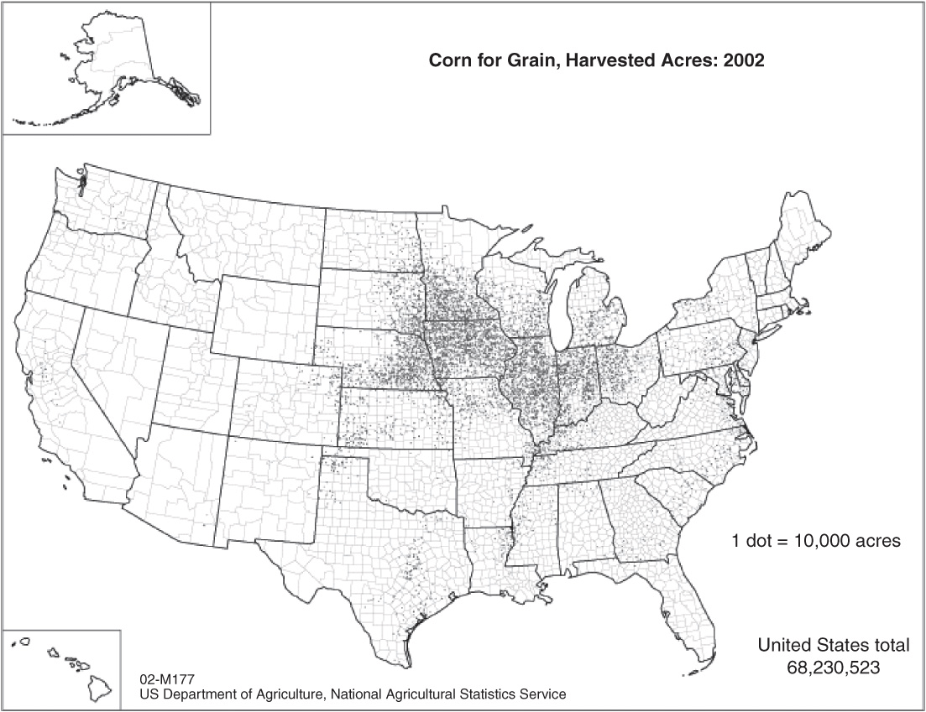
Figure 5 Example of a dot map.
A model is a simplified generalization of something in real life. Maps are a special form of model that depict information in two dimensions and usually on paper. Most models eliminate unnecessary details and isolate one or two important ideas in order to study them. AP Human Geography applies several important models that we will review in later sections of this manual.

New Geographic Technologies
The use of satellite imagery provides us with images of Earth’s features that aid us in mapping and studying various processes as they occur. This process of detecting the nature of an area from a distance is called remote sensing and has actually been around for over 150 years. People have attached cameras to airplanes, kites, and hot-air balloons in an attempt to photograph places from a distance for many years. Various processes such as water pollution, desertification, and even military surveillance can be accomplished with remote sensing through the use of infrared film and thermal scanning. Today, American Landsat satellites relay images from outer space to receiving stations, which digitally convert them into images for scientific study and mapping use.
Geographic Information Systems (GIS) marry mapping software with a database for the purpose of overlaying various data layers on a basic locational map grid. An abundance of data sets today have made GIS a valuable tool for human geographers studying questions about regional, social, and economic problems or analyzing physical processes as they impact human behaviors.

Spatial Behavior and Interaction
The two main questions geography answers are “Where?” and “Why?” Maps have long been the primary tool of geographers when answering the question of “where” places and activities are located on the surface of the Earth. To answer the “why” question, geographers must turn to the processes of spatial interaction and diffusion. The relationships between the members of your community depend on the type and kind of human interaction that occurs among the community members. In the same way, the interconnectedness between places depends on the amount of spatial interaction between them.
Key Idea:
Diffusion is the movement of people, ideas, customs, and information between places. Spatial diffusion is the spread of something over time or space. The two basic types of diffusion are relocation and expansion. The table here defines and gives examples of these two forms of diffusion. Spatial distribution refers to the array of items on the Earth’s surface. All spatial distributions have density, dispersion, and some type of pattern.
TYPE OF DIFFUSION | DEFINITION | EXAMPLES
Relocation | Physical transfer of idea, trait, or artifact to new region | Christianity to the New World by Spaniards; Islam to Indonesia by Muslim traders
Expansion (Types of expansion are shown below.)  - Hierarchical  - Contagious  - Stimulus | Spread of idea, trait, or artifact usage to neighboring region  Spread of ideas, etc. first to ruler, king, or highest authority and then downward to subjects or less prominent people  Idea, trait, etc. spreads evenly outward from diffusion origin or hearth  The spread of a general concept throughout a population | Spread of English in India under British rule so those in prominent positions needed to learn it first  Christianity’s spread throughout Europe from monasteries and Roman settlements  The development of a written language by Native American groups
Density is the number of an item within a unit of area. It is more than just a count of an item—it refers to how many of that item is in a limited space or area. One million people in a country the size of Switzerland will look a lot different than one million people in the People’s Republic of China, for example! Density is an important concept when studying spatial issues. We will discuss the different types of density in the section reviewing population.

Rapid Review
Human geography is the study of why people choose to live where they do. The study of human geography involves the use of maps, models, and spatial analysis technologies as a means of abstracting and simplifying space and all it contains for study. Maps depict a three-dimensional Earth in two dimensions, are inherently flawed due to this, and are designed with special purposes that should match the needs of the map-user

