5 For 5 Unit 2 Population and Migration

In This Section
Summary: In AP Human Geography, we look at population through the double lenses of space and place. Human populations have moved and settled in various locations for many years. What factors cause them to move to a new location? What makes up a population? What determines whether a population will grow or decline? This section reviews the basic concepts of population composition, dynamics, movements, settlement patterns, and how people relate to places.

Introduction
The study of population and migration is an important subject area that is heavily tested on the AP Human Geography exam. It is important to know and be able to apply the concepts discussed in this section at every scale from local to international. What comprises a human population and the dynamics, movements, and composition of that population are both interesting and complex topics for geographers.

Population Density, Distribution, Composition, and Scale
Key Idea:
Demography is the study of the characteristics of a human population. It is useful to examine some facts about a population before studying the human-environmental interactions that follow. Population density is the number of persons per unit of land area. In Figure.1, you will see which regions of the world have many inhabitants per unit of land area and which regions have very few, if any. Which regions have the most inhabitants? The largest cluster lives in East Asia (20 percent) with South Asia, Southeast Asia, and Europe following in order of population. The remainder of the world’s population is dispersed unevenly over the remaining ecumene. The northeastern coast of the United States and upward into the southeastern coastline of Canada comprises the fifth-largest cluster of population and the largest concentration of humans in the Western Hemisphere. The part of the Earth that is fit for humans to live is called the ecumene. Nearly 75 percent of the Earth’s inhabitants live on 5 percent of the Earth’s surface and 50 percent of these people live in urban centers.
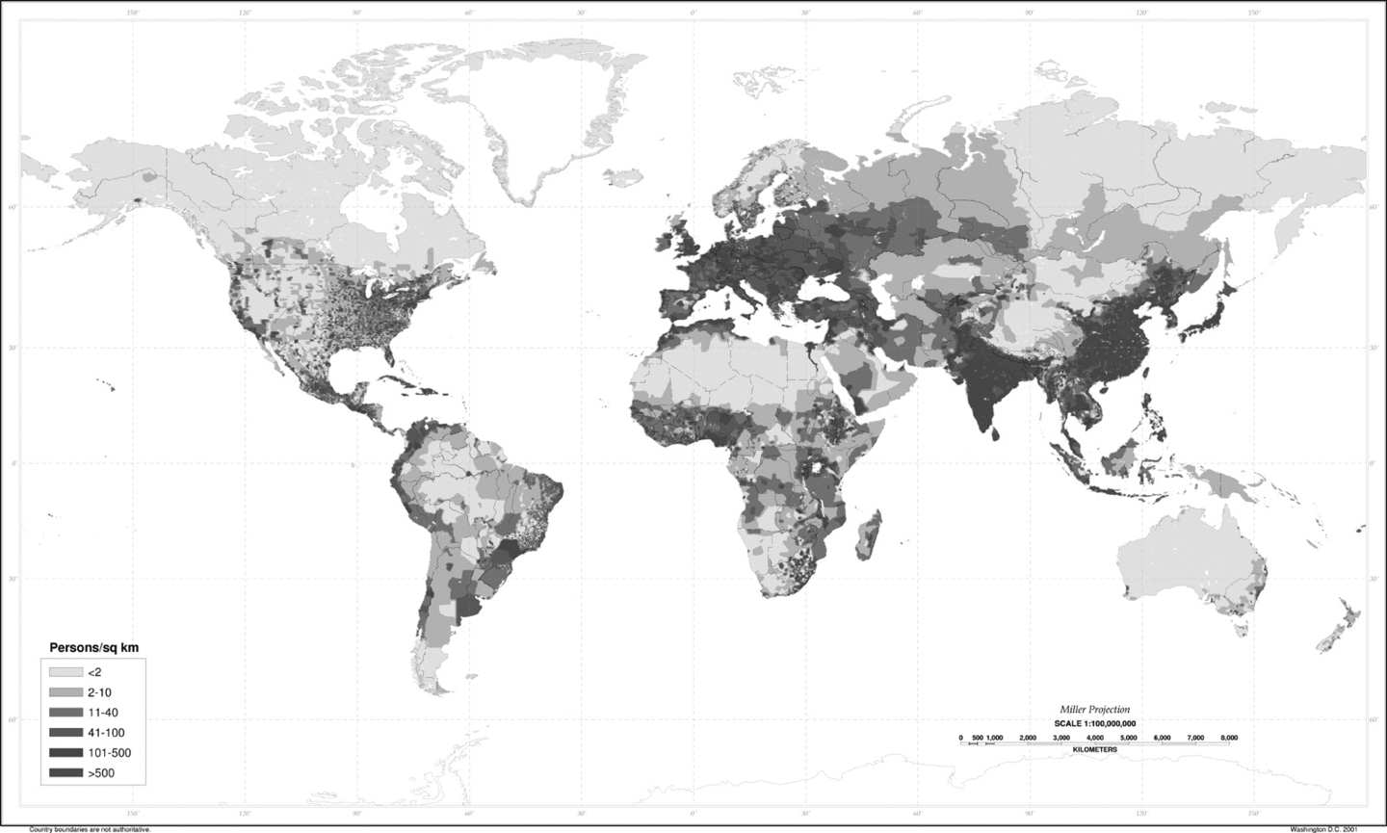
Figure 1 World population density, 1994. Source: US Department of Agriculture (USDA).
There are different ways of expressing the density of humans on the surface of the Earth. Perhaps the most helpful is physiologic density, which is the number of persons per unit of agricultural land. This number is helpful because it gives us a rough estimate of how many people a parcel of farmland can reasonably support. It could be useful in studying population pressure and overcrowding. Is the land very fertile and productive or is the soil poor and overworked? Since the productivity of the land makes a difference, physiologic density is not a foolproof statistic. Agricultural density refers to the number of people living in rural areas per unit of agricultural land. This figure omits people who live in cities and provides an estimate of the number of people actually living off the farmlands. Possibly the most general and least useful statistic is that of crude density, or arithmetic density. This is the number of people per unit of land. All you have to do is divide the total land area of a region, country, or other land area by the total population to compute the arithmetic density. As the unit of land area increases in size, the crude density figure becomes less meaningful since it “blends in” the urban populations and masks the sparsely inhabited areas into one fairly useless average. Although it could be useful for quick estimates because it is easy to calculate, crude density is not very meaningful. It is most useful for homogeneous areas, such as single towns, that have evenly distributed populations.
Carrying capacity, defined as how many people an area can support on a sustained basis, relates to density because together, they define whether or not an area is overcrowded. An area may be very densely populated and yet not overcrowded, if it also has a very high carrying capacity, perhaps because of fertile soil and modern agricultural techniques. On the other hand, a place like Greenland, with a very low carrying capacity, could be over-populated at a density that would make other places underpopulated.
Population distribution is the pattern of where humans live. Humans are not spread evenly throughout the world. Most people live in the Northern Hemisphere, on continental margins, and in lowlands. The table summarizes the place characteristics that produce high and low population densities in the world.
CHARACTERISTIC | DESCRIPTION | EXAMPLE
Place Characteristics That Produce Low Population Densities
Extreme climate | Too hot, cold, arid, or wet | Antarctica (too cold and too arid)
Extreme relief | Too high or too steep | Himalaya Mountain peaks
Extreme remoteness | Too hard to access | The island of Tristan da Cunha (the world’s remotest inhabited island)
Infertile land | Unproductive land supports fewer farmers | Amazon River Basin (tropical rainforest or selva)
Place Characteristics That Produce High Population Densities
Moderate climate | Not too hot or too cold | England
Adequate water supply | Ample rainfall year-round | Thailand
Fertile farmland | Many small farms feed many people | France
Mineral resources | Provision of jobs, raw materials, and energy for industries | Germany
Lowlands and river valleys | Flat or gently rolling land provides easier transportation and communication | China, Western Europe
Coastlines | 60 percent of world’s population live within 60 miles of the ocean | US Eastern Seaboard, South America
Migration is the movement of humans from one place to another. Migration flows occur at every possible scale from the family that moves from one neighborhood to another to the huge intercontinental flows of migrants from one continent to another. The reasons for these often large movements of humans have varied over the centuries, but these migrations are usually flights from dangerous or difficult circumstances in migrants’ home regions. For example, after the collapse of the USSR, large number of refugees fled their homelands for Western Europe where jobs and new lives as guest workers opened doors of opportunity for both them and their host countries. Migrations also occur between countries on a continent (intercontinental), within a country (interregional), and from the rural countryside to urban centers (rural to urban).

Population Growth and Decline
While both the crude birth rate (CBR) and the total fertility rate (TFR) reflect on the number of births in a population, they differ in important ways. The crude birth rate measures the number of babies born per 1000 people, and the total fertility rate measures the number of babies born per reproductive-age woman. The total fertility rate is a more accurate measure of the amount of reproduction occurring in a population. A population with large amounts of reproduction occurring would have a high fertility rate (many children per woman), but could still have a low crude birth rate if most of the population were male or very old or young, that is, not reproductive-age women.
The crude death rate (CDR) refers to the annual number of deaths per 1000 people. Improved antibiotics, vaccinations, pesticides, and access to medical care and safe water supplies have reduced death rates (also called mortality rates) since 1945, but the concentrations of very youthful populations in less developed countries (LDCs) is equally important when considering populations. The greatest drop in death rates has occurred in the “infants one-year-and-under” age cohort. This is the age group with the highest mortality rate so the changes in healthcare availability have had the greatest impact on this group. The drop in the infant mortality rate has been the most important factor impacting death rates all over the world.
HIV/AIDS is the fourth most common cause of death worldwide. It is a heterosexual phenomenon that is ravaging many Sub-Saharan African countries at an alarming rate. Since AIDS kills more women (who perform the majority of farm work as well as family care) than men in this region, food shortages threaten the survival of many families in Sub-Saharan Africa.
The rate of natural increase (NIR) is found by subtracting the crude death rate from the crude birth rate. (Immigration is not included in computing the NIR). The NIR is very large in the Southern Hemisphere (especially Africa), actually negative in Europe, and low in the United States. As a general rule, less developed countries (LDCs) tend to have higher rates of natural increase than more developed countries, although the pattern is not universal. Hence, population growth is usually faster in LDCs.
The doubling time is the length of time it takes for a country’s population to double in size if the growth rate stays the same. Simply use the Rule of 70 and divide 72 by the NIR to compute the doubling time of a population. A 2 percent rate of natural increase (medium-high) would double population in 35 years. The exponential growth of a growing population can be seen in the J-curve, which looks like a big letter J on a graph with the curve heading into the universe as population growth explodes. Population projections suggest reason for concern in some world regions as population appears to be approaching a point that exceeds available resources.
Because of population momentum, it can be very difficult to project what a population will be like in the future. Population momentum means that even though the fertility rates may be decreasing, the population can still be increasing. Developing countries (such as those in Asia and Latin America) have a much greater population momentum than the industrially developed countries because of a high proportion of the population in their reproductive years.
Key ideas:
The demographic transition model attempts to show the link between population growth and economic development. The stages in demographic transition are as follows:
- Stage 1: Slow population growth, when the birth and death rates are both high
- Stage 2: The population increases greatly as the death rate drops and birth rate stays high
- Stage 3: The population growth slows because of a falling birth rate
- Stage 4: The rate of natural increase is low or decreasing because of low death rates and low birth rates
There appears to be a fifth stage, which is represented by many European countries and Japan that have achieved the final stage of demographic transition and have subreplacement fertility rates (below 2.1 children per woman). These countries have higher death rates than birth rates. Most of the other developed countries like the United States, have achieved the fourth stage of demographic transition, as can be seen by their low rates of natural increase. Some analysts doubt the applicability of demographic transition to all parts of the world because of the effects of population momentum and the fact that some countries have lowered their death rates without accompanying economic development.
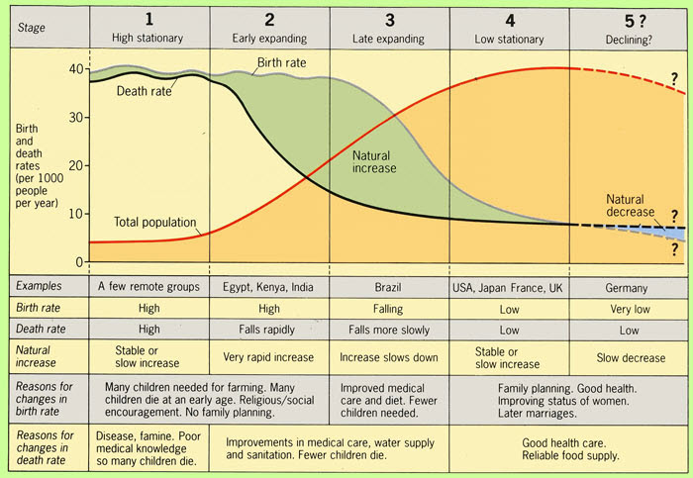
The Demographic Transition Model.
With over 6.5 billion inhabitants, the Earth is becoming a well-populated rock! Over the years, various theories have attempted to predict what will happen if our numbers continue to grow. Overpopulation is a value judgment (subjective determination) based on a person’s viewpoint about the Earth’s limited resources. Thomas Malthus, a British scholar, made the assumption regarding the relationship between population growth and food supply that population always grows geometrically, while food supply only grows arithmetically. This assumption is not always valid as we now realize today. Neo-Malthusians, on the other hand, believed that population growth has a tendency to exceed food supply growth (as did Malthus) but suggest that governmental policies can keep population growth in check. Governmental policies of birth control and family planning to reduce birth rates are implicit in the neo-Malthusian population growth model.
Now, some geographers are concerned about population implosion, or too few people on the Earth. Since the 1970s, several countries—many in Europe—have TFRs below the replacement level of 2.1 necessary to assure the population continues to replace itself. Many European countries developed pro-natalist policies and economic incentives designed to encourage families to produce more children, but reproduction rates still kept falling. Currently, many more developed countries (MDCs) and newly developed countries (also called newly industrialized countries or NICs) have fertility levels below replacement levels. These countries are concerned with the implications of a growing cohort of aging adults and a decreasing group of children and working-age adults to bear the socioeconomic costs. Achievement of zero population growth (ZPG), a condition in which births plus immigration equal deaths plus emigration for individual countries, would present unique socioeconomic problems. These socioeconomic problems would be made worse by shrinking national and international economies.

Patterns of Population
Key Idea:
The composition of a population is represented in a population pyramid, or age-sex pyramid. This graph shows the number of males and females in any given population by age group, or cohort. Population pyramids can help predict the future needs of a country’s population. For example, a triangular population pyramid (see Figure 1) with a very broad bottom structure and tapering apex suggests a population with a large number of babies and children. This might predict immediate needs for social services, immunizations, and schools for the too-young-to-work crowd. A rectangular or cylindrical pyramid with a larger aging cohort (see Figure 2) can predict the future needs of a large population of aging adults for medical care and services. Japan has the highest percentage of aging adults in the world with over 21 percent of its citizens in the age 65 and older cohort.
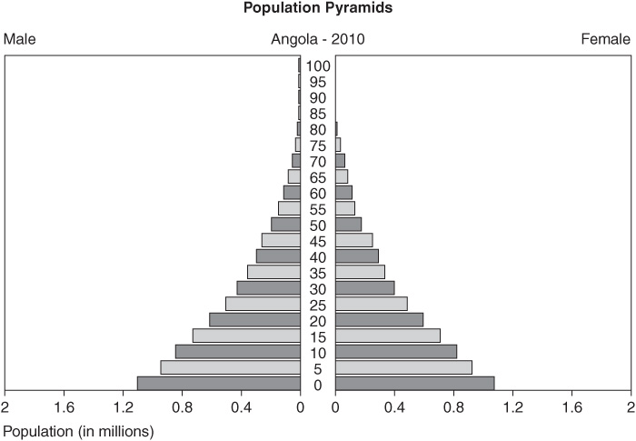
Figure 1 Age-sex pyramid for Angola, 2010. Population pyramids.
Source: US Census Bureau.
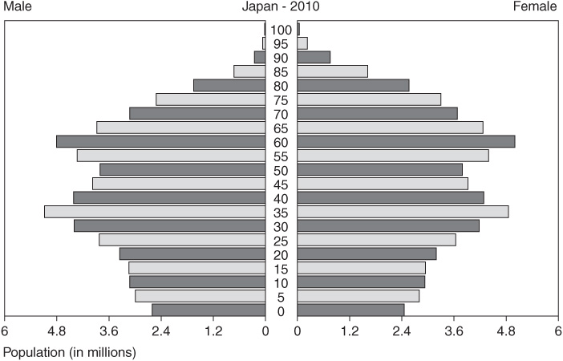
Figure 2 Age-sex pyramid for Japan, 2010. Source: US Census Bureau.
The dependency ratio (the ratio of people under age 15 and those 65 and older to those aged 15 to 65) gives us a good idea how many workers are required to support the dependent population. Many countries in Europe such as Sweden, Austria, Italy, and Greece as well as Japan will experience a decrease in their workforce at the same time as the number of dependents to each worker increases. Government spending for adult daycare, nursing homes, and home care social services will increase while government expenditures for education, child welfare and health services, and maternity services will decrease.

Population Movement
People move for many reasons, and geographers have created models and theories that address the processes of migration. When people move into a country, they immigrate. When they exit a country, they emigrate.
Key Ideas:
E. G. Ravenstein, a geographer, proposed several migration principles in the 1880s, many of which still hold true today. To summarize these principles, most migrants:
- Move only a short distance.
- Usually settle in urban areas if moving long distances.
- Move in steps.
- Move from rural to urban.
- Start a migration flow that produces a movement in the opposite direction.
- Are adults (families with children are less likely to move).
- If international, are young males whereas more internal migrants are female, but this has changed recently. Now, from 40 to 60 percent of international migrants are female.
Migrants are not representative of a cross section of their sending population. The majority of international migrants are young adults in all regions of the world. Female migrants usually move for better economic opportunities and send remittances (money) home to their families. Many migrants send remittances back home to their families. For example, since the early 1990s, Indians working abroad in oil-exporting countries of the Persian Gulf send remittances back home to India that contribute more to the Indian balance of payments than all other forms of capital inflow added together. Migrants also are typically well educated, and this often creates a “brain drain” back home in the sending country.

Push and Pull Migration Factors
There are many reasons why migrants move. The table here shows some of the major reasons people leave their homes and move. It is divided into push factors (factors that encourage leaving) and pull factors (factors that “pull” the migrant to the new location.
PUSH FACTORS | PULL FACTORS
Famine | Better jobs
War | Lower taxes
Lack of jobs | Nicer climate
Disease | Better schools
Violence | More room
High crime | Low crime
Overcrowding | Better medical care
Key Idea:
All moves are influenced by place utility, which is the person’s satisfaction or dissatisfaction with a place. People will choose whether to remain or move based on place utility. Distance decay is the principle that says migrants try to minimize the friction of distance. This means that migrants will be more inclined to move to locations closer to them; they will be less interested in moving to distant locations. Intervening opportunity is the idea that migrants will choose a location closer rather than farther if all other factors are roughly the same. The closer opportunities will appear more attractive to the migrant than those farther away. We usually know more about locations we are already closer to and we are less aware of facts about distant locations. Also, the costs in time and money increase the farther away the new location is from the present location.

Voluntary and Involuntary Migrations
Not everyone who migrates really wants to make the move. Sometimes forced, or involuntary, migrations occur as people are forced out of their homes by the government or some other group. Here is a list of the types of migrants:
- Immigrant: A person who is entering another country with the intention of living there
- Emigrant: A person who is leaving one country with the intention of living in a different country
- Refugee: A person who is residing outside the country of his or her origin because of fear of persecution because of religion, ethnicity, race, or political ideology
- Internally Displaced Person (IDP): A person who is forced out of the home region because of war, political or social unrest, environmental problems, etc. but does not cross any international boundaries
Refugees have become a huge problem in the world today with the regions of Africa, Europe, Southeast Asia, and Southwest Asia facing the worst problems. Fighting in the Darfur region of the Sudan, for example, has generated thousands of refugees; 250,000 refugees have fled from the Darfur province to Eastern Chad since the conflict began. Refugees typically flee their home in fear without official documents, taking only the clothes on their backs, and traveling on foot or using some other basic mode of transportation.
Refugees place demands on the host country’s resources which are usually already strained to capacity. Several African countries have asked the international aid community to share the refugee burden by contributing financial resources to infrastructure projects that would benefit both nationals and refugees. They contend that they absorbed the extra migrants instead of closing their borders and thus prevented a humanitarian crisis requiring the assistance of the developed countries (DCs).

Spatial Patterns and Theories of Migration
How long do migrants usually stay when they move? Short-term migration occurs when a person moves to another country for a period of at least three months but less than a year. Local movements or internal migration occur as people leave an area in a country or region and go to another part of that same country or region. Sometimes a drought or other agrarian hardship in one part of the region makes life intolerable and people living there go to another part of the region as occurs in India, for example. The ability to move within the country or region helps people survive hardships without going too far from home. Cyclic movement, or movement away from home for a short period, includes commuting, seasonal movement, and nomadism.
Once considered short-term migrants, guest workers are migrants permitted into a country to fill a labor need on the assumption that the workers will go “home” once the labor need subsides. They generally have short-term work visas and send remittances back to their home country. Increasingly however, guest workers from Southwest Asia and North Africa are bringing their families to live with them in Europe.
One type of local movement that is prevalent in Western nations is residential relocation because of the desire for a better school district, a more convenient location, changes in life cycle, income level, job location, perceived safety of neighborhood, etc.
Migration takes many spatial forms. Some migrants make a large move from one continent or culture to another, but often migrants make small, incremental moves. What are the typical spatial patterns of migration? The table here summarizes the forms of migration.
FORM OF MIGRATION | DEFINITION/DESCRIPTION | EXAMPLE
Step migration | Series of small moves to reach destination | Rural to big city by moving to village, small town, larger town, and then big city
Chain migration | Part of a migrant flow that follows former migrants to an area | Turkey to ethnic enclave in Berlin, Germany
Counter or return migration | Generally, about 25 percent will return to home area eventually | Ohio to West Virginia
Channelized migration | Repetitive pattern of migration not linked to family or ethnicity | Retired persons to Arizona and Florida

Barriers to Migration
Moving is not always easy! There are barriers to migration that affect the flow of persons from one region or country to another. Limiting factors on migration include financial and emotional costs, knowledge of opportunities in the new place, and personal characteristics such as gender, economic status, and age. The elderly and the poor are least likely to migrate whereas educated males between the ages of 18 to 34 are most likely to migrate. In addition, migration is usually controlled by government policies. Immigration laws restrict or allow migration of certain groups into a country. Government immigration quotas may limit the number of persons from each region entering a country. Restrictive immigration prevents certain individuals from entering a country.

Key Idea:

Human Capital Theory of Migration
National and international economies require a fluid movement of both labor and capital to function smoothly. When migrants move from one location to another, they shift human capital. The human capital theory of migration states that educated workers often migrate from poor countries to wealthy countries seeking better-paying jobs. This movement of human capital benefits both countries. The capital-rich country gains talented labor and the labor-rich country receives much-needed capital as the migrants send remittances home to their families. The loss of labor in the poor country also increases the wage rate for those who do not emigrate. When workers migrate, their education benefits the country where they move to work. Any healthcare needs or retirement benefits will be paid in the new country. Most countries now practice selective migration by requiring certain immigrants to possess specific qualifications such as skills, youth, and health.

Life Course Theory of Migration
The life course theory of migration states that the interaction of life course events (becoming married, having a child, becoming divorced) with migration has important repercussions on a society. Recent life course studies of internal and international migration show that changes in education and occupation are regarded as major reasons why individuals decide to change their region or country. Also, migration influences life course decisions in both individuals and families. Studies show that married individuals are less likely to move than are singles and that their relocation is generally more successful.
Childbearing is an important cause for housing- and environment-related moves. These are mostly moves within a labor-market area or they are migrations from urban regions to surrounding suburban or rural areas. The need for additional space or the desire to live in a more pleasant environment in which to raise children are major reasons why families decide to change their residence. Second, as the family grows, the likelihood for families to make job-related long-distance moves, especially to urban sites, declines strikingly. The economic and psychological costs of moving from one region to another increase as the family with school-age children grows in size.

Rapid Review
Population and human migrations are themes that are integral to the study of AP Human Geography. Geographers study the spatial distributions of humans and their movements by looking at demographic statistics such as CBR, CDR, TFR, and age-sex pyramids, and by analyzing the impact and rationale for migrations.

