Name \_\_\_\_\_\_\_\_\_\_\_\_\_\_\_\_\_\_\_\_\_\_\_\_\_\_\_\_\_\_\_\_\_\_\_\_\_\_\_ Date \_\_\_\_\_\_\_\_\_\_\_ Period \_\_\_\_\_\_\_\_\_

**Chapter 1 Toward Civilization (prehistory – 3000B.C.)**

**Essential Questions:** What makes a people group a civilization?

What are the benefits of living in a community? What are the drawbacks?

How does where we live influence how we live?

|  |  |
| --- | --- |
| **Vocabulary**  **Words** | Definitions |
| Prehistory | Time before writing |
| Traditional  Economy |  |
| Anthropology | The study of the origins and development of people and their societies |
| Culture |  |
| Archaeology | The study of past people and their cultures |
| Artifact |  |
| Technology |  |
| Division  of Labor |  |
| Nomad |  |
| Paleolithic Era |  |
| Neolithic  Revolution |  |
| Domestication |  |
| Civilization | A complex highly organized social order with 8 features |
| Surplus |  |
| Polytheistic |  |
| Artisans |  |
| City-State |  |
| Primary Source | a firsthand account of events written by people during the time period in which they occur |
| Secondary Source | An account or retelling of an event by someone who was not present at the event. |
| Cultural Diffusion |  |
|  | **The First People** |
| Spreading Aroundthe World | * Movement of man out of \_\_\_\_\_\_\_\_\_\_\_\_\_\_\_\_\_\_\_\_\_\_\_\_\_\_ |
| How do we  know? | * \_\_\_\_\_\_\_\_\_\_\_\_\_\_\_\_\_\_\_\_\_\_\_\_\_\_ refers to the long period of time before people * Prehistoric people had no cities, countries, central government, complex inventions * \_\_\_\_\_\_\_\_\_\_\_\_\_\_\_\_\_\_\_\_\_\_\_\_\_\_\_\_\_\_ refers to the origins, development and ways of life of a society that is handed down from one generation to the next * \_\_\_\_\_\_\_\_\_\_\_\_\_\_\_\_\_\_\_\_\_\_\_\_\_\_\_\_\_\_ is the study of past people and cultures by analyzing the artifacts or objects made by humans, such as: \_\_\_\_\_\_\_\_\_\_\_\_\_\_\_\_ |
| Historical Detection  http://www.familytree.com/wp-content/uploads/2015/07/history-detective.jpeg | * Historians study the written \_\_\_\_\_\_\_\_\_\_\_\_\_\_\_\_\_\_\_\_\_\_\_\_\_\_\_\_ * Historians must evaluate the evidence to determine if its reliable * Do records tell exactly what was said? Who recorded the info, is the writer recording as an eyewitness or rumor, is it a forgery, what about historian’s cultural background, personal experiences, political opinions. * \_\_\_\_\_\_\_\_\_\_\_\_\_\_\_\_\_\_\_\_\_\_\_\_\_\_\_\_\_\_\_\_\_\_\_\_\_\_ a firsthand account of events written by people during the time period in which they occur. Examples: \_\_\_\_\_\_\_\_\_\_\_\_\_\_\_\_\_\_\_\_\_\_\_\_\_\_\_\_\_\_\_\_\_\_\_\_\_\_\_\_\_\_\_\_\_\_\_\_\_\_\_\_\_\_\_\_\_\_\_\_\_\_\_ \_\_\_\_\_\_\_\_\_\_\_\_\_\_\_\_\_\_\_\_\_\_\_\_\_\_\_\_\_\_\_\_\_\_\_\_\_\_\_\_\_\_\_\_\_\_\_\_\_\_\_\_\_\_\_\_\_\_\_\_\_\_\_ \_\_\_\_\_\_\_\_\_\_\_\_\_\_\_\_\_\_\_\_\_\_\_\_\_\_\_\_\_\_\_\_\_\_\_\_\_\_\_\_\_\_\_\_\_\_\_\_\_\_\_\_\_\_\_\_\_\_\_\_\_\_\_ * \_\_\_\_\_\_\_\_\_\_\_\_\_\_\_\_\_\_\_\_\_\_\_\_\_\_\_\_\_\_\_\_\_\_\_\_\_ An account or retelling of an event by someone who was not present at the event. Examples: \_\_\_\_\_\_\_\_\_\_\_\_\_\_\_\_\_\_\_\_\_\_\_\_\_\_\_\_\_\_\_\_\_\_\_\_\_\_\_\_\_\_\_\_\_\_\_\_\_\_\_\_\_\_\_\_\_\_\_\_\_\_\_\_\_\_\_\_\_\_\_\_\_\_\_\_\_\_\_\_\_\_\_\_\_\_\_\_\_\_\_\_\_\_\_\_\_\_\_\_\_\_\_\_\_\_\_\_\_\_\_\_\_\_\_\_\_\_\_\_\_\_\_\_\_\_   \_\_\_\_\_\_\_\_\_\_\_\_\_\_\_\_\_\_\_\_\_\_\_\_\_\_\_\_\_\_\_\_\_\_\_\_\_\_\_\_\_\_\_\_\_\_\_\_\_\_\_\_\_\_\_\_\_\_\_\_\_\_\_ |

**Prehistory Civilizations**

|  |  |
| --- | --- |
| **Paleolithic / Old Stone Age**  Earliest Period of human history 2 million BC to about 10,000 BC | **Neolithic / New Stone Age / Neolithic Revolution**  About 11,000 years ago people began producing their own food and settled into permanent villages and developed tools and skills |
| **Economy**   * \_\_\_\_\_\_\_\_\_\_\_\_\_\_\_\_\_\_\_\_\_\_\_\_\_\_\_\_\_\_\_\_ * \_\_\_\_\_\_\_\_\_\_\_\_\_\_\_\_\_\_\_\_\_\_\_\_\_\_\_\_\_\_\_\_ | **Economy**   * \_\_\_\_\_\_\_\_\_\_\_\_\_\_\_\_\_\_\_\_\_\_\_\_\_\_\_\_\_\_\_\_\_ * \_\_\_\_\_\_\_\_\_\_\_\_\_\_\_\_\_\_\_\_\_\_\_\_\_\_\_\_\_\_\_\_\_ \_\_\_\_\_\_\_\_\_\_\_\_\_\_\_\_\_\_\_\_\_\_\_\_\_\_\_\_\_\_\_\_\_ * \_\_\_\_\_\_\_\_\_\_\_\_\_\_\_\_\_\_\_\_\_\_\_\_\_\_\_\_\_\_\_\_\_\_ |
| **Developments**   * Simple tools and weapons * \_\_\_\_\_\_\_\_\_\_\_\_\_\_\_\_\_\_\_\_\_\_\_\_\_\_\_\_\_\_\_\_\_ * \_\_\_\_\_\_\_\_\_\_\_\_\_\_\_\_\_\_\_\_\_\_\_\_\_\_\_\_\_\_\_\_\_ * \_\_\_\_\_\_\_\_\_\_\_\_\_\_\_\_\_\_\_\_\_\_\_\_\_\_\_\_\_\_\_\_\_ * \_\_\_\_\_\_\_\_\_\_\_\_\_\_\_\_\_\_\_\_\_\_\_\_\_\_\_\_\_\_\_ * \_\_\_\_\_\_\_\_\_\_\_\_\_\_\_\_\_\_\_\_\_\_\_\_\_\_\_\_\_\_\_ * Dependent on the environment * \_\_\_\_\_\_\_\_\_\_\_\_\_\_\_\_\_\_\_\_\_\_\_\_\_\_\_\_\_ * \_\_\_\_\_\_\_\_\_\_\_\_\_\_\_\_\_\_\_\_\_\_\_\_\_\_\_\_\_ | **Developments**   * **Neolithic Revolution / Man learns how to farm** * \_\_\_\_\_\_\_\_\_\_\_\_\_\_\_\_\_\_\_\_\_\_\_\_ * Increased status for males * \_\_\_\_\_\_\_\_\_\_\_\_\_\_\_\_\_\_\_\_\_\_\_\_\_\_\_\_\_\_\_\_ \_\_\_\_\_\_\_\_\_\_\_\_\_\_\_\_\_\_\_\_\_\_\_\_\_\_\_\_\_\_\_\_ * \_\_\_\_\_\_\_\_\_\_\_\_\_\_\_\_\_\_\_\_\_\_\_\_\_\_\_\_\_\_\_\_ \_\_\_\_\_\_\_\_\_\_\_\_\_\_\_\_\_\_\_\_\_\_\_\_\_\_\_\_\_\_\_\_ * Create first \_\_\_\_\_\_\_\_\_\_\_\_\_\_\_\_\_\_\_\_\_ * \_\_\_\_\_\_\_\_\_\_\_\_\_\_\_\_\_\_\_\_\_\_\_\_\_ * More interactions among human communities * Work divided work by \_\_\_\_\_\_\_\_\_\_\_\_\_\_\_\_\_\_ * Learn to weave \_\_\_\_\_\_\_\_\_\_\_\_\_\_\_\_\_\_ |
| Image result for stone age clip art |  |

Characteristics of a Civilization

|  |  |
| --- | --- |
| Developed CitiesC:\Users\kosborn\Downloads\city-skyline-300px (1).png | \_\_\_\_\_\_\_\_\_\_\_\_\_\_\_\_\_\_\_\_\_\_\_\_\_\_\_\_\_\_\_\_\_\_\_\_\_\_\_\_\_\_\_\_\_ \_\_\_\_\_\_\_\_\_\_\_\_\_\_\_\_\_\_\_\_\_\_\_\_\_\_\_\_\_\_\_\_\_\_\_\_\_\_\_\_\_\_\_\_\_\_ |
| Organized Government  Image result for organized government | \_\_\_\_\_\_\_\_\_\_\_\_\_\_\_\_\_\_\_\_\_\_\_\_\_\_\_\_\_\_\_\_\_\_\_\_\_\_\_\_\_\_\_\_\_\_ \_\_\_\_\_\_\_\_\_\_\_\_\_\_\_\_\_\_\_\_\_\_\_\_\_\_\_\_\_\_\_\_\_\_\_\_\_\_\_\_\_\_\_\_\_\_ \_\_\_\_\_\_\_\_\_\_\_\_\_\_\_\_\_\_\_\_\_\_\_\_\_\_\_\_\_\_\_\_\_\_\_\_\_\_\_\_\_\_\_\_\_\_ |
| Formalized Religion  Image result for religion | \_\_\_\_\_\_\_\_\_\_\_\_\_\_\_\_\_\_\_\_\_\_\_\_\_\_\_\_\_\_\_\_\_\_\_\_\_\_\_\_\_\_\_\_\_ \_\_\_\_\_\_\_\_\_\_\_\_\_\_\_\_\_\_\_\_\_\_\_\_\_\_\_\_\_\_\_\_\_\_\_\_\_\_\_\_\_\_\_\_\_ \_\_\_\_\_\_\_\_\_\_\_\_\_\_\_\_\_\_\_\_\_\_\_\_\_\_\_\_\_\_\_\_\_\_\_\_\_\_\_\_\_\_\_\_\_ \_\_\_\_\_\_\_\_\_\_\_\_\_\_\_\_\_\_\_\_\_\_\_\_\_\_\_\_\_\_\_\_\_\_\_\_\_\_\_\_\_\_\_\_\_ |
| Specialization of Labor  Image result for work clip art | \_\_\_\_\_\_\_\_\_\_\_\_\_\_\_\_\_\_\_\_\_\_\_\_\_\_\_\_\_\_\_\_\_\_\_\_\_\_\_\_\_\_\_\_\_ \_\_\_\_\_\_\_\_\_\_\_\_\_\_\_\_\_\_\_\_\_\_\_\_\_\_\_\_\_\_\_\_\_\_\_\_\_\_\_\_\_\_\_\_\_\_ \_\_\_\_\_\_\_\_\_\_\_\_\_\_\_\_\_\_\_\_\_\_\_\_\_\_\_\_\_\_\_\_\_\_\_\_\_\_\_\_\_\_\_\_\_\_ |
| Social Classes  C:\Users\kosborn\Dropbox\School\World History\Unit 6 - WWI\social-hierarchy1.jpg | 1..\_\_\_\_\_\_\_\_\_\_\_\_\_\_\_\_\_\_\_\_\_\_\_\_\_\_\_\_\_\_\_\_\_\_\_\_\_\_\_\_\_\_\_\_  2. \_\_\_\_\_\_\_\_\_\_\_\_\_\_\_\_\_\_\_\_\_\_\_\_\_\_\_\_\_\_\_\_\_\_\_\_\_\_\_\_\_\_\_\_  3. \_\_\_\_\_\_\_\_\_\_\_\_\_\_\_\_\_\_\_\_\_\_\_\_\_\_\_\_\_\_\_\_\_\_\_\_\_\_\_\_\_\_\_\_  4. \_\_\_\_\_\_\_\_\_\_\_\_\_\_\_\_\_\_\_\_\_\_\_\_\_\_\_\_\_\_\_\_\_\_\_\_\_\_\_\_\_\_\_\_  5. |
| Record Keeping and Writing  C:\Users\kosborn\Dropbox\School\World History\Unit 6 - WWI\f35cc5ef90749e6b68d050275ce8c8f1.jpg | \_\_\_\_\_\_\_\_\_\_\_\_\_\_\_\_\_\_\_\_\_\_\_\_\_\_\_\_\_\_\_\_\_\_\_\_\_\_\_\_\_\_\_\_\_\_ \_\_\_\_\_\_\_\_\_\_\_\_\_\_\_\_\_\_\_\_\_\_\_\_\_\_\_\_\_\_\_\_\_\_\_\_\_\_\_\_\_\_\_\_\_\_ \_\_\_\_\_\_\_\_\_\_\_\_\_\_\_\_\_\_\_\_\_\_\_\_\_\_\_\_\_\_\_\_\_\_\_\_\_\_\_\_\_\_\_\_\_\_ \_\_\_\_\_\_\_\_\_\_\_\_\_\_\_\_\_\_\_\_\_\_\_\_\_\_\_\_\_\_\_\_\_\_\_\_\_\_\_\_\_\_\_\_\_\_ |
| Art and ArchitectureC:\Users\kosborn\Dropbox\School\World History\Unit 6 - WWI\hungry-history-vomitoriums-fact-or-fiction_Corbis-E.jpeg | \_\_\_\_\_\_\_\_\_\_\_\_\_\_\_\_\_\_\_\_\_\_\_\_\_\_\_\_\_\_\_\_\_\_\_\_\_\_\_\_\_\_\_\_\_\_ \_\_\_\_\_\_\_\_\_\_\_\_\_\_\_\_\_\_\_\_\_\_\_\_\_\_\_\_\_\_\_\_\_\_\_\_\_\_\_\_\_\_\_\_\_\_ \_\_\_\_\_\_\_\_\_\_\_\_\_\_\_\_\_\_\_\_\_\_\_\_\_\_\_\_\_\_\_\_\_\_\_\_\_\_\_\_\_\_\_\_\_\_ \_\_\_\_\_\_\_\_\_\_\_\_\_\_\_\_\_\_\_\_\_\_\_\_\_\_\_\_\_\_\_\_\_\_\_\_\_\_\_\_\_\_\_\_\_\_ \_\_\_\_\_\_\_\_\_\_\_\_\_\_\_\_\_\_\_\_\_\_\_\_\_\_\_\_\_\_\_\_\_\_\_\_\_\_\_\_\_\_\_\_\_\_ |
| Public Works  C:\Users\kosborn\Dropbox\School\World History\Unit 6 - WWI\Aqueduct_of_Segovia_08.jpg | \_\_\_\_\_\_\_\_\_\_\_\_\_\_\_\_\_\_\_\_\_\_\_\_\_\_\_\_\_\_\_\_\_\_\_\_\_\_\_\_\_\_\_\_\_\_ \_\_\_\_\_\_\_\_\_\_\_\_\_\_\_\_\_\_\_\_\_\_\_\_\_\_\_\_\_\_\_\_\_\_\_\_\_\_\_\_\_\_\_\_\_\_ \_\_\_\_\_\_\_\_\_\_\_\_\_\_\_\_\_\_\_\_\_\_\_\_\_\_\_\_\_\_\_\_\_\_\_\_\_\_\_\_\_\_\_\_\_\_ \_\_\_\_\_\_\_\_\_\_\_\_\_\_\_\_\_\_\_\_\_\_\_\_\_\_\_\_\_\_\_\_\_\_\_\_\_\_\_\_\_\_\_\_\_\_ |

**Ancient River Valley Civilizations**

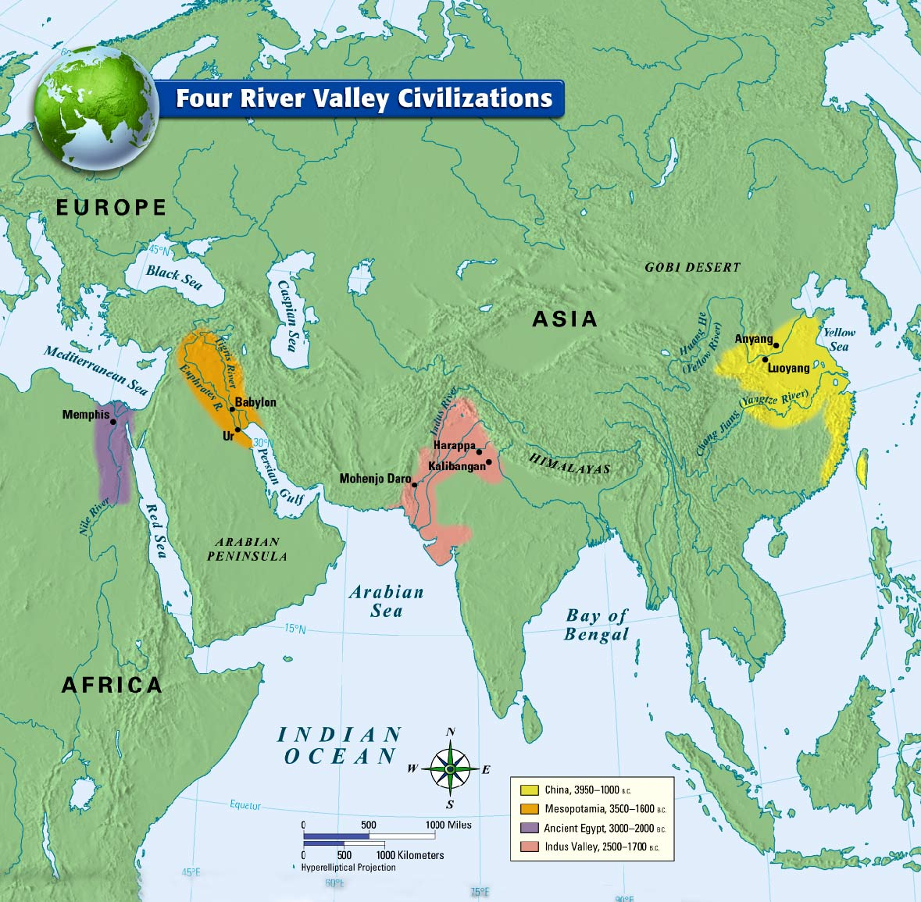

|  |  |  |  |
| --- | --- | --- | --- |
| **Mesopotamia** | **Egypt** | **India** | **China** |
| **Cities:\_\_\_\_\_\_\_\_\_\_\_\_\_\_\_\_\_**  **Government/Rulers: \_\_\_\_\_\_\_\_ \_\_\_\_\_\_\_\_\_\_\_\_\_\_\_\_\_\_\_\_\_\_\_\_\_\_\_**  **Religion:\_\_\_\_\_\_\_\_\_\_\_\_\_\_\_\_\_\_\_ Labor:\_\_\_\_\_\_\_\_\_\_\_\_\_\_\_\_\_\_\_\_\_ Social Classes:\_\_\_\_\_\_\_\_\_\_\_\_\_**  **Writing:\_\_\_\_\_\_\_\_\_\_\_\_\_\_\_\_\_\_\_\_**  **Art/Architecture:\_\_\_\_\_\_\_\_\_\_\_ \_\_\_\_\_\_\_\_\_\_\_\_\_\_\_\_\_\_\_\_\_\_\_\_\_\_\_\_**  **Public Works: \_\_\_\_\_\_\_\_\_\_\_\_\_\_** | **Cities:\_\_\_\_\_\_\_\_\_\_\_\_\_\_\_\_\_\_\_\_\_**  **Government/Rulers: \_\_\_\_\_\_\_\_ \_\_\_\_\_\_\_\_\_\_\_\_\_\_\_\_\_\_\_\_\_\_\_\_\_\_\_ Religion:\_\_\_\_\_\_\_\_\_\_\_\_\_\_\_\_\_\_\_ Labor:\_\_\_\_\_\_\_\_\_\_\_\_\_\_\_\_\_\_\_\_\_ Social Classes:\_\_\_\_\_\_\_\_\_\_\_\_\_**  **Writing:\_\_\_\_\_\_\_\_\_\_\_\_\_\_\_\_\_\_\_**  **Art/Architecture:\_\_\_\_\_\_\_\_\_\_\_ \_\_\_\_\_\_\_\_\_\_\_\_\_\_\_\_\_\_\_\_\_\_\_\_\_\_\_**  **Public Works: \_\_\_\_\_\_\_\_\_\_\_\_\_\_** | **Cities:\_\_\_\_\_\_\_\_\_\_\_\_\_\_\_\_\_\_\_\_\_**  **Government/Rulers:\_\_\_\_\_\_\_\_ \_\_\_\_\_\_\_\_\_\_\_\_\_\_\_\_\_\_\_\_\_\_\_\_\_\_\_ Religion:\_\_\_\_\_\_\_\_\_\_\_\_\_\_\_\_\_\_\_  Labor: \_\_\_\_\_\_\_\_\_\_\_\_\_\_\_\_\_\_\_\_  Social Classes:\_\_\_\_\_\_\_\_\_\_\_\_**  **Writing:\_\_\_\_\_\_\_\_\_\_\_\_\_\_\_\_\_\_\_\_**  **Art/Architecture:\_\_\_\_\_\_\_\_\_\_\_ \_\_\_\_\_\_\_\_\_\_\_\_\_\_\_\_\_\_\_\_\_\_\_\_\_\_\_**  **Public Works: \_\_\_\_\_\_\_\_\_\_\_\_\_** | **Cities:\_\_\_\_\_\_\_\_\_\_\_\_\_\_\_\_\_\_\_\_\_**  **Government/Rulers:\_\_\_\_\_\_\_\_\_\_\_\_\_\_\_\_\_\_\_\_\_\_\_\_\_\_\_\_\_\_\_\_\_\_\_\_ Religion:\_\_\_\_\_\_\_\_\_\_\_\_\_\_\_\_\_\_\_ Labor:\_\_\_\_\_\_\_\_\_\_\_\_\_\_\_\_\_\_\_\_\_ Social Classes:\_\_\_\_\_\_\_\_\_\_\_\_\_**  **Writing:\_\_\_\_\_\_\_\_\_\_\_\_\_\_\_\_\_\_\_\_\_**  **Art/Architecture:\_\_\_\_\_\_\_\_\_\_\_ \_\_\_\_\_\_\_\_\_\_\_\_\_\_\_\_\_\_\_\_\_\_\_\_\_\_\_**  **Public Works: \_\_\_\_\_\_\_\_\_\_\_\_\_\_\_** |