Greek Achievements!
GOVERNMENT! 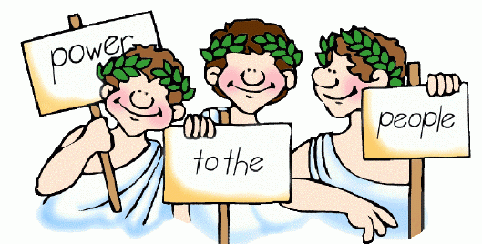
Democratic government was a Greek idea. Democracy, or rule by the people, began in Athens. The practice of having citizens serve on juries also began in Greece.
Democratic government in the United States has roots in ancient Greece. There are a number of important differences, however, between American democracy and ancient Greek democracy. For example, in Athens, all citizens debated and voted on every issue. But in the United States, citizens elect representatives to speak for them and to make laws. Another difference is that only native born men could be citizens in Athens. But in the United States, all men and women born in their country are US citizens, and people from other countries can become citizens, too.
THEATER!
The word theater comes from the Greek work that means “a viewing place.” Greek theater s were built as semicircles. The rows of seats rose steeply from the stage so that everyone in the audience could see and hear. These ideas are used in theaters built today.
The Greeks even invented special effects. For example, they used hoists to lift actors off the stage, so that they appeared to be flying. They also created scenery that revolved, or turned. Revolving the scenery let them quickly change where the action in a play was taking place. Perhaps the greatest Greek contributions to the theater are their stories and plays. Writers throughout the ages have been inspired by Greek myths and stories. Greek dramas are still performed all over the world.
LITERATURE AND HISTORY! 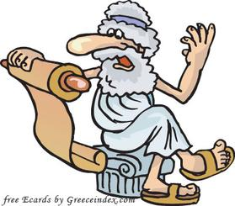
Did you know that the word alphabet comes from the first two litters of the Greek alphabet, alpha and beta? Our alphabet grew out of the one that ancient Greeks used. In addition, many English words have Greek roots. For example, the word telephone is made up of the Greek words, tel, meaning “far off,” and phone meaning “voice.”
Even the way we write sentences comes from the language of ancient Greece. The rules of English grammar, punctuation, and paragraphing are all based on Greek writing. And don’t forget literature . The Greeks created drama, including both tragedy and comedy. They also developed historical writing. Modern historians follow in the footsteps of great Greek writers such as Herodotus (huh-Rod-us-tuhus) known as the “father of history” and Thucydides (thoo-SID-ih-deeze)
Thucydides was one of the greatest historians of ancient Greece. He wrote History of the Peloponnesian War, an account of the conflict between Athens and Sparta in the 400’s B.C.E. Thucydides himself took part in the war, serving in the Athenian army. Although he was an eyewitness to history, he was careful to present facts rather than his own viewpoint or opinion. He is remembered today as one of the founders of historical writing.
ARCHITECTURE!
The word architecture comes from a Greek word that means “master builder.” Greek architecture was one of the achievements of the Golden Age of Athens. One feature was the way that the Greeks used columns to make their temples look balanced and stately. Another feature was pediments, the triangular shapes where roof lines come together. And a third architectural feature was the decorated bands called friezes.
Today, Greek styles are still used in many buildings. They are common in public structures such as government buildings, schools, churches, libraries, and museums. The U.S. Capital has elements of Greek architecture, such as columns and pediments. The buildings houses the U.S. Supreme Court is another example of a public structure inspired by Greek architecture
You can also see Greek building styles in homes and stores. For example, many houses have covered porches. The design of these porches reflects a feature of Greek architecture called stoa. This is a covered line of columns.
SPORTS!
Many modern sports trace their roots back to ancient Greece. The most famous example is the Olympic Games.
The firs Olympics were held in 776 B.C.E. to honor the Greek god Zeus. Today’s Olympic Games reflect ancient Greek customs. During the opening ceremony, an athlete lights the Olympic flame. This custom comes from the time in ancient Greece when the first Olympic athletes lit a fire on the altar of Zeus.
Many modern Olympic events grew out of Greek contests. One example is the pentathlon. Pentathlon is a Greek word that means “five contests,” The Greek pentathlon included the footrace, discus throw, long jump, javelin throw, and wrestling. The Greeks invented this event as a test of all around athletic skill. Although the five contests are different today, the pentathlon is still an Olympic event.
Astronomy! 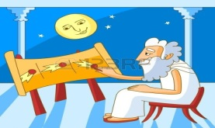
Astronomy comes from the Greek word for “star.” Astronomy is the scientific study of outer space. Ancient Greeks were pioneers in this field.
People in all civilizations observed the sun, moon, and stars. But a Greek scientist named Aristarchus (ayr-uh-StAHR- kuhs) was the first person to suggest that Earth moves around the sun. This idea upset many Greeks who believed that Earth was the center of the universe.
Another Greek Hipparchus (hih-PAHR=kuhs) is often called one of the greatest scientists of the ancient world. He studied and named more than 850 stars. He also figured out how to estimate the distances from Earth to both the sun and the moon. His theories allowed later scientists to accurately predict eclipses of the moon.
MATHEMATICS! 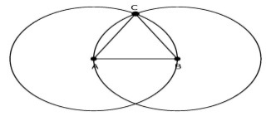
The Greeks loved reasoning, or looking for logical answers to nature’s mysteries. Greek scientists often found those answers in the field of mathematics.
One such scientist, Pythagoras (pih-THAG-er-uhs), believed that numbers were the key to understanding nature. He started a school where students developed mathematical theories (theories: a proposed explanation for something)
Like many Greeks, Pythagoras was especially fascinated gy geometry (geometry: the branch of mathematics involving points, lines, planes, ad figures) Geometry comes from Greek word that means “to measure land.” Geometry began as a system for measuring areas of land. The Egyptians could also measure shapes and spaces, but the Greeks created new and improved methods. Using geometry. They could figure out problems such as how much seed to buy for planting a field or how to lay out a city.
Another famous Greek mathematician was Euclid (YOOklid). His geometry textbook has been used as the basis for the teaching of geometry for more than 2,000 years.
Greek culture produced the first woman to earn fame as a mathematician, Hypatia (hie-PAY-shuh). Born in Egypt in about 370 C.E, she taught Greek philosophy and mathematics in the city
MEDICINE! 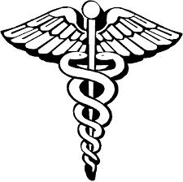
For centuries, the Greeks believed that gods and goddesses controlled natural events, including health and sickness. In fact, the earliest Greeks thought that illnesses and accidents were punishments sent by gods. Ancient Greeks didn’t know about the natural causes of disease and healing
A Greek man named Hippocrates (hih-POK-ruh- teez) changed the way people thought about health and medicine, Hippocrates is often called the “father of medicine.” He brought a scientific way of thinking to his work as a doctor. Hippocrates believed that diseases had natural causes. He taught his students to carefully observe their patients and write down what they saw.
Even more important, Hippocrates established principles of medicine that are still followed. Today, people who become doctors take the Hippocratic Oath, based on these ideas of ethical behavior. Doctors promise to be honest, to preserve life, and to keep information about their patients private.
The Greeks loved to participate in and watch competitions in sports. Their interest in athletics gave them some knowledge about how the human body moves. But their understanding of the body was limited, partly because it was forbidden to look inside the body to see how it worked. The early Greeks believed that cutting open a human body offended the gods. As these beliefs changed over time, the Greeks made new discoveries.
Several centuries after Hippocrates, Greek medical (medical: relating to the practice and treatment of medicine) students were able to name ad describe organs inside the body. They also learned that the brain was the center of the nervous system.
BIOLOGY!
Ancient Greeks developed the science of biology (biology: the study of living things; their structure, growth and function). About 600 B.C.E. Greek thinkers believed each event has a cause and an effect. They used this idea to study the natural world
Curiosity led Greeks to study plants and animals. Scientists learned about the anatomy, or body structure, of animals and humans. This knowledge helped doctors in their medical studies.
The Greeks identified plants and also named their parts. The Greeks learned that plants reproduce by spreading seeds. Greek doctors used plants, such as herbs, as medicines and for pain.
The Greek philosopher Aristotle was fascinated by living things. He collected information about many types of animals and plants. Then he organized animals into groups, such as “those with backbones” and “those without backbones.” He divided plants into such groups as “herbs,” “shrubs, “ and “trees.” The way we classify, or group, animals and plants today reflects the work of Aristotle
GEOGRAPHY 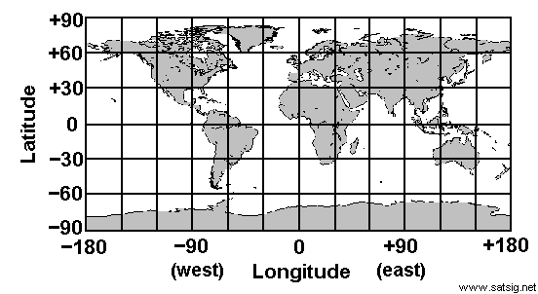
The study of geography has roots in ancient Greece. The word geography comes from Greek words that mean “writing about the earth” The Greek historian Herodotus created the first map of the known world, in about 450 B.C.E. To gather the information for his map, Herodotus asked geographic questions. He found some answers to his questions by traveling and talking with other travelers. He organized the information by displaying it on a map.
Another great geographer of ancient times was Ptolemy (Tah-luh-mee) A Greek scientist who lived in Alexandria, Egypt. He wrote a book called Geographia that listed about 8,000 places around the world. His book contained maps that showed how to represent the curve of Earth on a flat surface.
Ptolemy also designed a system of lines drawn on a map called latitude (latitude: a measure of hwo far north and south a place on Earth is measured from the equator) and longitude (longitude; a measure of how far east or west a place on Earth is from an imaginary line that runs between the North and South Poles) With this system, heh recorded the specific locations for the thousands of places he listed in his book. Centuries later, Arab scholars would further develop the study of geography, especially in the field of mapmaking

