Name _____________________________________________ Period_____ Date____________
AP Human Geography Unit 2 / Population and Migration / Guided Notes
- Knowledge of the geographic patterns and characteristics of human populations facilitates understanding of cultural, political, economic, and urban systems
- Populations grow and decline over time and space
- Causes and consequences of migration are influenced by cultural, demographic, economic, environmental, and political factors

Demography: _________________________________________________________________________ _______________________________________________________________________________________________________________________________________________________________________________________________________________________________________________________________
A little information about World Population: _______________________________________________ _______________________________________________________________________________________________________________________________________________________________________________________________________________________________________________________________

Population Growth the Earth Graph

Density:_______________________________________________________________________________ ___________________________________________________________________________________
Concentration:________________________________________________________________________ __________________________________________________________________________________________________________________________________________________________________________
population Distributions / Concentrations: _________________________________________________ ____________________________________________________________________________________________________________________________________________________________________________________________________________________________________________________________________________________________________________________________________________________
US Population Distribution US Population Distribution : ______________________________________ _______________________________________________________________________________________________________________________________________________________________________________________________________________________________________________________________
Ecumene, or portion of the earth’s surface that has permanent human settlement has expanded to cover most of the earth’s land area
Why are some land areas not part of the ecumene?
- Dry Lands______________________________________________________________________ ____________________________________________________________________________________________________________________________________________________________
- Wetlands: _____________________________________________________________________ ____________________________________________________________________________________________________________________________________________________________
- Cold Lands: ____________________________________________________________________ ____________________________________________________________________________________________________________________________________________________________
- High Lands: ____________________________________________________________________ ____________________________________________________________________________________________________________________________________________________________
Places that Produce Low Population
Characteristic | Description | Example
Extreme Climate
Extreme relief
Extreme Remoteness
Infertile Land
Over Population: ______________________________________________________________________ __________________________________________________________________________________________________________________________________________________________________________
Carrying Capacity: _____________________________________________________________________ __________________________________________________________________________________________________________________________________________________________________________
Local Scale: ___________________________________________________________________________ _____________________________________________________________________________________
Global Scale: __________________________________________________________________________ _____________________________________________________________________________________
Density: Methods used to calculate population densities the number of things—which could be people, animals, plants, or objects—in a certain area. The frequency something occurs
- Arithmetic density: ______________________________________________________________ ____________________________________________________________________________________________________________________________________________________________
- Physiological density_____________________________________________________________ ____________________________________________________________________________________________________________________________________________________________
- Agricultural density______________________________________________________________ ____________________________________________________________________________________________________________________________________________________________
- Housing density-________________________________________________________________ ____________________________________________________________________________________________________________________________________________________________
Population Composition: A “composite” is something made of different parts
______________________________________________________________________________________________________________________________________________________________________________________________________________________________________________________
Development: _____________________________________________________________________ _________________________________________________________________________________
Characteristics of MDC’s  More Developed Countries | Characteristics of MDC’s  Less Developed Countries
Potential Workforce: ________________________________________________________________ __________________________________________________________________________________
Dependency Ratio: _________________________________________________________________ ____________________________________________________________________________________________________________________________________________________________________
Measuring Population: Population increases rapidly in places were more people are born than die, and it declines in places were deaths outnumber births. Populations also increase and decrease when people move in and out
Crude Birth Rate: ___________________________________________________________________ ____________________________________________________________________________________________________________________________________________________________________
Crude Death Rate: __________________________________________________________________ ____________________________________________________________________________________________________________________________________________________________________
Natural Increase: ___________________________________________________________________ ____________________________________________________________________________________________________________________________________________________________________
Fertility rate: ______________________________________________________________________ ____________________________________________________________________________________________________________________________________________________________________
Infant Mortality Rate: _______________________________________________________________ ____________________________________________________________________________________________________________________________________________________________________
Doubling Time: _____________________________________________________________________ ____________________________________________________________________________________________________________________________________________________________________
Population Replacement level: ________________________________________________________ __________________________________________________________________________________
Changes in Fertility (Total Fertility Rate TFR) _____________________________________________ ________________________________________________________________________________________________________________________________________________________________________________________________________________________________________________________________________________________________________________________________________
- Life Expectancy: is the average number of years an individual can be expected to live, given current social, economic, and medical conditions. ____________________________________ ___________________________________________________________________________________________________________________________________________________________
- Demographic Transition Model: Model that shows changes in natural increase, fertility, and mortality rates. This process has several stages. ____________________________________ __________________________________________________________________________________________________________________________________________________________________________________________________________________________________________ ______________________________________________________________________________
Demographic Transition Model
Stages: | Stage 1 | Stage 2 | Stage 3 | Stage 4 | Stage 5
Birth Rates and Death rates
Examples
Birth Rates
Death Rates
Natural Increase
Reasons for changes in Birth Rate
Reasons for changes in Death Rate

Gotta Knows about the DTM Stages
- Stage1: ________________________________________________________________________ __________________________________________________________________________________________________________________________________________________________________________________________________________________________________________
- Stage 2: _______________________________________________________________________ __________________________________________________________________________________________________________________________________________________________________________________________________________________________________________
- Stage 3: _______________________________________________________________________ ________________________________________________________________________________________________________________________________________________________________________________________________________________________________________________________________________________________________________________________
- Stage 4: _______________________________________________________________________ ________________________________________________________________________________________________________________________________________________________________________________________________________________________________________________________________________________________________________________________
- Stage 5: _______________________________________________________________________ ________________________________________________________________________________________________________________________________________________________________________________________________________________________________________________________________________________________________________________________

- Causes of Industrial Revolution: ___________________________________________________ ____________________________________________________________________________________________________________________________________________________________

Effects of the Industrial Revolution
Immediate Effects | Long Term Effects
What causes the Crude Birth Rate to Drop?
- Change in Social Customs
- People choose to have fewer children
- More service jobs, less farming jobs
- In urban areas children are not economic assets
- Urban homes are smaller
- ________________________________________________________________________________________________________________________________________________________________________________________________________________________________________________________________________________________________________________________

Characteristics of the DTM Stages
Factor | 1. High Stationary | 2. Early Expanding | 3. Late Expanding | 4. Low Stationary | 5. Declining
Birth rates
Death Rates
Population Change
Examples Today
Population Structure
Problems with the Demographic Transition Model
- based on European experience, assumes all countries will progress to complete industrialization
- ______________________________________________________________________________ ______________________________________________________________________________
- ____________________________________________________________________________________________________________________________________________________________
- ____________________________________________________________________________________________________________________________________________________________
- ____________________________________________________________________________________________________________________________________________________________

POPULATION PYRAMIDS
- An inverted bar Graph that shows a wide population base (younger population) with a narrow top (older population)
- Population Pyramids Show
- _______________________________________________________________________
- _______________________________________________________________________
- _______________________________________________________________________
- Most pyramids follow the same fundamental structure, however, as with most types of graphics, the format can vary
- The vertical axis shows age groups, known as cohorts, They are often listed in the middle, but are sometimes shown on the left or right side
- Pyramids usually show the male population on the left and the female population on the right
- The values of the horizontal axis may be percentages or absolute members of males and females (in the thousands or millions)
- Pyramids are most commonly constructed at a country scale, but they can also be constructed for cities, states, or multi-country regions
- __________________________________________________________________________________________________________________________________________________________________________________________________________________________________________
- __________________________________________________________________________________________________________________________________________________________________________________________________________________________________________
- __________________________________________________________________________________________________________________________________________________________________________________________________________________________________________
- __________________________________________________________________________________________________________________________________________________________________________________________________________________________________________

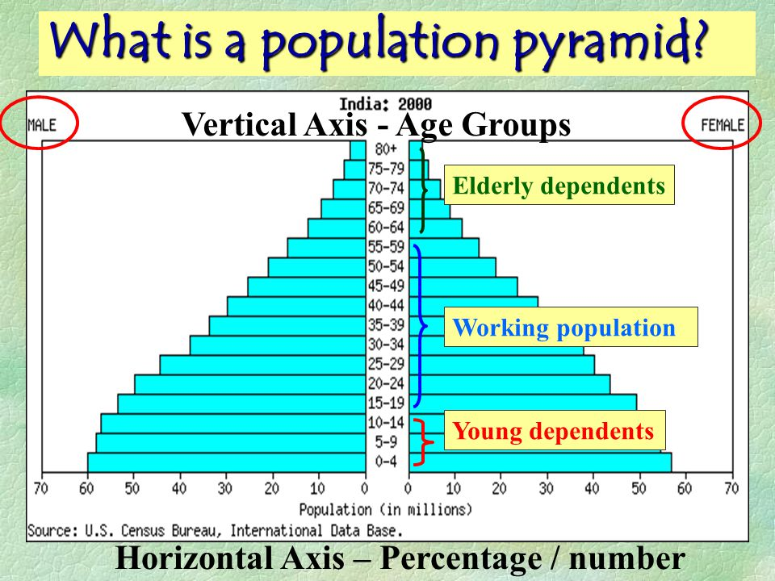 | 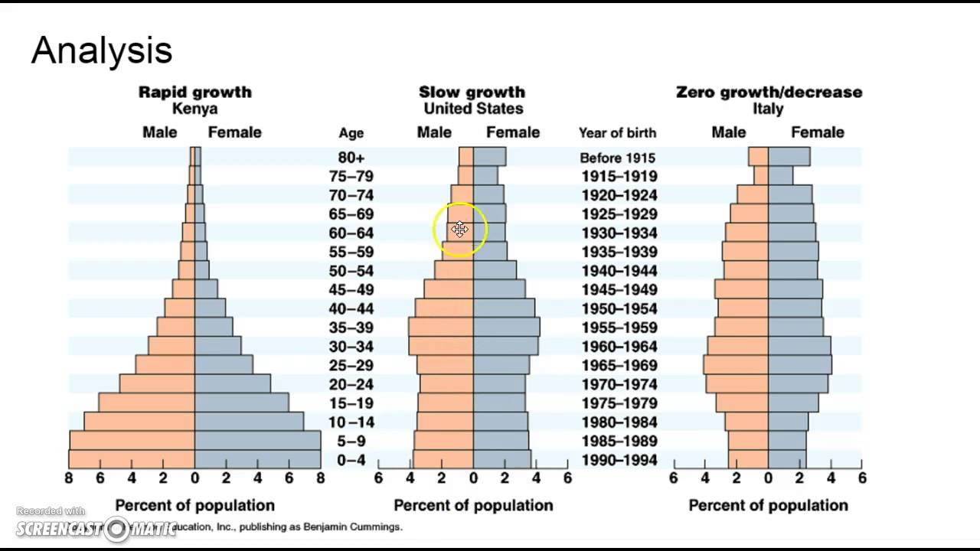
Types of Population Pyramids
- Expansive: _____________________________________________________________________ ____________________________________________________________________________________________________________________________________________________________
- Constrictive: ___________________________________________________________________ ____________________________________________________________________________________________________________________________________________________________
- Stationary or near stationary: _____________________________________________________ __________________________________________________________________________________________________________________________________________________________________________________________________________________________________________
Percent if Population under 15: About one-third of world population is under 15, but the percentage by country varies from over 40% in most of Africa and some Asian countries, to under 20% in much of Europe
Thomas Malthus: An Essay on the Principle of Population (1798) Earth’s population was growing much more rapidly than the Earth’s food supply. Food shortages and chaos inevitable. Possible checks on population growth: __________________________________________________________________
____________________________________________________________________________________________________________________________________________________________________________________________________________________________________________________________________________________________________________________________________________________ _____________________________________________________________________________________
Neo Malthus: _________________________________________________________________________ _______________________________________________________________________________________________________________________________________________________________________________________________________________________________________________________________
J Curve: ______________________________________________________________________________ _____________________________________________________________________________________
S Curve: _____________________________________________________________________________ __________________________________________________________________________________________________________________________________________________________________________
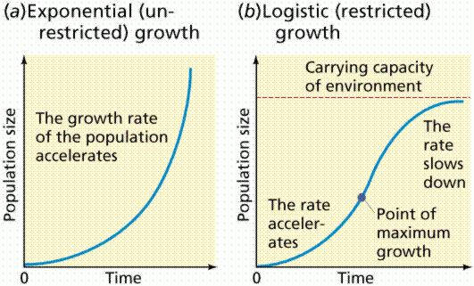
Malthus did not foresee: _______________________________________________________________ ____________________________________________________________________________________________________________________________________________________________________________________________________________________________________________________________________________________________________________________________________________________
Jean Antoine Condorcet: _______________________________________________________________ __________________________________________________________________________________________________________________________________________________________________________
Esther Boserup argued: ________________________________________________________________ __________________________________________________________________________________________________________________________________________________________________________
Population Policies: Essentially the stances governments can take on population:
- ___________________________________ ______________________________________
- ___________________________________ _____________________________________
- ___________________________________ ______________________________________
- ___________________________________ ______________________________________
- ___________________________________ _____________________________________
- ___________________________________ _____________________________________
Role of Women in Society: _____________________________________________________________ _______________________________________________________________________________________________________________________________________________________________________________________________________________________________________________________________
(pro natalist policies: ___________________________________________________________________ __________________________________________________________________________________________________________________________________________________________________________
anti- natalist: _________________________________________________________________________ __________________________________________________________________________________________________________________________________________________________________________
Population policies that encourage large families and raise the rate of natural increase
- ______________________________________________________________________________
- ______________________________________________________________________________
- ______________________________________________________________________________
- ______________________________________________________________________________
- ______________________________________________________________________________
Restrictive Policies population policies that attempt to reduce the natural increase rate
- ______________________________________________________________________________
- ______________________________________________________________________________
- ______________________________________________________________________________
China’s One Child Policy Effects
- ______________________________________________________________________________ ______________________________________________________________________________
- ____________________________________________________________________________________________________________________________________________________________
- ____________________________________________________________________________________________________________________________________________________________
- ____________________________________________________________________________________________________________________________________________________________
- ____________________________________________________________________________________________________________________________________________________________
World Death Rates
Top Causes of Death 1900 | Top Causes of Death 2010

Epidemiological Transition Model Stages: The predictable stages in disease and life expectancy that countries experience as they develop. / They correspond with the stages of the DTM
Stage | Description | Effects of Population
1. Pestilence and Famine

2. Receding Pandemics

3. Degenerative and Human Created Diseases

4. Delayed Degenerative Diseases

5. Reemerging of Infectious and Parasitic Diseases

Pandemics, they are still a thing. Are we Ready?
- ______________________________________________________________________________ ______________________________________________________________________________
- ____________________________________________________________________________________________________________________________________________________________
- ____________________________________________________________________________________________________________________________________________________________
- _______________________________________________________________________________________________________________________________________________________________________________________________________________________________________________________________________________________________________________________

Stage 5:
- ______________________________________________________________________________ ______________________________________________________________________________
- ____________________________________________________________________________________________________________________________________________________________
- ____________________________________________________________________________________________________________________________________________________________
- _______________________________________________________________________________________________________________________________________________________________________________________________________________________________________________________________________________________________________________________

Additional Notes:
________________________________________________________________________________________________________________________________________________________________________________________________________________________________________________________________________________________________________________________________________________________________________________________________________________________________________________________________________________________________________________________________________________________________________________________________________________________________________________________________________________________________________________________________________________________________________________________________________________________________________________________________________________________________________________________________________________________________________________________________________________________________________________________________________________________________________________________________________________________________________________________________________________________________________________________________________________________________________________________________________________________________________________________________________________

