Unit One-Pager Directions
- All work must be on one side of the paper with your name on the back
- Start with a border that reflects the unit of learning. This can include words, pictures, symbols, or even quotes. (5 points)
- Include the name of the unit. (5 points)
- Draw TWO visual images related to the unit of study. This could be a thing, map or person. (5 points each)
- Draw a word cluster about each image. Use these words to give characteristics of the image, or to explain its importance. (5 points each)
- Write a brief (about a paragraph) overview of what this chapter is about. (10 points)
- Include at least two geographers from the unit and what they are known for, not just the name of their theory). (10 points each)
- Create and answer TWO questions about the unit of study. (10 points each)
- Make a connection between an idea and a real world example. (10 Points)
- Be colorful and neat. Your entire page should be filled with these elements. If you have more room, you may choose to repeat any of the previous. Nothing should be left in pencil nor should it only be in one color of ink. You need demonstrate effort (10 points)
- You many not double dip which means, for example, you cannot use your questions and answers for two things like for the boarder and for questions. Each item is a standalone separate item.
- Create a One Pager that you will find helpful, either as a review or as something to look at to help you get this information in your head.
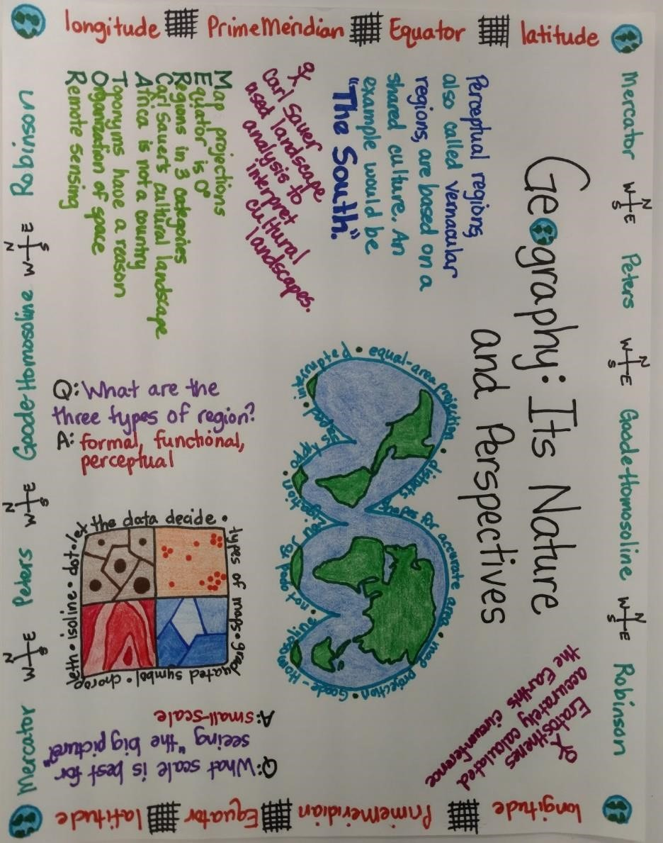
2
3
4
5
6
7
8
9
7

