Unit 1 Maps
LONGITUDE  (shown as a vertical line) is the angular distance, in degrees, minutes, and seconds, of a point east or west of the Prime (Greenwich) Meridian. Lines of longitude are often referred to as meridians.  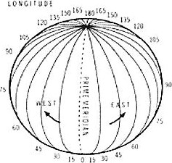  E.g. Place: Guatemala  Long: 90⁰ W  Lat: 15 ⁰N | LATITUDE  (shown as a horizontal line) is the angular distance, in degrees, minutes, and seconds of a point or south of the Equator. Lines of latitude are often referred to as parallels.  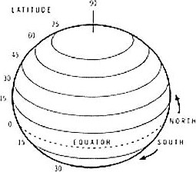  E.g. Place: The island of Martinique  Long: 61 ºw  Lat: 15⁰N
ABSOLUTE LOCATION  The position or place of a certain item on the surface of the Earth as expressed in degrees, minutes, and seconds of latitude, 0 ⁰ to 90⁰ north or south of the equator, and longitude, 0⁰ to 180⁰ east or west of the Prime Meridian passing through Greenwich, England  Does not change  • Determined by a frame of reference, typically longitude and longitude  APPLY IT:  The absolute location of Chicago is 41 ⁰ , 53 minutes North Latitude and 87 ⁰ 38 minutes West Longitude. | SITE  The internal physical attributes of a place, including its absolute location, its spatial character and physical setting.  Contributes to a country's economic success  • Physical characteristics of a particular location determine its site  APPLY IT:  New Orleans has a poor site due to its location below sea level. When Hurricane Katrina hit, the city was flooded. Natural disadvantages are difficult to overcome.
SITUATION  The external locational attributes of a place; its relative location or regional position with reference to other places. The relationship of a location with another location.  APPLY IT:  Pittsburg has an ideal situation for its production of steel. Pittsburg is located on the confluence of two major rivers, the Allegheny and Monongahela, which form the Ohio River. This river system gave the city a perfect means to ship its steel products all over the world | RELATIVE LOCATION  The regional position or situation of a place relative to the position of other places. The location is described relative to other features. Distance, accessibility, and connectivity affect relative location.  Constantly modified and can change over time  APPLY IT:  "Chicago is on Lake Michigan, south of Milwaukee." "Chicago is located where the cross-country railroads met in the 1800s." These are descriptors Of Chicago's relative location.

Big Idea; Types of Maps
Mental Map
The map you have in your mind
Revived from visual observation of the real world
Developed over years of looking at various map's atlases People use them everyday

Cartographer
Science of map making
For centuries, geographers have worked to perfect the science of mapmaking Contemporary cartographer are assisted by computer and satellite imagery Projection
The scientific method of transferring location on Earth's surface to a flat map
- Maps are a visual representation of the Earth's surface, drawn to scale and made for a specific purpose Each unique map projection serves a particular purpose
Types of Maps
Physical maps show evaluation, mountains, rivers etc.
Political maps show countries, cities, capital countries Special purpose maps are designed for a special purpose Ex: Highway maps. Projection maps etc.
- Maps have 4 properties—Scale, Dislema, Area, Distribution. When you take a round globe and flatten it, one or more of these properties will be distorted
Proiection | What is distorted? | Maps |  |  |  |  |  | Advantages | Disadvantages
Robinson | Compromises polar areas |  | 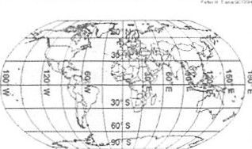  Robinson Projection |  |  |  |  | Shows minimal distortion, used by  Schools. | Hard to see poles
Mercator | Area larger near the poles | 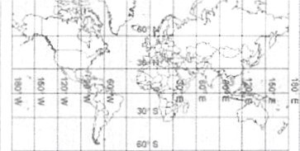 |  |  |  |  |  | Shows the direction. Used by ship navigators | Greenland is longer than  South America and looks as big as Africa.
 |  |  |  |  |  | r toe Projection
Azimuthal | Latitude Lines | 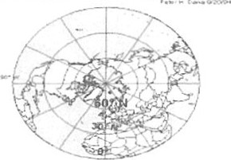  Azimuthal Equidistant |  |  |  |  |  | Used by airplane pilots to plot the best routes around the globe. | Can't see the entire world
{Aft

Types of Maps Oval
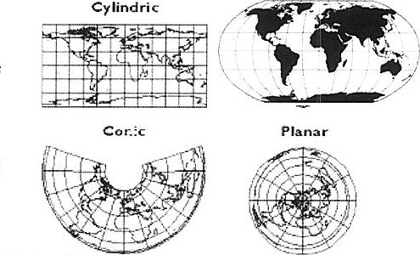
•4 map classes
-Cylindrical- shows accurate direction
-Planar- shows the earth from one point like one of the poles
-Conic- as if a cone was put over the earth
-keeps distance but loses direction
-Oval- combination of cylindrical and conic
Types of Maps:

-Thematic Maps- a map that designed to show a particular theme
•Isoline Map- map that uses continuous lines joining areas of the same value
Commonly show Weather Weather maps:
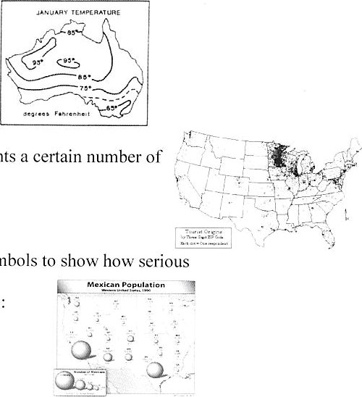
Dot Map- each dot on the map represents a certain number of something
-Population:
•Proportional- uses size of shapes or symbols to show a theme is in the area
-Population of people in Mexico:
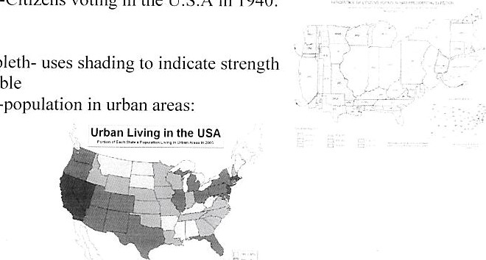
•Cartogram- shows how much of something by how big the actual area is Citizens voting in the U.S.A in 1940:
•Choropleth-
-population
of variable
Sense Of place
A. Definition
l. A state of mind derived through the infusion of a place with meaning and emotion by remembering important events that occurred in that place by labeling a place with a certain character
B.
- how people identify themselves because Of what they call "home" and the places they know because of meanings, experiences, important events, or a certain character
C. Identity and sense of place
Identity affects how we define and experience place Sense of place fully becomes part of our identity
i. The feeling that you belong to that place because of the certain qualities of that place
2. Sense of place is fluid and changing
a. How we think of the place changes as we change and the place changes
D Examples
I . What people consider their "home"
11. Spatial Perspective A. Definition
I . Observing variations in geographic phenomena across space
B. Easy Definition
  - . Where and why certain phenomena are spatially distributed where they are and their relationships between the different phenomena
  - C. How it's used
Human geographers use spatial perspective to study various phenomena and their relationships
    - Explains why agglonleration and deindustrial ization occurs D. Examples
The distribution of McDonald's corporations and restaurants
    - Why they are located and/or successful in various parts of the world
    - How they spread to these places
Scale
- Definition
  - Representation of a real world phenomenon at a certain level of reduction or generalization
- Easy Definition
  - How geographers study various places and patterns at different levels to better understand the connections
  - C. Important info
Various scales including:
    - Local, regional, national, and global
2. Two meanings of scale in geography
[he distance on a map compared to the distance on the Earth
    - The territorial extent of something use this definition in human geography
  - make different observations at different scales study a single phenomenon across various scales to see how it affects the global scale affects the local and vice versa
  - the scales tells us what level of detail we can expect to see different patterns at different scales
  - can be used as a political scale
a. rescale-when a country involves other players at other scales to create a global outcry of support for their position
D. Different kinds
  - Map scale- the ratio between the distance on a map and actual distance on earth's surface
  - Geographic scale- a conceptual hierarchy of spaces, from small to large, that reflects actual levels of organization in the real world
Neighborhood, urban area, metropolitan area, region, watershed, ecosystem, landscape, biome
E. Examples
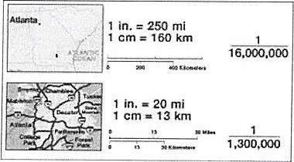
a. map keys cartography

