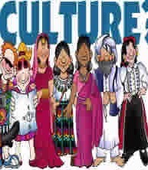
Name_______________________________________________________Period____Date_________
AP Human Geography / Unit 3 Culture/
Culture and Ethnicity / Guided Notes

- Culture is all of a group’s learned behaviors, actions, beliefs, and objects. It is visible force seen in a group’s actions, possessions, and influence on the lands space:
- Visible Force Example: in a large city you can see factories, stores, high rise apartments, offices, architecture, land use patterns
- Culture is also Invisible force that guides people through shared belief systems, customs, traditions, manners, values, humor/jokes, food preferences
Artifact: The material manifestation of a culture including tools, housing systems, use of land, clothing
Visual or Material Culture
_________________________________________________________________________________________________________________________________________________________________________________________________________________________________________________________________________________________________________________________________________________________________________________________________________________________________________
Invisible or Non-Material Culture
____________________________________________________________________________________________________________________________________________________________________________________________________________________________________________________________________________________________________________________________________________________
Defining Culture:
____________________________________________________________________________________________________________________________________________________________________________________________________________________________________________________________________________________________________________________________________________________
How do generations Pass Down Culture?
- Children learn Culture by
- Imitation, ______________________________________________________________________ ______________________________________________________________________________
- Informal instruction, ____________________________________________________________ ______________________________________________________________________________
- Formal instruction: _____________________________________________________________ ______________________________________________________________________________
- Cultural Traits: ____________________________________________________________________ ___________________________________________________________________________________________________________________________________________________________________________________________________________________________________________________
Cultural Hearth
________________________________________________________________________________________________________________________________________________________________________________________________________________________________________________________________________________________________________________________________________________
Taboo: Behaviors heavily discouraged by a culture
____________________________________________________________________________________________________________________________________________________________________________________________________________________________________________________________
Cultural differences in food: ____________________________________________________________ ________________________________________________________________________________________________________________________________________________________________________
Cultural Differences in Communication: ___________________________________________________ ________________________________________________________________________________________________________________________________________________________________________
Cultural landscape The boundaries of a region reflect the human imprint on the environment _______ ____________________________________________________________________________________________________________________________________________________________________________________________________________________________________________________________
Places said to have a strong "sense of place" have a strong identity that is deeply felt by inhabitants and visitors: Examples:;_________________________________________________________________ ________________________________________________________________________________________________________________________________________________________________________
Culture and Beauty and Clothes _________________________________________________________ ________________________________________________________________________________________________________________________________________________________________________
Ethnocentrism Belief in the superiority of one's nation or ethnic group
________________________________________________________________________________________________________________________________________________________________________________________________________________________________________________________________________________________________________________________________________________________________________________________________________________________________________________________________________________________________________________________
Cultural relativism : ____________________________________________________________________ __________________________________________________________________________________________________________________________________________________________________________
Sequent Occupancy: ____________________________________________________________________ __________________________________________________________________________________________________________________________________________________________________________
Syncretism___________________________________________________________________________ __________________________________________________________________________________________________________________________________________________________________________
Convergence of Cultural Landscapes: ______________________________________________________ __________________________________________________________________________________________________________________________________________________________________________
When cultures collide, they change
cultural convergence: ___________________________________________________________________ __________________________________________________________________________________________________________________________________________________________________________
cultural divergence occurs: ______________________________________________________________ __________________________________________________________________________________________________________________________________________________________________________
Cultural Regions
Formal Regions ________________________________________________________________________ __________________________________________________________________________________________________________________________________________________________________________
Functional Regions: ____________________________________________________________________ __________________________________________________________________________________________________________________________________________________________________________
Vernacular Regions: ____________________________________________________________________ __________________________________________________________________________________________________________________________________________________________________________
Boarders and Barriers Transition Zones: ___________________________________________________ __________________________________________________________________________________________________________________________________________________________________________
Cultural Realms are larger areas that include several regions, Cultures within a cultural realm have a few traits that they all share, such as language families, religious traditions, food preferences architecture or shared history
Cultural Diffusion, the spread of culture over wider areas
- Relocation Diffusion is the spread of a cultural trait by who migrate and carry their culture traits with them. Examples: ____________________________________________________________ ____________________________________________________________________________________________________________________________________________________________
- Contagious Diffusion occurs when a cultural trait spreads contiguously outward from its hearth through contact with people
Examples: ____________________________________________________________________ ____________________________________________________________________________________________________________________________________________________________
- Hierarchal Diffusion Occurs when the diffusion innovation or concept spreads from a place or person of power or high susceptibility to another in a level
Examples: _____________________________________________________________________ _____________________________________________________________________________ _
- Reverse Hierarchical _____________________________________________________________ ______________________________________________________________________________
Rapid diffusion of popular clothing styles: Individual clothing habits reveal how popular culture can be distributed across the landscape with little regard for distinctive physical features
_______________________________________________________________________________________________________________________________________________________________________________________________________________________________________________________________
- Stimulus Diffusion occurs when people in a culture adopt an underlying idea or process from another culture but modify it because they reject on trait of it
Examples: ____________________________________________________________________ ____________________________________________________________________________________________________________________________________________________________
- Acculturation occurs when two cultures come into contact with one another and the “weaker” (politically or with less mainstream acceptance) of the two adopts traits from the more dominant culture. _____________________________________________________________ __________________________________________________________________________________________________________________________________________________________________________________________________________________________________________
- Assimilation: ___________________________________________________________________ __________________________________________________________________________________________________________________________________________________________________________________________________________________________________________
- Multiculturalism the coexistence of several cultures in one society, with the ideal of all cultures being valued and worthy of study. A major idea of multiculturalism s that the interaction of cultures enriches the lives of all. ____________________________________________________ ____________________________________________________________________________________________________________________________________________________________
- Nativism ______________________________________________________________________ __________________________________________________________________________________________________________________________________________________________________________________________________________________________________________
- counter culture ________________________________________________________________ ____________________________________________________________________________________________________________________________________________________________
- 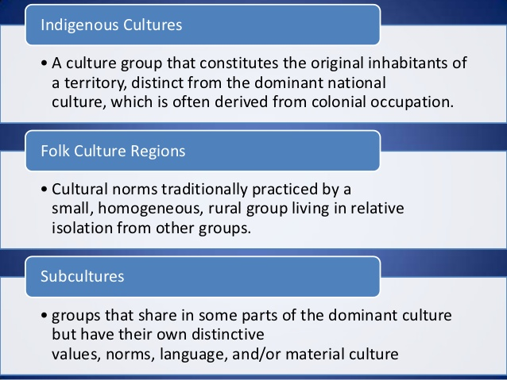
Transculturation: _____________________________________________________________________ _______________________________________________________________________________________________________________________________________________________________________________________________________________________________________________________________
Effects of Globalization on Culture ________________________________________________________ _______________________________________________________________________________________________________________________________________________________________________________________________________________________________________________________________
Commodification ______________________________________________________________________ _______________________________________________________________________________________________________________________________________________________________________________________________________________________________________________________________
- Neolocalism is a common phenomenon wherein displaced ethnic groups will celebrate their heritages in locations alien to their origins. ___________________________________________ _____________________________________________________________________________________________________________________________________________________________________________________________________________________________________________________________________________________________________________________________________________________________________________________________________________________
- Localism _________________________________________________________________________ __________________________________________________________________________________________________________________________________________________________________
- Gender: Social differences between men and women rather than the anatomical, biological differences between the sexes. _______________________________________________________ ___________________________________________________________________________________________________________________________________________________________________________________________________________________________________________________
- Ethnicity refers to a group of people who share similar ancestry and cultural traditions of a particular homeland or hearth. ______________________________________________________ ___________________________________________________________________________________________________________________________________________________________________________________________________________________________________________________
- Examples of Ethnicities / Ethnic Groups ________________________________________________ __________________________________________________________________________________________________________________________________________________________________
- Ethnic Enclaves are small areas inhabited by particular ethnic groups found in urban areas. _________________________________________________________________________________________________________________________________________________________________
- Toponyms can hint at the presence of an ethnic enclave, ex. Polish Hill or Chinatown ________________________________________________________________________________
- Where Ethnicities are Distributed in US _______________________________________________ ___________________________________________________________________________________________________________________________________________________________________________________________________________________________________________________
- Ethnic Islands small, usually rural and ethnically homogeneous enclaves situated within a larger and more diverse cultural context.
- Apartheid _______________________________________________________________________ __________________________________________________________________________________________________________________________________________________________________
- Latino vs Hispanic______________
___________________________________________________________________________________________________________________________________________________________________________________________________________________________________________________
- Xenophobia – fear or hatred of foreigners
Symptoms of Xenophobia ___________________________________________________________ ___________________________________________________________________________________________________________________________________________________________________________________________________________________________________________________
- Ethnic Cleansing is the systematic attempt to remove all people of a particular ethnicity from a country or region either by forced migration or genocide
- Genocide is a premeditated effort to kill everyone from a particular ethnic group
- __________________________________________________________________________________________________________________________________________________________________________________________________________________________________________
- Race: A categorization of humans based on skin color and other physical characteristics. ... Belief that race is the primary determinant of human traits and capacities and that racial differences produce an inherent superiority of a particular race
- ________________________________________________________________________________________________________________________________________________________________________________________________________________________________________________________________________________________________________________________________________________________________________________________________________________________________________________________________________________________________________________________________________________________________________________________________________________________________________________________________________________________________________________________________________________________________________________________________________________________________________________________________________________________________________________________________________________________________________

