Name ___________________________________ Period_____ Date ______

AP Human Geography
Unit 3 Culture Guided Study Questions
Throughout unit 3 I have introduced many opportunities for you to THINK about the information. It won’t be in your book, you will either have to think it through, or search for the answers. Wherever you see THINK, that’s your cue to arrive at answers yourself.
Section A – What is Culture?
1. Define Culture.

Give an example of a visible force:

Give an example of an invisible force:

How do generations pass on their culture?
a.

b.

c.

2. What are cultural traits? Give two examples.

3. What is a cultural hearth? Give an example.

What is a taboo? Define and provide an example.

5. What are cultural regions?

Define and give an example:
Formal Regions –

Functional Regions –

Perceptual Regions –

6. What are cultural landscapes?

What cultural significance is associated with the following elements?

- National Parks

- Signage

- Schools

- Office buildings

After watching the Ted talk video What Do Landscapes Tell Us About Our Culture, answer the following questions: https://www.youtube.com/watch?v=5onjyWsWa78&fbclid=IwAR2icNW3udz7dVG8MMZBZftgTPG8I6MaTP8Si4wvDv4yRAMP5EK6tW8DvJ8
What is cultural geography?
How can landscape tell you about a culture
What is the value from reading the landscape? Name 3.

- ____________________________________________________________________
- ____________________________________________________________________
- ____________________________________________________________________
What can we learn from the landscape?

How can we tell how a culture has changed an area or evolved?

How is what we value reflected in a landscape?

What do our suburbs say about us?

What is our recreational landscape?

7. Define and provide an example of an ethnic enclave.

8. Why may it be difficult to identify cultural borders?

9. Define and provide examples of cultural realms.

10. What impact does globalization have on cultural interactions?

11

12. What is the Geography of Gender? Provide an example.

Why would some traditional cultures resist globalization in relation to gender? Think about the rights of women in less developed countries (LDCs) compared to more developed countries (MDCs)

13. What are some other reasons why people would resist globalization?

14. Although we covered diffusion in unit 1, it doesn’t hurt to revisit it here. Culture spreads through diffusion so it’s very important that you understand the connection between culture and diffusion.
- Relocation –

- Expansion –

- Hierarchical –

What is reverse hierarchical diffusion? Provide an example.

When does stimulus diffusion occur? Provide an example.

15. When cultures come into contact with each other, the following results occur:
Acculturation –

Assimilation –

Multiculturalism –

Nativism –

16. THINK ONE: how did environmental determinism impact culture? In particular, food, housing, and clothing.

17. THINK TWO: what impact have television and the internet had on world culture?

18. Watch the Frontline video Bhutan The last Place. https://www.youtube.com/watch?v=BZPKjLtVT04

What was this video about?

- Describe 2 Positive impacts –

- Describe 2 Negative impacts -

- What was something they discovered about the outside world? How did that comare to them?

Name ___________________________________

Section B – Chapter 7 Languages
Language Tree

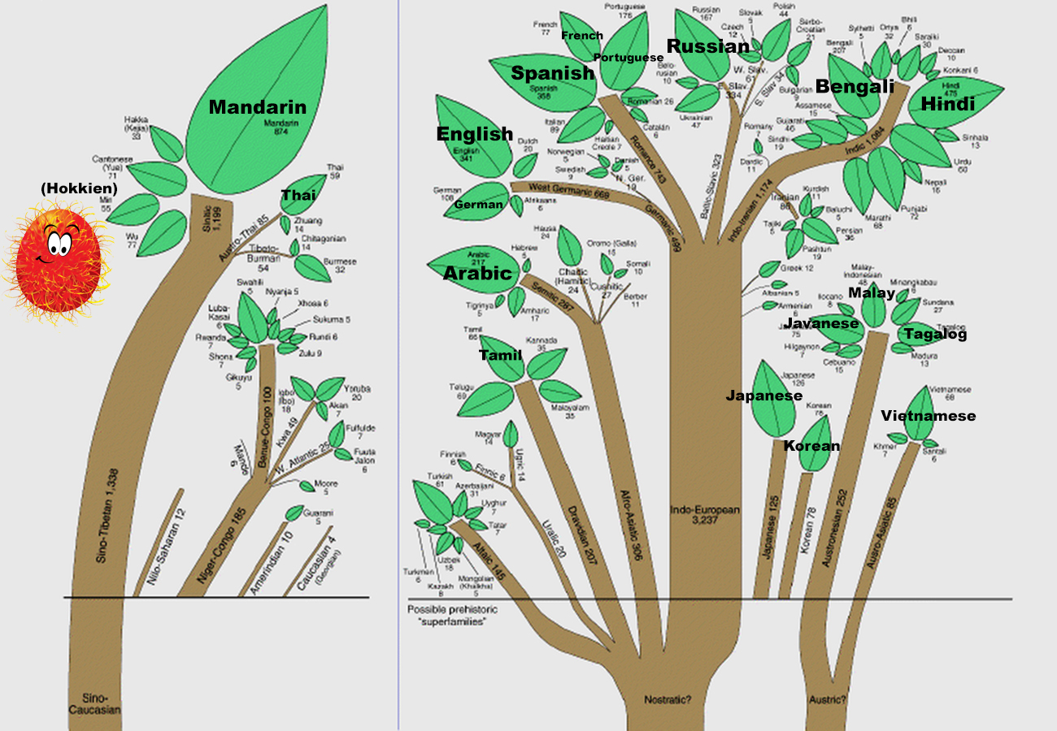

20. How many languages are there in the world? How many will there be by the end of the century?

What impact does the loss of a language have on a culture?

21. Summarize the origins of languages.

22. Language classification

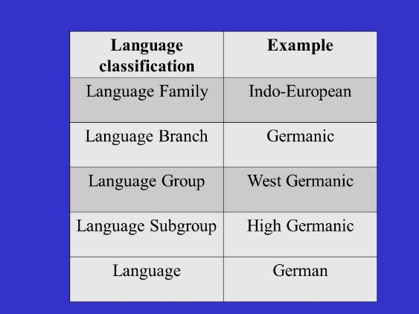

23. What are language families? How have these languages spread?

24. Indo European is one of the 15 language families.

How old is it?

How many people speak one of the Indo European languages?

25. Draw the Indo-European Language family

26. What are the Romance languages? How are they connected to Latin? Give examples of words that are similar in the various Romance languages.

27. Regional variations:

- What are accents?

- What are isoglosses?

- What are dialects? Give some examples of the differences between British and American dialects.

- What are sub dialects?

28. Why do some languages diffuse while others do not? Give examples.

29. What is a lingua franca? Give examples of lingua francas.

Why would some countries resent the use of English in their linguistic and cultural practices?

30. Define the following:
- Slang

- Pidgin

- Creole

What is Swahili and where is it spoken? THINK FIVE - What does the word mean?

31. How is language linked to the cultural landscape of a region?

How do Toponyms reflect the culture of a region?

32. Some countries have an official language, a language designated by law to be the legal language of government. There are three instances where a country may have an official language (provide examples):

Name ___________________________________
Section C – Chapter 8 Religion
33. Explain ethnicity and nationalism.

How does religion relate to both of these groups?

34. How are cultural hearth, ethnicity and religion linked?

35. Baptists are the most common group at a regional level in the Southeast. Is this true at all levels?

36. Define the following and provide examples
- Fundamentalism

- Shar’ia

- Theocracies

37. Describe the regional patterns of religious groups in the U.S.

- New England –

- Southeast –

- Midwest –

- Northeast –

- Southwest –

- Utah –

- Urban areas –

38. THINK SIX: Using the map below, sketch the major religious locations in the United States. Provide a key!
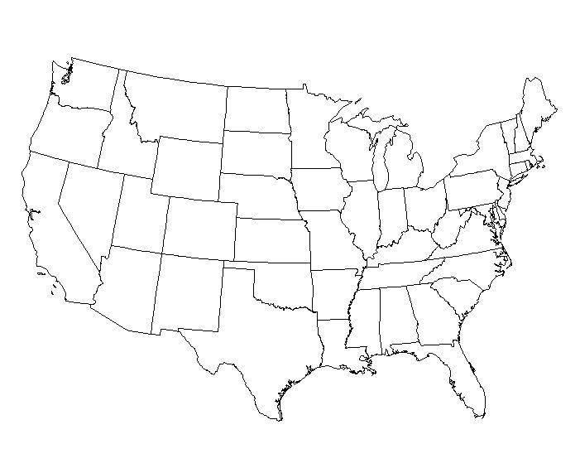
39. What impact has globalization had on religion?

40. What is neolocalism? Provide an example

41. Using the map on page 188-190, create a key and color your world map according to religion.

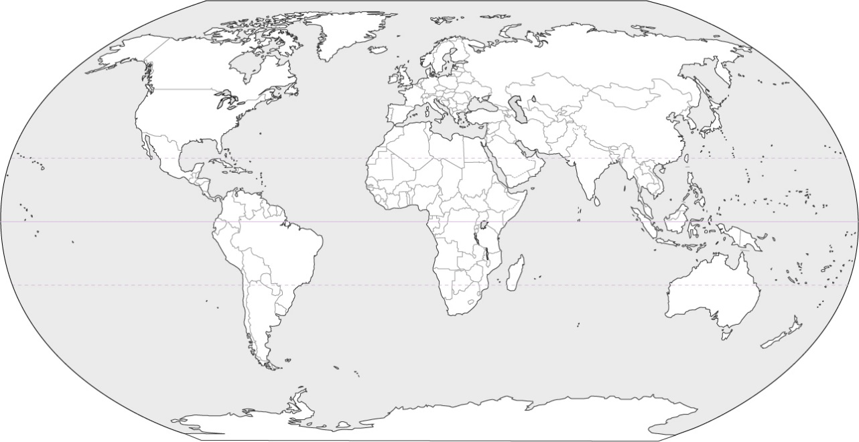

Key:

42. Major Eastern Religions - Hinduism is a religion found mostly in India. Explain the following:

- Polytheism

- Monotheism

- Karma

- Caste System

Buddhism grew out of Hinduism. Who was the Buddha and what was his message?

43. Major Middle Eastern Religions

The three main religions trace their history to Abraham. Explain the history, holy book and message of these religions:

- Judaism

- Christianity

- Islam

44. Ethnic and Universal Religions
What are the characteristics of ethnic religions? Provide examples.

What are the characteristics of universal religions? Provide examples.

Define diaspora –

Define pilgrimage –

45. Religious Hearths and Diffusion – complete the table

Religion | Hearth | Type of Diffusion
Hinduism

Buddhism

Judaism

Christianity

Islam

46. What role did colonialism, imperialism and trade play on spreading religion and culture?

47. How have religions impacted laws and customs?

- Islam

- Christianity in the U.S.

- Hinduism

- Judaism

Give examples of religious holidays that have been secularized (no longer religious). THINK SEVEN – why do you think this has happened?

48. The impact of religion on the landscape. Like all human activity, religion influences the use of space, both natural features and what people build.

- Provide examples of natural features that have religious importance.

- Provide examples of places where religious events occurred.

- Provide examples of how religious architecture has impacted the landscape

Christianity –

Hinduism –

Buddhism –

Judaism –

Islam –

Shinto –

49. What is a charter group? Provide examples.

50. What is an ethnic island? Provide examples.

51. What are urban ethnic neighborhoods? Provide examples.

52. What is sequence occupance? Provide examples.

53. THINK NINE: Fill in the following chart about other Universalizing Religions not covered in your book.
Religion | Basic Beliefs | Interesting Facts
Sikhism

Baha’i

Fill in the following chart with facts about each of the following ethnic religions not covered in your book.
Religion | Basic Beliefs | Interesting Facts
Confucianism

Daoism
(Taoism)

Animism

54. THINK TEN: the toughest one of all!

Why do territorial conflicts arise between religious groups? Be detailed.

Why have the following conflicts happened?
Arab-Israeli Conflict

Protestants vs. Catholics in Northern Ireland

What do you know about the refugees escaping religious persecution in Myanmar?

Model 6: Core-Domain-Sphere Model
Person who developed the model/theory:

Premise: (What is the model supposed to explain?)

Function: (How or when is the model/theory used?)

Illustration: (Draw the model or symbols to demonstrate the key ideas)

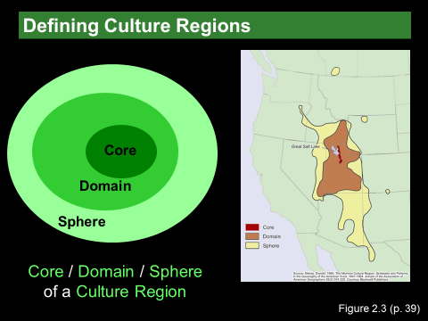

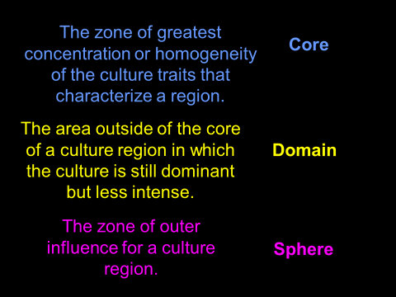
Strength of the model:

Weakness of the model:

