Name ___________________________________________________ Period____ Date___________
AP Human Geography / Unit 3 Language/
Guided Notes
Language: the method of human communication, either spoken or written, consisting of the use of words in a structured and conventional way

- Linguist: _______________________________________________________________________ ______________________________________________________________________________
- __________________________________________________________________________________________________________________________________________________________________________________________________________________________________________
- Languages and Communication: ___________________________________________________ ________________________________________________________________________________________________________________________________________________________________________________________________________________________________________________________________________________________________________________________
- 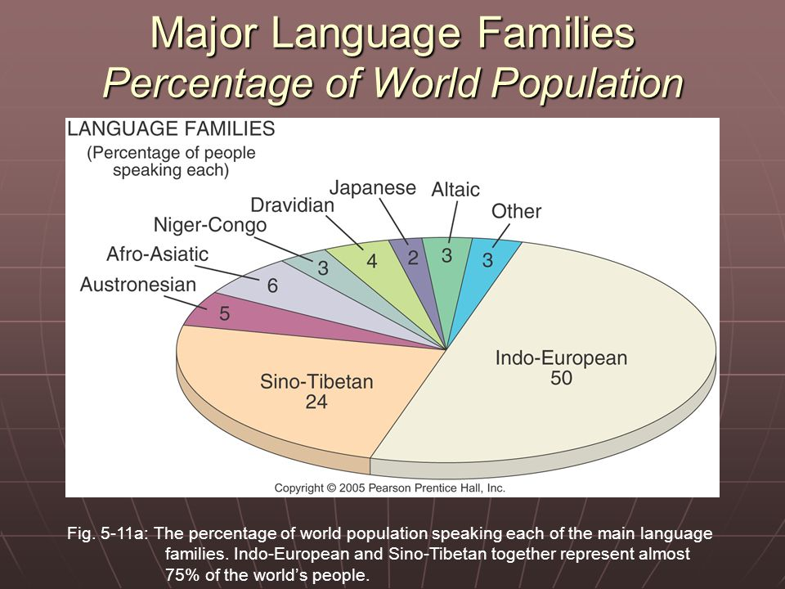
- Institutional Languages: __________________________________________________________ ____________________________________________________________________________________________________________________________________________________________
- Official Language: ______________________________________________________________ __________________________________________________________________________________________________________________________________________________________________________________________________________________________________________
- Literary Language: _______________________________________________________________ ____________________________________________________________________________________________________________________________________________________________
- Developing Language: is spoken in daily use by people of all ages, from children to elderly . It also has a literary tradition, through literature and the language may not be widely distributed. ______________________________________________________________________________
- Vigorous Language: ______________________________________________________________ ____________________________________________________________________________________________________________________________________________________________
- Monolingual ___________________________________________________________________ ______________________________________________________________________________
- Multilingual: ___________________________________________________________________ ______________________________________________________________________________
- Grammar: _____________________________________________________________________ ____________________________________________________________________________________________________________________________________________________________
How languages are formed
Language Convergence: _________________________________________________________________ __________________________________________________________________________________________________________________________________________________________________________
Language Convergence__________________________________________________________________ __________________________________________________________________________________________________________________________________________________________________________
Language Diffusion: ____________________________________________________________________ ____________________________________________________________________________________

Organizing Language Families
- Language Family: __________________________________________________________ ___________________________________________________________________________________________________________________________________________________________________________________________________________________________
- Language Branch __________________________________________________________ ____________________________________________________________________________________________________________________________________________________________________________________________________________________________________________________________________________________________________
- Language Group: __________________________________________________________ ___________________________________________________________________________________________________________________________________________________________________________________________________________________________________________________________________________________________________
- Language Tree Info: ________________________________________________________ ____________________________________________________________________________________________________________________________________________________________________________________________________________________________________________________________________________________________________

Language Families
Language Family | Information | Examples
#1 Indo-European | Is the most widely used language family, it is the Predominate language family in Europe, South Asia, North America and Latin America.
#2. Sino-Tibetan
Austronesian
Austro Asiatic
Japanese
Korean
Dravidian
Altaic
Uralic
. Afro-Asiatic
Niger-Congo
Nilo-Saharan
Quechuan

- Diffusion of Mandarin Chinese: ____________________________________________________ ____________________________________________________________________________________________________________________________________________________________
- Indo European Language Tree _____________________________________________________ ________________________________________________________________________________________________________________________________________________________________________________________________________________________________________________________________________________________________________________________
- Origins and Diffusion of Romance Languages: ________________________________________ ________________________________________________________________________________________________________________________________________________________________________________________________________________________________________________________________________________________________________________________
- Origins and Diffusion on Indo European Language ____________________________________ ________________________________________________________________________________________________________________________________________________________________________________________________________________________________________________________________________________________________________________________
- Sedentary Farmer Thesis. The theory that the first Proto-Indo-European speakers lived in Anatolia, and diffused their language throughout Europe and South Asia along with their agricultural practices, as opposed to war and conquest
- Origins and Diffusion of English: ___________________________________________________ ___________________________________________________________________________________________________________________________________________________________________________________________________________________________________________________________________________________________________________________________________________________________________________________________________________________________________________________________________________________
- Expansion and Diffusion of English: _______________________________________________ _________________________________________________________________________________________________________________________________________________________________________________________________________________________________________
- The Importance of Language: ______________________________________________________ __________________________________________________________________________________________________________________________________________________________________________________________________________________________________________
- Lingua Franca: __________________________________________________________________ ____________________________________________________________________________________________________________________________________________________________
- Pidgin Language: _______________________________________________________________ ____________________________________________________________________________________________________________________________________________________________
- Creole Language: ________________________________________________________________ ____________________________________________________________________________________________________________________________________________________________
Chinese
Logograms: ___________________________________________________________________________ _____________________________________________________________________________________
Ideogram ____________________________________________________________________________ __________________________________________________________________________________________________________________________________________________________________________
Dialect is a regional variation of a language distinguished by distinctive vocabulary, spelling and pronunciation. _______________________________________________________________________________________________________________________________________________________________________________________________________________________________________________________________
Subdialect is a subdivision of a dialect _____________________________________________________ ____________________________________________________________________________________
Standard Language: in a language with multiple dialects, one dialect may be recognized which is well established and recognized as the most acceptable for government, business, education and mass communication
In England this is known as Received Pronunciation RP: it is well known around the world as the dialect commonly used by politicians, broadcasters and actors
Distribution of Dialects in US _____________________________________________________________ ____________________________________________________________________________________________________________________________________________________________________________________________________________________________________________________________________________________________________________________________________________________
Idioms exist in every language. They are words or phrases that aren't meant to be taken literally. For example _____________________________________________________________________________ _______________________________________________________________________________________________________________________________________________________________________________________________________________________________________________________________
Hot Spots were languages are dying out
- What is an Extinct Language? _____________________________________________________ __________________________________________________________________________________________________________________________________________________________________________________________________________________________________________
- Where are languages becoming extinct? ____________________________________________ __________________________________________________________________________________________________________________________________________________________________________________________________________________________________________
- Why does this matter? __________________________________________________________ __________________________________________________________________________________________________________________________________________________________________________________________________________________________________________
- What is being done to prevent language extinction? __________________________________ __________________________________________________________________________________________________________________________________________________________________________________________________________________________________________

- Additional Notes:
______________________________________________________________________________________________________________________________________________________________________________________________________________________________________________________________________________________________________________________________________________________________________________________________________________________________________________________________________________________________________________________________________________________________________________________________________________________________________________________________________________________________________________________________________________________________________________________________________________________________________________________________________________________________________________________________________________________________________________________________________________________________________________________________________________________________________________________________________________________________________________________________________________________________________________________________________________________________________________________________________________________________________________________________________________________________________________________________________________________________________________________________________________________________________________________________________________________________________________________________________________________________________________________________________________________________________________________________________________________________________________________________________________________________________________________________________________________________________________________________________________________________________________________________________________________________________________________________________________________________________________________________________________________________________________________________________________________________________________________________________________________________________________________________________________________________________________________________________________________________________________________________________________________________________________________________________________________________________________

