Unit 4 Practice FRQ #1
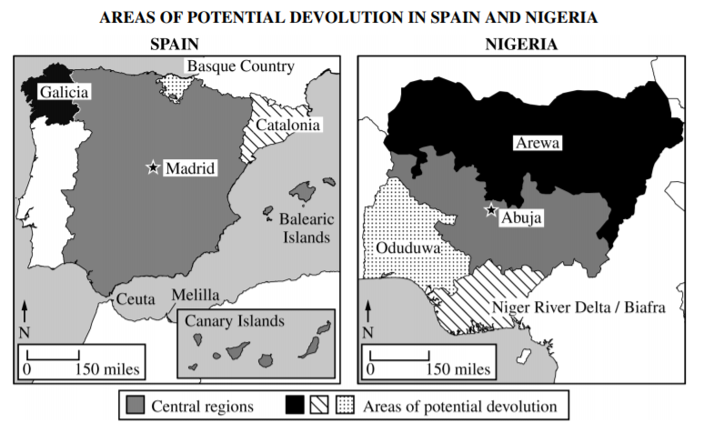
The number of states in the world has grown to approximately 200. The creation of new countries has been possible as a result of devolutionary forces. Countries such as Spain and Nigeria face devolutionary pressures.
A. Define devolution.
B. Describe how cultural diversity contributes to devolutionary pressures within a country.
C. Describe how regional economic differences contributes to devolutionary pressures within a country.
D. Describe how physical geography and territorial size contributes to devolutionary pressures within a country.
E. Identify and explain ONE internal effort on the part of a government to lessen devolutionary pressures in a country.
F. Identify and explain ONE political impact resulting from devolutionary pressures related to cultural differences in either Spain or Nigeria.
G. Identify and explain ONE impact on population which can result from devolutionary pressures related to cultural differences.

