Unit 7
Land Use Models
All information in this packet is from the LEWIS HISTORICAL SOCIETY AP HUMAN GEOGRAPHY website.

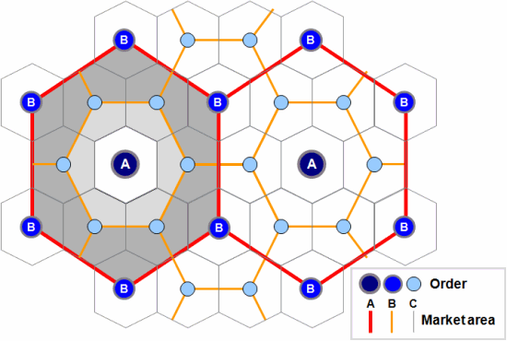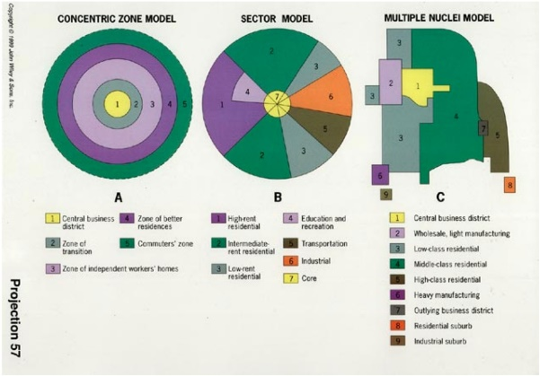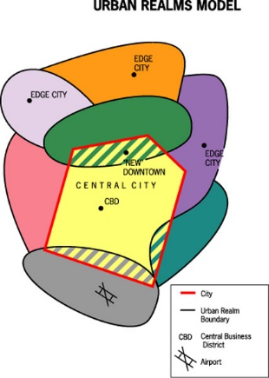

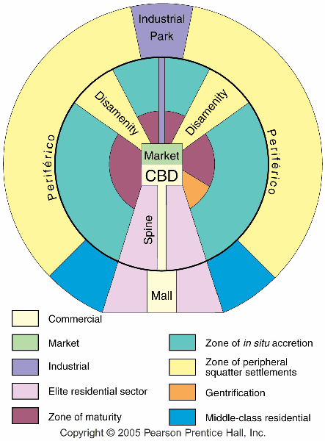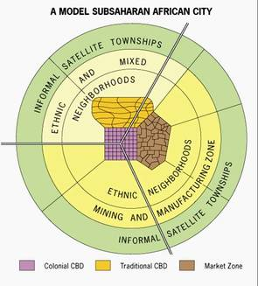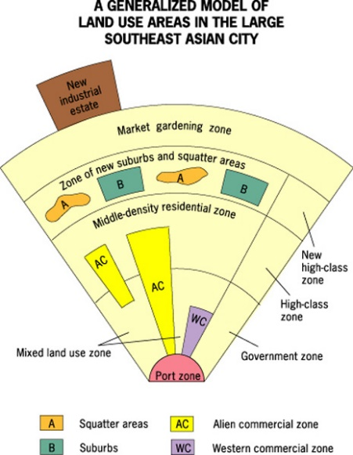
Central Place Theory
By: Cho and Liwanag
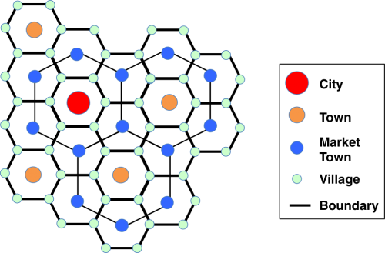

Central Place Theory
A central place is a market center for the exchange of goods and services by people attracted from the surrounding area. The central place is so called because it is centrally located to maximize accessibility from the surrounding region. Central places compete against each other to serve as markets for goods and services, according to central place theory.
The geographic concept of central place theory explains how services are distributed and why a regular pattern of settlements exists, at least in a MDC such as the United States. Central Place Theory was first proposed in the 1930s by German geographer Walter Christaller, based on his studies of southern Germany. August Losch in Germany and Brian Berry and others in the U.S further developed concepts during the 1950s. The theory applies most clearly in regions such as the Great Plains, which are neither heavily industrialized nor interrupted by major physical features such as rivers or mountain ranges.
In regards to human geography, central place theory is another way to help predict how cities grow and develop. Nodal regions such as market areas and locations of resources and certain activities are also pointed out by central place theory. Central place theory helps in answering why certain consumer services are distributed in a regular pattern, as observed in actual cities.
Christaller postulated:
Cites would be regularly spaced w/central places where the same product was sold at the same price was a standard distance apart
Each city has a complementary region in which they have a monopoly on the sale of certain goods
Assumptions
Many of the assumptions that go with this model are similar to the ones in the von Thunen Model.
To develop the theory, Christaller made the following simplifying assumptions:
* an unbounded isotropic (all flat), homogeneous, unbounded limitless surface (abstract space)
* an evenly distributed population
* all settlements are equidistant and exist in a triangular lattice pattern
* evenly distributed resources
* distance decay mechanism
* perfect competition and all sellers are economic men maximizing their profits
* consumers are of the same income level and same shopping behavior
* all consumers have a similar purchasing power and demand for goods and services
* Consumers visit the nearest central places that provide the function which they demand. They minimize the
distance to be travelled
* no provider of goods or services is able to earn excess profit(each supplier has a monopoly over a hinterland)
* there is only one type of transport and this would be equally easy in all directions
* transport cost is proportional to distance traveled in example, the longer distance = the higher transport cost
Threshold, Range, and Hinterlands
Central Place Theory also relies on these concepts:
Threshold — size of population required to make provision of the service economically feasible
Range — average maximum distance people will travel to purchase a good or service
Hinterlands — large tributary trade areas associated with central places that offer many services. In other words, the area surrounding the city that interacts with it in regards to services
Because range of central goods and services varies, tertiary centers are arranged in an orderly hierarchy
1.At the top are regional metropolises that offer all services associated with central places, and that have large hinterlands
2. At the bottom are small market villages and roadside hamlets that may contain nothing more than a post office, service station, or cafe
3. Between the two extremes are central places of various degrees of importance
4. Each high-ranked central place offers all goods and services of next lower ranked place, plus at least one or two more
Crucial to his theory is the fact that different goods and services vary both in threshold and range. Larger number of people required to support a hospital, university, or department store than a gasoline station, post office, or grocery store. People are willing to travel farther to consult a heart specialist, record a land title, or purchase a car than to buy a loaf of bread or mail a letter.
Which are Higher Order and which are Low Order Goods?
The higher the order of the goods and services (more durable, valuable and variable), the larger the range of the goods and services, the longer the distance people are willing to travel to acquire them.
Examples for low order goods and services are: newspaper stalls, groceries, bakeries and post offices. They are supported by a smaller threshold population and demand. Examples for high order goods and services are: jewelry, large shopping arcades and malls. They are supported by a much larger threshold population and demand.
The Model
Why are hexagons used in theory to delineate market areas:
1.Circles are equidistant from center to edge, but they overlap or leave gaps.
2.Squares nest together without gaps, but their sides are not equidistant from the center.
3.Geographers use hexagons to depict the market area of a good or service, because hexagons offer a compromise between geometric properties of circles and squares.
Sunbelt Phenomenon
-Many Americans have moved south in the last decades.
-As cities grew and newer places were created, they seemed to follow a pattern consistent with the ideas of Central Place Theory. Phoenix rises in stature and other places nearby reflect the idea that it is a central place of a higher degree.
Another View
Christaller’s Assumptions
He noted that centralized areas tend to be spaced apart so that each had a monopoly on providing certain services
All central places were a part of a system of counterparts that spread across an area
Larger central places controlled a larger area /Smaller central places controlled smaller areas
Evenly distributed population and resources
The countryside in the areas he studied would be flat, so no barriers would exist to interfere people’s movement across it
Human Behavior Assumptions
Humans will always purchase goods from the closest place that offers it
Whenever demand for a certain good is high, it will be offered in close proximity to the population.
When demand drops, so does availability
All settlements are equidistant and exist in a triangular lattice pattern
Consumers have same income level and shopping behavior
Have similar purchasing power and demand for goods and services
Visit nearest central places that provide what they need.
Market Area/Hinterlands
The area surrounding a service from which customers are attracted is the market area/hinterland. This is a large tributary trade area that is associated with central places that offer many services. EX: since people get services from the nearest location, consumers near the center of the circle obtain services from local establishments. The closer to the periphery of the circle, the greater the percentage of consumers who will choose to obtain services from other nodal regions.
Size of Market Area/Hinterland
To determine the extent of a market area, geographers need a service’s range and threshold.
Range
The maximum distance people are willing to travel to use a service or purchase good
A Convenience store has a small range, whereas a baseball stadium has a large range.
The range is the radius of the circle drawn to outline a service’s hinterland
To determine the range, geographers observe consumer behavior
How far the typical customer is willing to travel for various services
Threshold
The minimum number of people needed to support the service
Low-order goods
Things used frequently, like food and routine household items
These items are purchased regularly so small businesses in small towns can survive because people will buy at the closer locations instead of going into the city.
High-order goods
Specialized items, like cars, that are not often bought
Since people do not purchase them regularly, many businesses selling these items cannot survive in areas where the population is small.
They locate in larger cities with a large population
Hierarchy of Tertiary Centers
At the top are regional metropolises
Offer all services and have large hinterlands
At the bottom are small market villages and roadside hamlets
The central place is located at the vertexes (points) of equilateral triangles. They then serve the evenly distributed consumers who are closest to the central place. As the vertexes connect, they form a series of hexagons- the traditional shape in many central place models. This shape is ideal because it allows the triangles formed by the central place vertexes to connect and it represents the assumption that consumers will visit the closest place offering the goods.

Concentric Zone Model
By: Joan Bunyi
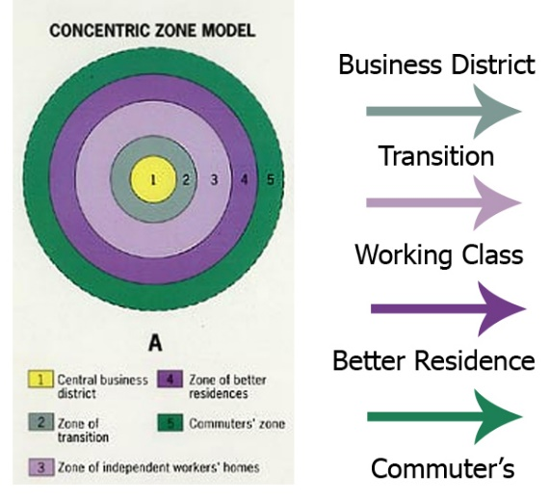
The Concentric Zone model is a model of the internal structure of cities in which social groups are spatially arranged in a series of rings. The Concentric Zone model was the first to explain the distribution of different social groups within urban areas. It was originally based off Chicago (although the model does not apply well to Chicago today). The model was created in 1923 by E.W. Burgess, Robert Park, and Roderick McKenzie. The idea behind this model is that the city grows outward from a central area in a series of rings. The size of the rings may vary, but the order always remains the same. This model suggests that the social structure extends outwards from the central business district, meaning that the lower classes live closer to the city center, while the upper classes live farther from the city center because they can afford the commute. Also, as you get further away from the city density decreases. The rent tends to increase as you get further away from the CBD and residents are more likely to rent near the center. As you get further away from the CBD it is more likely that you will find condominiums. Indianapolis is a city that can be applied to the concentric zone model today. That is because more people rent near the CBD than away from it. However, this model has its weaknesses. It does not take into account any physical barriers and it does not take into account gentrification- which may occur in these cities.
An important feature of this model is the positive correlation of socio-economic status of households with distance from the CBD — more affluent households were observed to live at greater distances from the central city. Burgess described the changing spatial patterns of residential areas as a process of "invasion" and "succession." As the city grew and developed over time, the CBD would exert pressure on the zone immediately surrounding it (the zone of transition). Outward expansion of the CBD would invade nearby residential neighborhoods causing them to expand outward. The process was thought to continue with each successive neighborhood moving further from the CBD. He suggested that inner-city housing was largely occupied by immigrants and households with low socio-economic status. As the city grew and the CBD expanded outward, lower status residents moved to adjacent neighborhoods, and more affluent residents moved further from the CBD.
Burgess's work is based on the bid rent curve. This states that the concentric circles are based on the amount that people will pay for the land. This value is based on the profits that are obtainable from maintaining a business on that land. The center of the town will have the highest number of customers so it is profitable for retail activities. Manufacturing will pay slightly less for the land as they are only interested in the accessibility for workers, 'goods in' and 'goods out'. Residential land use will take the surrounding land.
Problems with the Concentric Zone Model
The model has been challenged by many contemporary urban geographers. Firstly, the model does not work well with cities outside the United States, in particular with those developed under different historical contexts. Even in the United States, because of changes such as advancement in transportation and information technology and transformation in global economy, cities are no longer organized with clear "zones" (see: Los Angeles School of Urban Analysis).
• It assumes an isotropic plain - an even, unchanging landscape
• Physical features - land may restrict growth of certain sectors
• Commuter villages defy the theory, being in the commuter zone but located far from the city
• Decentralization of shops, manufacturing industry, and entertainment
• Urban regeneration and gentrification - more expensive property can be found in 'low class' housing areas
• Many new housing estates were built on the edges of cities in Britain
• It does not address local urban politics and forces of globalization
• The model does not work well for cities which are essentially federations of similar sized towns, for example Stoke-on-Trent
The Different Rings of the Concentric Zone Model
1) Central Business District (CBD)- This area of the city is a non-residential area and it’s where businesses are. This area s called downtown in the U.S. and city center in Europe. This area has a developed transportation system to accommodate commuters coming into the CBD. Also, due to the high land cost in this area, a lot of sky scrapers are built in order to take full advantage of that land. Most government institutions, businesses, stadiums, and restaurants chose this area to build on due to its accessibility.
2) Zone of Transition- the zone of transition contains industry and has poorer-quality housing available. Immigrants, as well as single individuals, tend to live in this area in small dwelling units, frequently created by subdividing larger houses into apartments. Most people in this area rent.
3) Zone of the working class- This area contains modest older houses occupied by stable, working class families. A large percentage of the people in this area rent.
4) Zone of better residence- This zone contains newer and more spacious houses. Mostly families in the middle-class live in this zone. There are a lot of condominiums in this area and residents are less likely to rent.
5) Commuter’s Zone- This area is located beyond the build-up area of the city. Mostly upper class residents live in this area. This area is also known as the suburbs in the United States.
Other Names for the Concentric Zone Model
• The Burgess Model
• The Bull's Eye Model
• Concentric Ring Model
• Concentric Circles Model

Sector Model
By: Aaron Sanabria
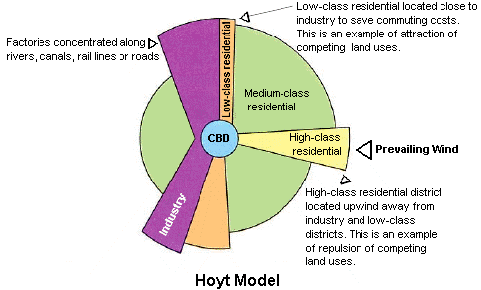 |  | AKA Hoyt Model
Sector model- a model of the internal structure of cities in which social groups are arranged around a series of sectors, or wedges radiating out from the central business district (CBD) and centered on major transportation lines.
• Also known as the Hoyt Model. Developed in 1939 by land economist Homer Hoyt.
• He said that a city develops in a series of sectors, not rings.
• Different areas attract different activities by chance or by environmental factors.
• As the city grows, activities within it grow outward in a wedge shape from the CBD.
CBD- central business district, the area of a city where retail and office activities are clustered. It is also called the central activities district. In North America, it is called “downtown.” In Chicago, it would be the area closest to the lake, most notably Michigan Avenue.
Industry
• Industry follows rivers, canals, railroads, or roads
• Lower class workers work here. Paid little, bad working conditions.
• Produces goods or other domestic products for city
Low Class Residential
• Low income housing
• Near railroads that feed factories or
• Inhabitants tend to work in factories
• Live near industry to reduce transportation costs
• Pollution or poor environmental conditions due to industry (traffic, noise and pollution make it cheap)
Middle Class Residential
• More desirable area because it is further from industry and pollution
• Access to transportation lines for working people who work in the CBD, making transport easier
• Largest residential area
High Class Residential
• Housing on outermost edge
• Furthest away from industry
• Quiet, clean, less traffic
• Corridor or spine extending from CBD to edge has best housing.
Where it does and doesn’t apply (some weaknesses)
• Applies well to Chicago
• Low cost housing is near industry and transportation proving Hoyt’s model
• Theory based on 20th century and does not take into account cars which make commerce easier
• With cars, people can live anywhere and further from the city and still travel to the CBD using their car. Not only do high-class residents have cars, but also middle and lower class people may have cars.

Multiple Nuclei
By: Joseph Park on: Mon 26 of April, 2010 00:03 CDT (56165 Reads)
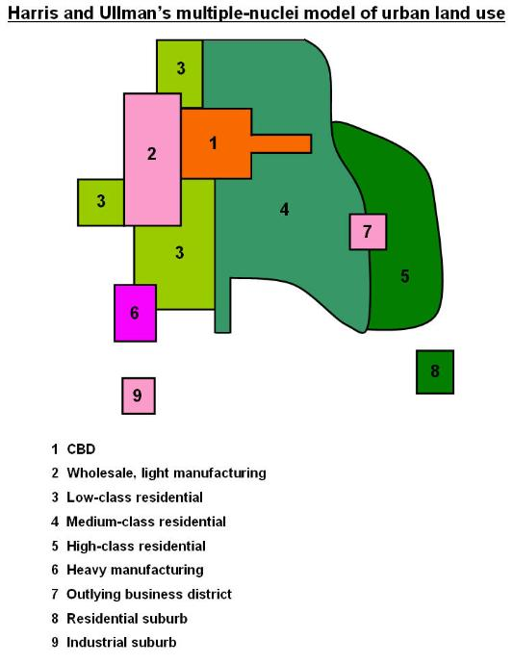
Definition:
* Multiple-Nuclei model is a model of urban land use in which a city grows from several independent points rather than from one central business district. Each point acts as a growth center from a particular kind of land use, such as industry, retail, or high-quality housing. As these expand, they merge to form a single urban area. The CBD is not the only generator of change.
* Some centers or nodes include:
o ports,
o universities,
o airports,
o parks,
o neighborhood business centers.
This model, unlike others, takes into account the varied factors of decentralization in the structure of the North American city.
The multiple-nuclei theory was formed based on the idea that people have greater movement due to increased car ownership. This increase of movement allows for the specialization of regional centers (eg. heavy industry, business park). A term for the specialization of regional centers would a node. There is no clear CBD in this type of model.
The distant decay theory is still applicable to this model. Land value and population density decline with distance from the central places.
Difference among Concentric, Sector and Multiple nuclei models
1. monocentric – concentric, sector model; polycentric – multiple nuclei
2. multiple nuclei more complex in term of land use zones, e.g. industrial suburbs
3. multiple nuclei allows the suburbanization, transport development, outward growth of city
4. multiple nuclei model gives the idea of land use pattern of a city only
Criticisms about the Multiple nuclei model
1. Negligence of height of buildings.
2. Non-existence of abrupt divisions between zones.
3. Each zone displays a significant degree of internal heterogeneity and not homogeneity.
4. Unawareness of inertia forces.
5. No consideration of influence of physical relief and government policy.
6. The concepts may not be totally applicable to oriental cities with different cultural, economic and political
backgrounds.

Urban Realms Model
By: Lewis Historical Society
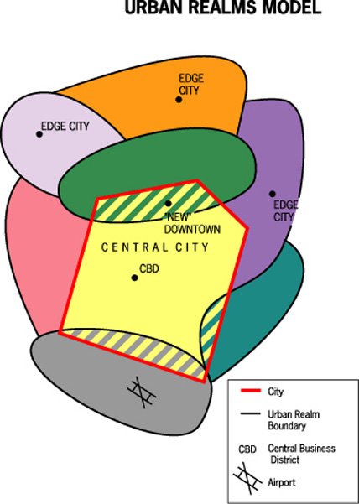
Urban Realms Model
Each realm is a separate economic, social and political entity that is linked together to form a larger metro framework.
Main issue to note with this model is that the city has been decentralized and that edge cities are now the center of realms which surround the city. The main CBD is no longer as influential as it once was. Know what an edge city is to fully understand this model.

The creator of the theory of urban realms was James E. Vance Jr., and he created it in the 1960’s. Now urban realms have become, so large they even have exurbs, not just suburbs. Exurbs are suburbs that are, so far away from a city they really can’t be called suburbs any more. The model works extremely well wit the San Francisco Bay area, because it is where Vance came up with the model for it. The city this worst applies to is to Phoenix, Arizona, because the city just sprawls, with very bad development, and shows a lot of characteristics of urban sprawl.
- Vance developed the urban realms model from his observation of the San Francisco Bay area and its sprawling metropolis.
- This model includes independent suburban downtowns as their foci, and yet they are within the sphere of influence of the central city and its metropolitan CBD.
- Each urban realm depends on four factors:
i. The overall size of the metropolitan region
ii. The amount of economic activity in each urban realm
iii. The topography and major land features, which help to identify each realm
iv. The internal accessibility of each realm for daily economic functions and travel patterns.
- An urban realm is likely to become self-sufficient if:
i. The size of the overall metropolis is large
ii. There is a large amount of decentralized economic activity in the region
iii. Topography barriers isolate the suburban region
iv. Good internal accessibility for daily commercial and business travel exists (especially to airport)

Latin American City Model //Griffin -Ford Model
By: Colleen Baker-Johnson
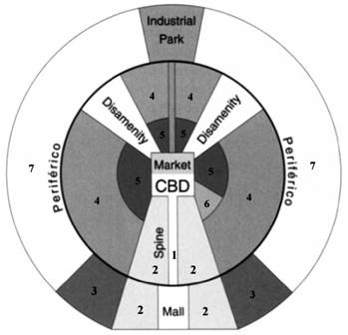
1. Commercial
2. Elite Residential Sector
3. Middle-class Residential
4. Zone of situ accretion
5. Zone of maturity
6. Gentrification
7. Zone of peripheral squatter settlements
General Definition: The Latin American City Model combines elements of Latin American Culture and globalization by combining radial sectors and concentric zones. Includes a thriving CBD with a commercial spine. The quality of houses decreases as one moves outward away from the CBD, and the areas of worse housing occurs in the disamenity sectors.
Different aspects of the model:
Commercial/CBD: The focus of employment, entertainment, and economic activity; Roads, trains, and buses are fairly reliable here.
Market: - informal economy - primitive form of capitalism; beyond control/taxation of gov't; unlicensed people sell homemade goods and services; may or may not be illegal.
- formal economy - taxed and licensed by the government
Industrial
Elite residential sector: The elite sector forms on either side of a narrow spine that contains amenities attractive to the wealthy, such as water and electricity, as well as offices, shops, restaurants, etc.
Zone of maturity: Residential area in which a stable population has gradually transformed the district into one that is fully serviced.
Zone of in situ accretion: A mix of middle and low income housing, generally thought of as a transitional area (moving either up on down).
Zone of peripheral squatter settlements/periferico: Home for impoverished and unskilled; housing consists of mostly shantytowns. Lawless barrios /favelas and is usually behind a main ring highway known as a periferico.
Gentrification: A process of converting an urban neighborhood from a predominantly low income renter-occupied area to a predominantly middle to upper-middle class owner-occupied area.
Disamenity: Contains relatively unchanging slums (barrios or favelas) that may not be connected to regular city services.
Outside the CBD, the dominant component is a commercial spine surrounded by the elite residential sector
These two zones are interrelated and called the spine/sector
Essentially an extension of the CBD down a major boulevard
Here are the city’s important amenities — parks, theaters, restaurants, and even golf courses
Strict zoning and land controls ensure continuation of these activities, protecting elite from incursions by low-income squatters - Note: zoning does not usually occur in these cities excepting in the elite areas
Inner-city zone of maturity
Less prestigious collection of traditional colonial homes and upgraded self-built homes
Homes occupied by people unable to participate in the spine/sector
Area of upward mobility - parts of it may be gentrifying
Zone of accretion
Diverse collection of housing types, sizes, and quality
Transition between zone of maturity and next zone
Area of ongoing construction and change
Some neighborhoods have city-provided utilities
Other blocks must rely on water and butane delivery trucks for essential services
Zone of peripheral squatter settlements
Where most recent migrants are found
Fringe contrasts with affluent and comfortable suburbs that ring North American cities
Houses often built from scavenged materials
Gives the appearance of a refugee camp
Surrounded by landscape bare of vegetation that was cut for fuel and building materials
Streets unpaved, open trenches carry wastes, residents carry water from long distances, electricity is often “pirated”
Residents who work have a long commute
Many are transformed through time into permanent neighborhoods
Note:
This model makes sense when you think about it.
-The larger poor areas reflect the influx of intraregional migrants (rural moving to urban areas)
-The industry in the city and even entering into the city to the core reflects the economic strength of many of these peripheral countries that now take on industrial work.
-the gentrification and middle class areas as well as the elite reflect an economy that is improving or allowing some to rise up (not what we see in the African City Model).
-Industry is on the opposite side of the elite
-the middle class are next to the elite separating them from the poor
-disamenity can reach all the way to the core but tends to stick to the outside
-gentrification is more likely near the CBD and elite area
-model created by Griffin and Ford and sometimes called that (Griffin-Ford Model)
-Physical geography could also influence the distribution of classes like in Rio, where residents were attracted to the neighborhoods that had nice views of the Atlantic Ocean and beaches.

African City Model FV
By: System Administrator

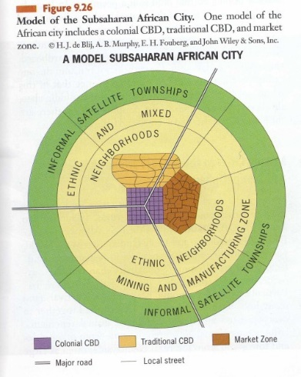
The Sub-Saharan? African City Model is also called the De Blij Model because De Blij, a famous geographer, created this. The tropics of Africa remain under forty percent urbanized and outside this area, the remaining regions are about fifty-seven percent urban. Africa has the world’s fastest growing cities, and the impact that European Colonialism has had is clearly evident. The Europeans created prominent urban centers including ports along the coast. Africa also has certain cities that are neither traditional nor colonial such as South Africa’s major urban centers that are mostly Western, with elements of European and American models, including high-rise central business districts and suburbs. Due to the diversity of its cities, it is complicated to develop an African City Model.
The central city is found to have three central business districts (CBDs): a remnant of the colonial CBD, an informal and periodic market zone, and a transitional business center where commerce happens from the curbside or storefronts. The former colonial CBD has vertical development, the traditional business center is usually a zone of single-story buildings with a touch of traditional architecture, and the market zone is open-air, informal (economically), and yet important. Sector development is the encircling zone of ethnic and mixed neighborhoods, in which people have strong ethnic identities. Mining and manufacturing zones are found next to some parts of these ethnic neighborhoods. On the outermost part of many African cities, there are informal satellite townships, which are squatter settlements. These squatter settlements consist of poor neighborhoods, or shantytowns, in which people make home anywhere that is possible or open, no matter if it is public or private.
Note:
-this reflects the nature of Africa's development. Of the three CBDs, the colonial reflects the past
-the mining and manufacturing areas reflect the nature ofthe types of jobs found in African cities
-the lack of an mentioned areas of elite, middle-class and gentrification tells something as well
-the small colonial CBD reflects a lack of development since that is the area of the formal economy and TNCs (transnational corps)
-the ethnic hoods reflect the tribalism that exists
-the informal satellite townships means the poor who have moved in close to the city
-the lack of any other class getting mentioned reflects the poverty of the area

Southeast Asian City Model (McGee Model)
By: Sarah Bannon

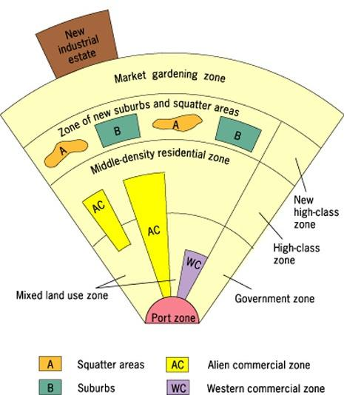

Background- Southeast Asia contains some of the most populous and fastest growing cities in the world. While they are still developing, many feature high-rise developments and several of the world’s tallest buildings.
-This model was developed in 1967 by T.G. McGee. It is sometimes called the McGee Model. McGee studied several cities in Southeast Asia and discovered that they shared certain aspects of land-use. Some similarities include:
Old colonial port zone surrounded by a commercial business district
Western commercial zone (dominated by Chinese merchants)
No formal central business district (CBD)
Hybrid sectors & zones growing rapidly
New Industrial parks on the outskirts of the city
- As the model shows, no CBD is visible. However, several components of the CBD are present in separate areas in the city. Basically the components of the CBD are clustered around the port zone. The Western commercial zone for western businesses. The alien commercial zone is dominated by the Chinese who have migrated to other parts of Asia and live in the same buildings as their businesses. These are Chinese merchants. And then there is the mixed land-use zone that has miscellaneous activities including light industry. There is also a separate area known as the government zone near the center of the model. Also note the mixed- land use zone contains various economic uses which can include informal business.
-The focal point is the Port Zone reflecting a city oriented around exporting.
Key Concepts:
-The Southeast Asian City Model is similar to the Latin American (Griffin-Ford) City Model in that they each feature high-class residential zones that stem from the center, middle-class residential zones that occur in inner-city areas, and low-income squatter settlements that occur in the periphery.
- The main difference between the two models is that the Southeast Asian City Model features middle-income housing in suburban areas. This reflects the larger percentage of middle-class citizens that reside in the peripheral regions than those of Latin America. This may reflect a smaller MC in Latin-American cities by comparison.
-Due to the alien commercial zone these cities also experience a blended culture but also strong ethnic ties.
Where it applies:
Many of the medium-sized cities in Southeast Asia have the strongest similarities. Since these cities are developing rapidly, aspects of the city are subject to change. However, as the city continues to develop, it is likely that the middle-class region will expand.
- It is also important to note that the Southeast Asian City model does not explain why the areas were formed but rather points out trends and patterns.
Examples of the model:
Kuala Lampur, Malaysia
Jakarta, Indonesia

Gravity Model
By: Sugrue and Wilcek on: Mon 26 of April, 2010 00:28 CDT (11687 Reads)
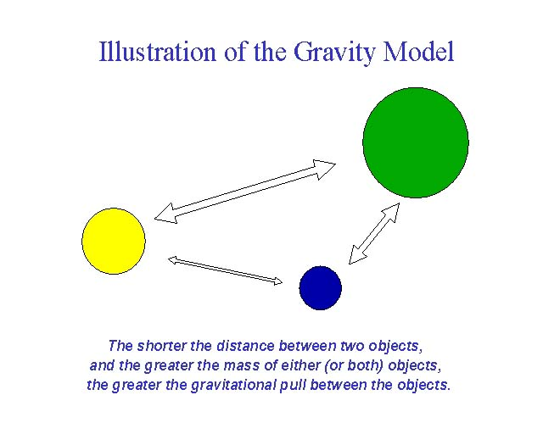
Gravity Model Wiki
The Gravity Model holds that the potential use of a service at a particular location is directly related to the number of people in a location and inversely related to the distance people must travel to reach the service.
Main Points Right Here
According to the Gravity Model, consumer behavior reflects two patterns:
1.The greater the number of people living in a particular place, the greater is the number of potential customers for a service. A city block or apartment building that contains 100 families will generate more customers than a house containing only one family.
2.The farther people are from a particular service, the less likely they are to use it. People who live 1 kilometer from a store are more likely to patronize it than people who live 10 kilometer away.
In other words, cities, countries or regions or other things that have higher numbers of people and are close together are more likely to interact
Small cities or countries with low populations that are further away are less likely to interact.
So China and the US interact because, even though they are further apart, they are both large
The US has perhaps the most interaction with Mexico because both countries are large and close together
Whereas Nepal probably does not interact with Paraguay as they are both small and far away. You do this same thing with big and small cities
Best Location in a Nonlinear Settlement
-Most settlements are more complex than a single main street. Geographers still apply the gravity model to find the best location, following these steps:
1.Identify a possible site for a new service.
2.Within the range of the service, identify where every potential user lives.
3.Measure the distance from the possible site of the new service to every potential user.
4.Divide each potential user by the distance to the potential site for the service.
5.Sum all of the results of potential users divided by distances.
6.Select a second possible location for the new service, and repeat steps 2, 3, 4, and 5.
7.Compare the results of step 5 for all possible sites. The site with the highest score has the highest potential number of users and is therefore the optimal location for the service.
While the gravity model was created to anticipate migration between cities (and we can expect that more people migrate between LA and NYC than between El Paso and Tucson), it can also be used to anticipate the traffic between two places, the number of telephone calls, the transportation of goods and mail, and other types of movement between places. The gravity model can also be used to compare the gravitational attraction between two continents, two countries, two states, two counties, or even two neighborhoods within the same city.
Opponents of the gravity model explain that it can not be confirmed scientifically, that it's only based on observation. They also state that the gravity model is an unfair method of predicting movement because its biased toward historic ties and toward the largest population centers. Thus, it can be used to perpetuate the status quo.
The Gravity Model, based off of Newton’s Law of Gravity, is used to measure the movement of ideas and people between two places. In this model distance between two areas and their population sizes are taken into consideration.
There is a general “formula” used when determining the “gravitational pull” a city has.
Population of area 1 x Population of area 2
Distance^2
Things such as employment, wages, settlement locations, traffic, trade, migration, and other ideas can be discovered using this model.
A downside and often criticism of this model is that there technically is no theoretical support, it is merely an observation.
Reilly’s Law of Retail Gravitation is a variation of this theory/model. Reilly used this model in order to establish the hinterland around a city. For example, the hinterland of two cities of the same size would have a trade area boundary exactly in the middle of each city. In other cases, the smaller the city, the closer the hinterland. The boundary between both cities is known as the breaking point. At this point, half of the populations shop in either city.
Faults related to this model, as with many others, are its assumptions. Reilly’s assumptions include a land void of any geographical variances, consumer preferences; political boundaries that effect an individuals “progress” towards a city.
Distance decay is directly relatable to this model and law.
Distance decay states that the further away two cities or ideas are, the less likely they are to interact and move.

