5 Steps to a 5 / Unit 5 Agriculture Information

In This Section
Summary: Agriculture is a primary economic activity that is found in almost every country of the world. Everyone depends on agriculture to survive. Over the centuries, agriculture has changed from a small and isolated practice into a worldwide mega-industry. Agriculture is constantly changing as new technologies and products make it increasingly efficient. It takes many forms and has gone through distinct changes and phases as it globalizes. The effects of agriculture—both large and small—on the human population are an important part of the study of AP Human Geography.

Introduction
Agriculture is the raising of crops and livestock to provide food and other products, such as fertilizer, feed crops for animals, hides and plant fiber for clothing, etc. It is called a primary economic activity because it involves taking something from the Earth. The history of agriculture is long and marked with infrequent, but major, changes that greatly impact human life on this planet.

Development and Diffusion of Agriculture
The earliest humans on Earth hunted animals, gathered plants and other items, and fished for their sustenance, living on whatever was available to eat in their region of the world. Almost simultaneously, in approximately nine different culture hearths around the world, humans began to domesticate plants and animals. This enabled people to settle down in one location, or become sedentary. It marked the transition of humans from hunting and gathering groups to sedentary groups who lived in villages and towns. This transition involved the use of seed agriculture and farm and draft animals and marked the First Agricultural Revolution, often referred to as the Neolithic Agricultural Revolution. These sedentary societies modified their natural environment so they could grow surplus crops by using irrigation and storage techniques. Because of these settlements of high-density population, the societies could utilize division of labor, establish trade relationships, and develop a culture enriched with art and architecture. The sedentary nature of societies led to the need for centralized administrations and political structures, too, and populations grew.
The Second Agricultural Revolution, which started in the seventeenth century in Europe and North America, increased efficiency of crop production and distribution. Initially, as crop yields increased because of the horse-drawn hoe and seed drill in England, people ate healthier because more food was available at lower prices. This led to a surplus of crops in England and spread throughout Europe, permitting more people to move to the cities as the Industrial Revolution got under way. The eighteenth century’s European colonies became sources of raw agricultural and mineral products for the industrializing nations. As death rates decreased, populations increased rapidly.
Agriculture blossomed into an industry through the use of mechanization and industrial methods in the early twentieth century. Mechanization led to greatly increased farm production on a much larger scale than ever before thought possible. The internal combustion engine led to the first tractors, which were used to pull combines and reapers until the 1930s when self-powered harvesting equipment was invented. Farming changed from a family farm enterprise into commercial enterprises (agribusinesses) that emphasized single crops and profits. Mechanization replaced humans in the fields with machinery and chemical fertilizers replacing the use of animal fertilizers to increase soil fertility and crop production.
Today agricultural industrialization completes the industry’s transformation. Machines have replaced human labor, and new seeds, chemical pesticides, and fertilizers have placed the farm as only one of many links in the chain of agricultural processing. Industrial substitutes are replacing natural crop products during this current phase.
The Green Revolution began in the mid-1970s when scientists developed hybrid higher-yield seeds and new fertilizers to use with them. Scientists were trying to use intensive agricultural technology to help poor countries produce larger harvests without farming larger acreage. These new seeds and fertilizers were diffused from core to periphery countries during this time to aid in producing a larger harvest and to help eradicate hunger. New high-yield rice, wheat, and maize seeds were used to increase harvests worldwide.
China and Southeast Asian countries saw rapid increases in rice harvests, and India doubled its rice production (Figure 1). Rice is the chief food for over half the world’s population, with China and India alone contributing over half the total rice production. However, poor farmers cannot afford pricey seeds and fertilizers and irrigation to improve their harvests; as a result, they have not benefited much from the Green Revolution. Also, Africa’s chief food crops are millet, sorghum, yams, and cassava, which haven’t been much affected by the Green Revolution; only maize hybrid seeds have helped increase harvests there.
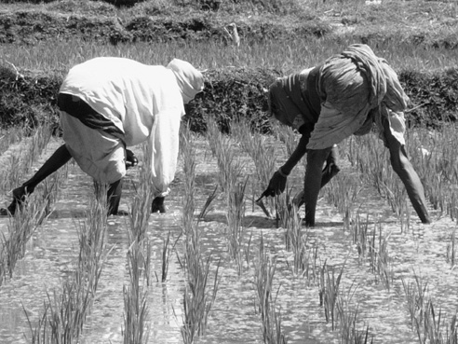
Figure 1 Rice-growing in India.
While it has increased yields, the Green Revolution’s increased use of irrigation has caused environmental damage. Soil salinities have caused many soils to become less productive. Irrigation has also decreased groundwater levels while causing conflicts over water usage. Another negative side effect of the Green Revolution is the loss of biodiversity and native food crops (plants, etc., that are adapted to the climate and agricultural practices of the native populations). Many indigenous societies try new technologies to increase harvests while at the same time maintaining highly diverse cropping. This is not easy to do in the face of increasing market pressures to produce and export a single crop. Encouraged by government agencies to adopt new agricultural practices, traditional societies are usually hesitant and slow to adapt them.
Key Idea:
Modern commercial agriculture is large-scale agricultural production for profit using specialized methods, technologies, and genetically engineered seeds. More Developed Countries (MDCs), like the United States and Canada, use specialized agricultural methods to raise crops for profit. The table below shows countries of the world ranked by agricultural output. Make sure you know the main crops that the top five countries produce for the exam. The law of supply and demand influences farmers to raise the crops for which there is market demand. Prices for these crops typically bring the highest profits (selling price minus costs to raise the crop). Governments often distort the market influence by subsidizing certain key crops (rice in Japan or milk in the United States) in order to protect local production (Japan) or guarantee prices in the market (United States). Farms that produce a single crop that minimizes risks (climate, costs of inputs like labor and fertilizer, market demand, etc.) and maximizes profits (choice of crop best suited for growing conditions and soil, potential pricing, etc.) have been the norm in the United States since the 1950s.

Countries Ranked by Agricultural Output, 2009
RANK | COUNTRY | OUTPUT  (IN MILLIONS, US DOLLARS)
1 | China | 520,352
— | European Union | 312,498
2 | India | 210,116
3 | United States | 171,075
4 | Brazil | 96,016
5 | Japan | 81,089
6 | Russia | 57,774
7 | Spain | 48,313
8 | France | 48,167
9 | Australia | 40,885
10 | Italy | 38,129
Vertical integration (contracts between farmer and purchasing/processing company) caused farm outputs to increase by the 1990s. This evolution from the single farm to the integrated production and marketing partnership model is called agribusiness. The fast-food industry has driven this evolution with its demand for uniformly grown livestock and produce that meets certain specifications. Because this form of agriculture is so efficient, a food surplus now exists, which keeps prices down in the face of stagnant demand.
The map in Figure 2 shows the net trade in agricultural products for countries and regions of the world. The darkest areas are regions that produce and export more food crops than they import. The lightest areas import more food crops than they export. If you compare this map to a climate map of the world, you can readily see the regions with climate extremes are unable to produce sufficient crops for their inhabitants whereas middle latitude regions generally possess more favorable conditions for agriculture.
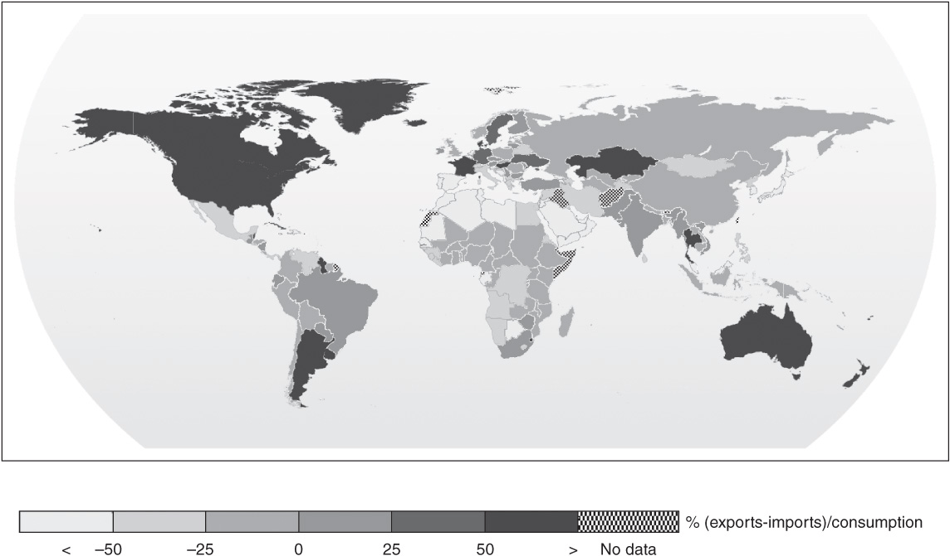
Figure 2 Net trade in agricultural products, 2000–2002

Major Agricultural Production Regions
In less-developed countries (LDCs), at least two-thirds of the population is involved in growing crops for food or in herding livestock. In most of Africa, Latin America, South Asia, and East Asia, farming is the chief occupation. In Bhutan, 90 percent of the people are employed in farming and herding. While agriculture is a large part of the economies of LDCs worldwide, employment in agriculture is declining steadily and matches global trends in MDCs. Farming for local domestic markets and for export globally is a crucial part of an LDC’s national income.
Subsistence agriculture, the consumption of everything that is grown, gradually took over hunting and gathering. The various forms of subsistence agriculture have important differences. Shifting agriculture is based on growing crops in different fields on a rotating basis. For example, the Maya in the Yucatan grow maize by rotating fields on a seven-year cycle. The fields are cut and burned off each year to enrich the soil with nutrients. Seeds are planted just in time for the rainy season. This is also called swidden agriculture or slash-and-burn and is prevalent in locations such as the Amazon Basin.
Intensive subsistence agriculture depends on heavy inputs of fertilizer and human labor on a small piece of land for substantial crop yield. China, India, and Southeast Asian countries rely on this type of agriculture to double-crop (two harvests of a crop per year), or even triple-crop (three harvests of a crop per year), rice to support their large and rapidly growing populations.
Usually several crops are produced (polyculture), and animals are also raised for labor, food, or clothing. Urban subsistence farming in the form of small city gardens is a rapidly growing activity and accounts for one-seventh of the world’s food production according to recent UN figures. These gardens form an important source of sustenance for poor urban families unable to buy adequate food for their families. Waste and garbage is recycled as fertilizer, and both contribute to reducing the need for waste disposal while at the same time contributing to the spread of infectious disease and water pollution. Some cities like Bulawayo, Zimbabwe, strictly regulate urban farmers by destroying crops grown on land not owned by the farmers.
Pastoralism is a form of subsistence agriculture in which animals are herded in a seasonal migratory pattern. Today there are nearly 200 million pastoralists in the world who breed and herd cattle, goats, sheep, camels, and reindeer. Pastoralism is found in arid, marginal lands, such as deserts and steppes where rainfall is scarce and unreliable—sufficient for grazing grasses but not enough for other forms of subsistence farming. Pastoralism is widely practiced in North Africa, the steppes of Central Asia, and the Middle East. When pastoralists move their herds constantly in a set seasonal pattern of grazing (from mountain to valley pastures, for example), the movement is called transhumance.
In MDCs, agricultural activities range from large livestock and grain-producing farms to smaller farms that service local markets. In the United States, mixed crop and livestock farming is the most prevalent form of commercial agriculture west of the Appalachian Mountains. Northern and western Europe also engage in this type of farming most often. In this type of farming, most of the grain crops are fed to the livestock, which are then sold in the markets. Because they are able to both grow the livestock and the crops to feed them, this is an efficient, risk-reducing farming lifestyle.
Grain farming is a specialized agricultural activity where farmers grow one crop (monoculture) corn, wheat, or rice for commercial markets. The map in Figure 1 shows the corn production by US county in 2009. The United States produces over 70 percent of the corn and a large percentage of the wheat for world markets. The use of machinery, fertilizers, pesticides, and genetically modified seeds (a type of genetically modified organism, or GMO, discussed later in the section) has made this a highly efficient and very productive means of growing cereal crops for market. These agribusinesses have largely taken the place of the traditional small family-owned farms of the past.
.
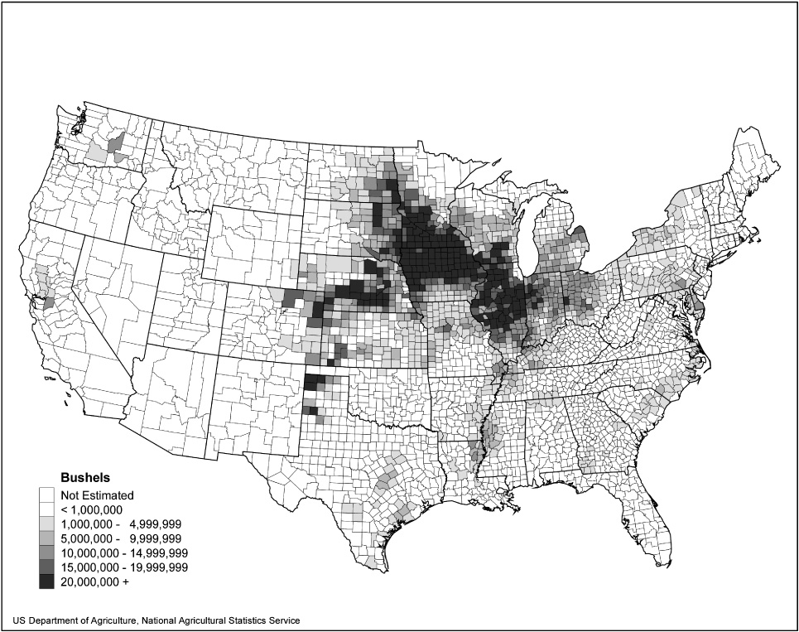
Figure 1 Corn production by US county, 2009.
Dairy feedlots near large cities operate like factories in their efficiency. The high levels of mechanization and automation allow these dairies to not only serve the nearby urban markets but also compete effectively in the globalized market for dairy products.
Plantation agriculture (also called monocropping) on a large estate is a specialized form of agriculture that is usually located in former colonial areas. Plantations are most often found in tropical regions of the world where ample rainfall and fertile soils allow the crop to be produced in abundance. Climate is the most important requirement for producing a plantation crop (rice, cane sugar, rubber, cacao, tea, coffee) and most plantations are located near the coasts for easy shipping access. Plantations generally use an alien labor force of immigrants from various other LDCs but require foreign investment and management to function efficiently. Mediterranean agriculture is another form of specialized agriculture that is known for producing grapes, olives, citrus, and figs—crops requiring a warm year-round climate with plenty of summer sunshine.
Ranching (cattle and sheep grazing) is prevalent in South America on the pampas (grasslands) of Argentina, Australia and New Zealand (sheep), and South Africa (sheep) but is only found in Spain and Portugal in Europe. Since it is more profitable to raise crops than livestock, ranching is declining in areas that have adequate rainfall.
Key Idea:
In the United States, truck farming, or commercial gardening and fruit farming, is the predominant agricultural activity in the Southeast. Most of the fruits and vegetables grown are sold to large processing companies, but some are also sold to individual consumers. Migrant farm workers and large-scale automation and mechanization maximize profits while keeping costs at a minimum. In New England, specialty farming provides upscale customers with fresh produce.
Access to markets is a huge problem for farmers all over the world. Von Thünen’s model as shown in Figure 2 below, helps explain the relationship between the cost of land and the cost to transport the crop to market. The closer the land is to the city, the more expensive it is, and the farther away, the cheaper it is. Von Thünen was a German farmer who wrote The Isolated State in 1826 in an attempt to resolve a farmer’s dilemma—how to balance the cost of land with the best crop to produce. The costs of transporting different farm products to the central market determined the agricultural land use around a city. The most productive activities will locate closest to the market on more expensive land, and less productive activities will locate further away on cheaper land.
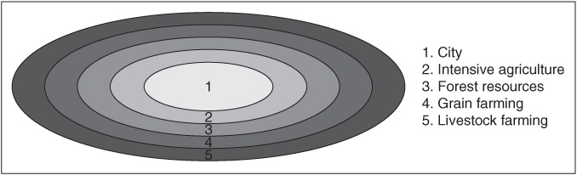
Figure 2 Von Thünen’s agricultural land-use model.
The main assumptions of this model (based on early nineteenth-century urban-rural land use conditions) are:
- Isolated state: no trade with the outside world
- Land characteristics uniform: flat land with uniform fertility around the city
- Transportation: no roads or rivers, just farmers with carts and horses for transportation of products
Farmers who supplied fresh milk and dairy products to the city market needed to locate close to the marketplace or risk delivering soured milk and cream. Perishable fruits and vegetables also needed to be grown closer to the marketplace because of perishability concerns. These crops were grown in the intensive farming area, whereas forest resources (needed then for fuel) could be grown and harvested further out from the market. Grain farming was in the next ring outside the city because grains could be grown, harvested, and stored easily and cheaply until needed. Livestock could be raised in the outer ring where cheap pastureland was plentiful. In von Thünen’s day, livestock destined for market were driven into the city market “on the hoof,” and large refrigerated tractor-trailer rigs were not needed to transport the packaged meat.

Rural Land Use and Settlement Patterns
Settlements in the United States were originally based on resources such as agriculture, fishing, and forestry and proximity to water (coastlines, rivers, etc). The impact of increasing globalization in agriculture combined with the possible reduction of price supports to farmers contribute to the changeover of rural farmlands to alternative land uses. Land use functions such as housing, employment, recreation, and water storage are also putting increasing pressures on rural land use. For example, when people move to the rural countryside for amenities such as a rustic, simpler lifestyle in picturesque surroundings, they become agents of change and build housing developments that modify the environment, making it less rural.
Today, 75 percent of the US inhabitants live in urban areas with the remaining 25 percent of US inhabitants living in rural areas. Rural areas consist of open country and settlements with fewer than 2500 residents and have population densities as high as 999 per square mile or as low as 1 person per square mile. Three factors affect the pattern of rural settlement:
- The kind of resource that attracts people to the area (forests, farmland)
- The transportation methods available at time of settlement (rivers, roads)
- Role of government policy, especially the land survey system (metes-and-bounds, long lot, rectangular, etc.)
- On the journey from subsistence agriculture to commercial agriculture, agriculture has greatly changed. Modern commercial agriculture is large-scale agricultural production for profit using specialized methods, technologies, and sometimes, genetically engineered seeds. Commercial agriculture has diffused from the core countries (MDCs) where many of the techniques were developed into the peripheral countries (LDCs) that use them to increase crop yields and feed their growing populations. We have already discussed the three revolutions so let’s take a quick look at some modern elements of modern commercial agriculture today.
- Key Idea:
- Biotechnology is the application of scientific techniques to modify and improve plants, animals, and microorganisms to enhance their value. A genetically modified organism (GMO) is created when scientists take one or more specific genes from an organism (including plants, animals, bacteria, or viruses) and introduce those genes into another organism. An organism that has been transformed using genetic engineering techniques is called a transgenic organism, or a genetically modified organism. Approximately 65 to 70 percent of food products on store shelves may contain at least a small quantity of crops produced with these new techniques.
- The first genetically modified food product was a tomato which was transformed to delay its ripening. Certain food plants (tomatoes, potatoes, and tobacco) have been genetically modified to produce insulin and certain vaccines. If these vaccines are proven successful in trials, they give the LDCs hope that they can cheaply grow and provide vaccines locally for their populations.

Organic Farming and Local Food Production
Organic farming is the process of producing food naturally. Organic farming avoids the use of synthetic chemical fertilizers and genetically modified organisms to influence the growth of crops. The organic farmer strives to protect the Earth’s resources and produce safe, healthy food for consumption with “zero-impact” on the environment. Farmers grow their crops without the help of artificial fertilizers and harmful chemical pesticides, and organic ranchers and dairy farmers raise their livestock free of drugs and animal hormones. Organic food products are increasing in demand as consumers try to avoid harmful toxins and residues of pesticides in the food supply.
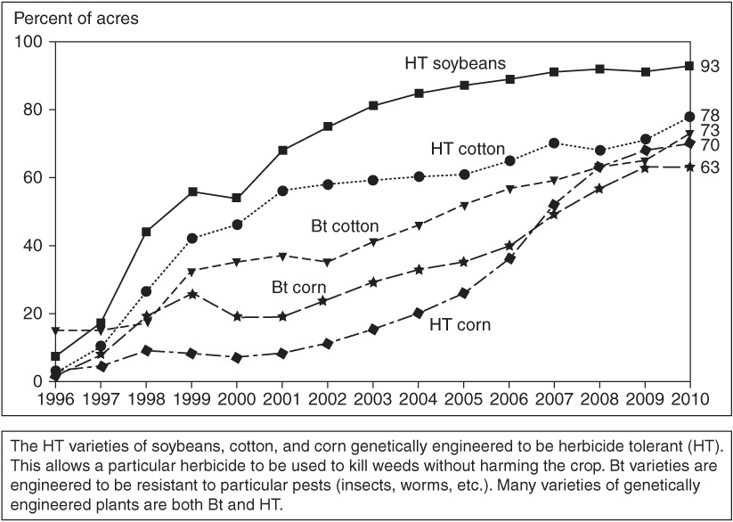
Figure 1 The adoption of genetically engineered crops in the United States.
Source: US Department of Agriculture (USDA)
Locally produced foods are fresher, more nutritious, and tastier than those found in supermarkets because they traveled a much shorter distance from field to shelf. Buying from local farmers also helps the local economy by enabling farmers to stay in business. Farmers’ markets, roadside produce stands, and local specialty stores emphasizing local produce are just a few of the ways local food production is manifested today.

Environmental Impacts of Agriculture
Agricultural practices worldwide have caused many adverse impacts on the environment. Intensive farming techniques are often too hard on the soils and they become too depleted or polluted for further use. Clearing land for farmland or cattle ranching has caused massive deforestation in many countries. Dry or semiarid regions such as the African Sahel are at risk of desertification, which is the turning of agricultural land into deserts through use of overgrazing and the subsequent erosion of unprotected topsoils by winds. The use of pesticides and fertilizers pollutes soil and drinking water supplies and also kills off useful insects that provide natural pest control. Widespread use of water for irrigation depletes water tables and changes the ecology of rivers and streams. People working in agricultural industry often suffer health problems caused by working with agricultural chemicals. As farmers strive to produce enough food for the growing global population, can we produce it in a sustainable way? Sustainability is the principle that we must meet our present needs without compromising the ability of future generations to meet their needs. Sustainability emphasizes the stewardship of both natural and human resources.
Key Idea:
Conservation agriculture is a new way of farming based on optimizing crop yields and profits without depleting soil, encouraging erosion, and harming the environment. Conservation agriculture methods include reduced use of fossil fuels, pesticides, and other pollutants thus keeping the environment safer for the inhabitants, too. Some common conservation practices include:
- Conservation crop rotation: planting low-residue (low-fiber) crops such as soybeans in one year, followed by a high residue crop, such as corn in the following year on the same field
- Conservation tillage: allowing the crop residue to stay on top of the field, rather than being plowed under when planting begins
- Terraces: creating an embankment (a terrace) at a right angle to sloping land in order to allow water to soak into the soil rather than to move down the slope, taking the soil with it
- Grassed waterways: creating a broad and shallow depression, usually below a terraced area, that is planted with grasses to prevent erosion by slowing the flow of runoff, holding a bank, and filtering out soil particles

Rapid Review
Agriculture is a global industry that has changed and evolved through the years from being an isolated family farm to a multimillion-dollar commercial agribusiness. The foods we eat every day come from global communities far away. Can we raise crops in a sustainable way without harming our planet?

