5 Steps to a 5 Unit 3 Culture/Language / Religion

In This Section
Summary: This section focuses on the cultural traits, behaviors, and patterns that make a group of people different and unique from other groups. It also reviews the spatial patterns and diffusion of culture traits and look at how cultural landscapes evolve over time.
Culture, or what makes a group of people special and unique, is an important part of AP Human Geography. All the parts of a culture—both material and nonmaterial—create unique landscapes called cultural landscapes that help human geographers differentiate between groups and societies. The study of the diffusion and spread of innovations, cultural traits, and culture systems is integral to AP Human Geography.

Introduction
What is culture? It includes everything about the lifestyle, beliefs, and values of a group of people. Even the definition of “family” is a part of a group’s culture. Culture is transferred within a society by imitation, instruction, and example and is learned, not inherited, from your parents. Geographers investigate how and why a culture is found in a particular location.

Cultural Concepts

Culture Traits: Material and Nonmaterial
A culture trait is a single feature of a culture. For example, the type of clothing and the system of religious beliefs of a group of people are culture traits. A culture complex is a group of individual cultural traits that are interconnected. For example, keeping cattle is a cultural trait of the Maasai society of Kenya and Tanzania. The culture complex is comprised of related traits of cattle as a measure of wealth, the imbibing of milk and cattle blood, and the elevated status of herders in Maasai society.
Material culture is composed of artifacts (tangible things) such as tools, weapons, and furniture. Nonmaterial culture is made up of mentifacts (language, religion, artistic pursuits, folk stories, myths, etc.) and sociofacts(educational and political institutions, religious organizations, family structure, etc.). The distinctions are not always clear-cut. For example, a house is an artifact because it provides shelter for its owners. This house can also be a sociofact because it expresses the nature of the family it houses, and it is also a mentifact because it reflects a culture group’s beliefs about architecture, building design, and housing materials.

Diffusion: How Culture Begins and Spreads
Culture spreads from one region to another in a process called cultural diffusion. Diffusion involves the movement of people, ideas, and goods from one location to another. A culture trait such as language, religion, or housing style is spread from one area to another through a form of cultural diffusion. A culture hearth is a place where innovations and new ideas originate and spread outward (diffuse) to other regions. Examples of culture hearths are Egypt, Mesopotamia, the Indus River Valley, and West Africa. Agriculture and trade were essential attributes of each culture hearth and led to the stratification of each society into farmers, administrators, rulers, artisans, soldiers, and priests. All culture hearths were urban-centered and cultural traits such as religion, forms of architecture, and writing spread and diffused outward from each one as innovations, or new inventions. The two-headed jaguar throne in Figure 1 is found at Uxmal, Yucatan (Mexico), and is one of many still-standing structures from the Maya, a Mesoamerican culture hearth.
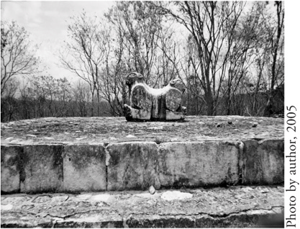
Figure 1 Two-headed jaguar throne, Uxmal, Mexico.
Sometimes cultural barriers, or hindrances to diffusion, occur in a society and keep cultural traits from spreading. A taboo is a potent form of cultural barrier that prevents certain habits or new ideas from establishing themselves in a society because of already-established prohibitions, customs, and rules. Many societies have food taboos (dietary restrictions) that prohibit the consumption of a certain kind of meat. For example, Hinduism prohibits consumption of beef, Muslim and Judaism prohibit consumption of pork, and most Somali clans restrict the consumption of fish.

Acculturation, Assimilation, and Globalization
Key Idea:
Acculturation is the change that occurs within a culture when it adopts a practice from another culture. An example of acculturation occurred when the Mongols under Genghis Khan swept down for the Central Asian steppes to conquer China in the thirteenth century. The Mongolian occupiers largely adopted Chinese culture within a generation and were acculturated by the society they had conquered. Transculturation occurs when an equal exchange of traits or influence between two culture groups occurs. Syncretism is the birth of a new culture trait from blending two or more cultural traits. An example of this is folk Catholicism in which the indigenous religions of the Maya and Aztec were blended with Roman Catholicism brought across the Atlantic by the Spanish. The Spanish conquerors forced the natives to convert, but the natives incorporated the old gods and goddesses of their indigenous religion into statues of Catholic saints and altarpieces so the natives could worship their old gods while feigning compliance. The resulting folk Catholicism is a rich synthesis of two religions.
Acculturation is the process of adopting some of the values, customs, and behaviors of the host culture (the larger group into which the minority culture migrated). Immigrants may adopt the language and a few other customs of the host group but will still retain many of the distinctive customs and traditions of their cultural group.
Assimilation is the process in which immigrants become totally integrated into the host culture. The immigrants are still often aware of the differences between the two cultures, thus retaining their ethnic identity. The United States and Canada actively incorporate their immigrant minorities into their host societies (in different ways and to different degrees), but many other countries marginalize minority cultures and either demand total assimilation or ban the use of minority languages and religion.
Globalization is the increasing interconnection of all regions in the world through politics, communication, transportation, marketing, manufacturing, and social and cultural processes. The increasing amount of connectivity in the world today presents a multitude of spatial advantages and also some problems. Rapid and intensive sharing of knowledge has the ability to improve quality of life and transmit news faster than the speed of light due to globalization. The downside of globalization includes the loss of cultural uniqueness, loss of languages, and a general “sameness” that follows the spread of pop culture.

Culture Regions
A culture region is a portion of the Earth’s surface occupied by populations sharing recognizable and distinctive cultural characteristics. An example of a culture region would be the spatial extent of the Muslim religion or the area in which English is widely spoken.

Cultural Differences
Cultures vary greatly in many ways, and they are constantly changing and never remain the same. For example, the culture today in the United States is much different from the culture when your parents were children. Differences between cultural groups are usually much greater than differences within a single cultural group, however. The greatest areas of difference lie in the following culture traits: language, religion, and ethnicity.
The physical environment helps form culture. Cultural ecology is the study of how the natural environment shapes and influences a culture group. While geographers today agree that the environment is important in shaping cultures, geographer Ellsworth Huntington and others endorsed the theory of environmental determinism. This theory states that human behavior is controlled by the physical environment. Therefore, people who live in the cold, brisk climates of Europe will be energetic, hard workers, and generally achieve more than people living in hot, humid tropical environments, which were thought to contribute to a slow, sluggish tendency. Of course, this theory is no longer accepted. How did the Maya flourish and establish a highly advanced civilization in tropical Mesoamerica? How could the majority of culture hearths be located in the lower latitudes if this theory held true? Possibilism—the theory that the physical environment merely establishes limits of what is possible on the human population—has been more widely accepted in recent years, although it, too, raises questions. The human race has pushed beyond the limits imposed on it by the physical environment thanks to advanced technology and communications.

Language
Language is the most important channel for the transmission of culture. The linguistic diversity of the world is rapidly decreasing. Of the thousands of languages still spoken today, over half of the Earth’s inhabitants speak one of only eight languages. Many languages are no longer spoken (dead), and many more are on the verge of extinction.
A language family is a group of languages that are related and derived from a single, earlier language—the protolanguage, a reconstructed ancestral language. It can be further divided into subfamilies, branches, or groups of languages that are related. The Indo-European language family is the largest language family and the languages in this family are spoken by roughly half the world’s population. It includes most European languages and many of those spoken in Asia, as well as the introduced languages of the Americas. The Indo-European people probably came from Eastern Europe and spread throughout Europe and Asia taking their language with them to the people they subjugated. The map in Figure 1 shows the main language families.
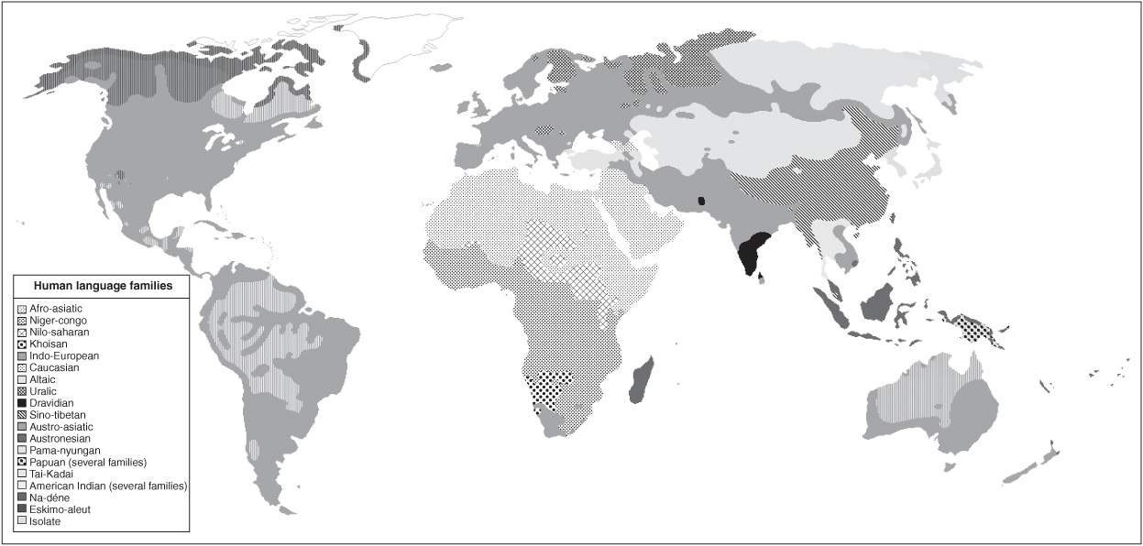
Figure 1 Language families of the world.
The map in Figure 1 also shows the processes of cultural diffusion at work. You can see where the Indo-European languages have spread by expansion diffusion and then jumped every ocean in the world by relocation diffusion. In many areas, hierarchical diffusion, or the adoption of an official language by the ruler or administration, diffused a language downwards into the society. Where obtaining a government post or well-paying job depended on the ability to speak the official language of the land, a person had to learn the new language of governmental administration.
The figure here shows the six world languages that have the most speakers (first language). Roughly one-third of the world’s inhabitants speak one of the six languages in the figure as their first language.
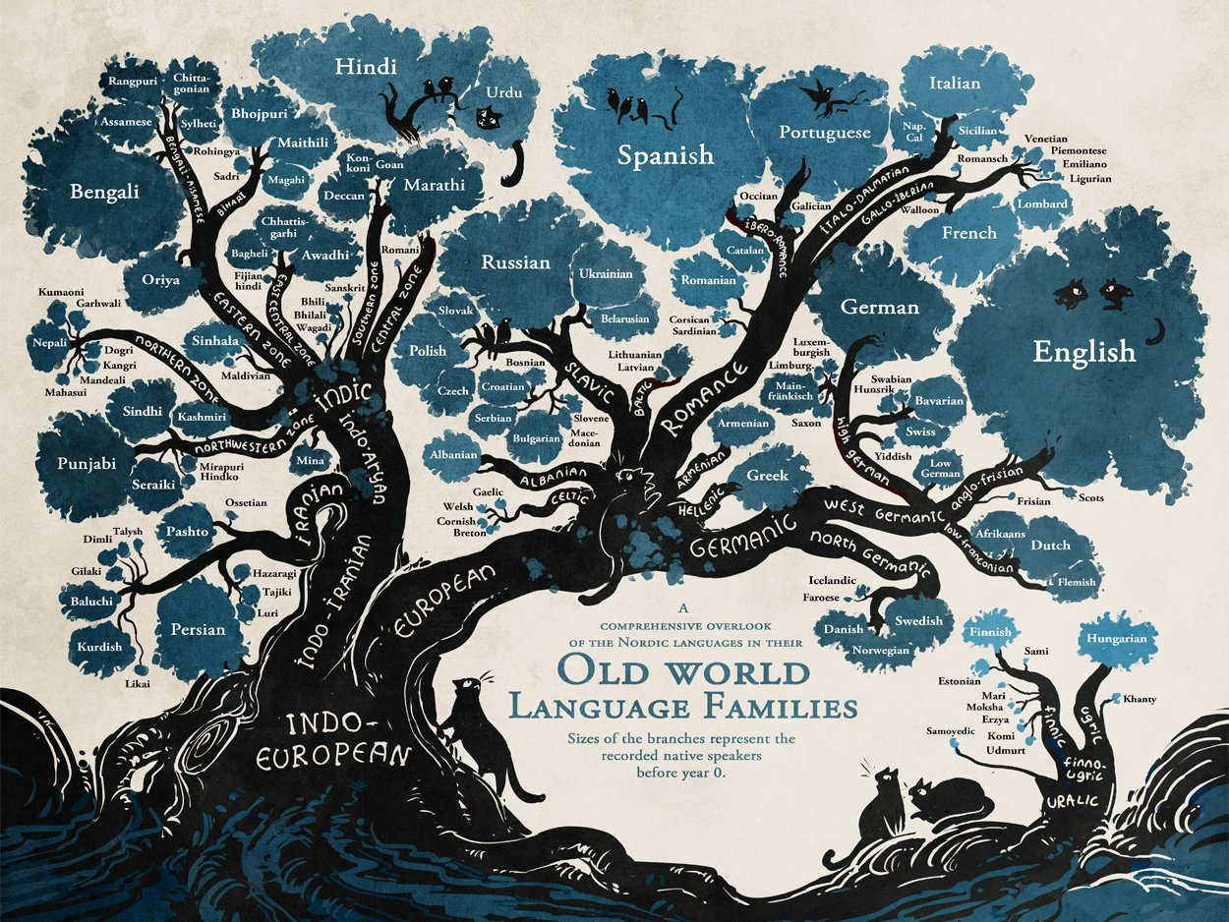
Key Idea:
Language is one of most important factors in maintaining local and national cultures. Globalization (the increasing interconnections between countries and cultures of the world) threatens indigenous cultures and their languages. Schools as well as all forms of media, from the Internet to magazines and newspapers, contribute to the loss of a language. When a family migrates from one country to another, their children attend school and are educated in the language of the country and not in their native tongue. In Indonesia, there are languages that are endangered—even though tens of thousands of people speak them—because children are being educated in the national Indonesian language instead of the language native to their region. Sometimes a country with many different regional languages adopts a lingua franca, a language that is informally agreed upon as the language of business and trade. For example, Hindi, Mandarin Chinese, and Swahili are used in India, China, and many countries of Sub-Saharan Africa, respectively, as lingua francas because of the great diversity of native languages spoken in each of these regions.
Language can also be a tool of separatism in a country. Many Basques in the Pyrenees Mountains of Spain speak Euskara, a language dating back to the pre-Indo-European era. The Basques’ steadfast insistence on retaining their language as an important part of their culture has kept it alive. Catalan, Gaelic, and Breton are just a few other localized languages that ethnic groups are striving to retain. Language can also serve as a potent unifier in a country of diverse ethnicities. In India, for example, the return to old Hindu place names signifies a resurgence of Hindu nationalism and a rejection of any lingering vestiges of colonialism.
A language may have several dialects or speech variants, which reflect the local region in which they are spoken. In the United States, English can sound very different depending on what part of the country you are visiting! These regional variations can be understood by other English-speakers and are based on differences in vocabulary and accent. Many Scandinavian languages are mutually intelligible meaning that a Norwegian can understand a Swede speaking in Swedish although they are two separate languages. Pidgin or creole languages are simplified mixtures of two or more languages that are adopted in areas of cultural diversity. Swahili is a pidgin language composed of various Bantu dialects and Arabic. Afrikaans, Haitian Creole, and Bazaar Malay are other creole languages widely used in other regions of the world today.

Religion
Religion is a dynamic cultural trait—a mentifact—that can identify, unite, or divide a group of people. The changing spatial patterns of religion over the centuries reveal wars, conquests, conversions, and revivals. See Figure 2 to review the distribution of major religions in the world today. Universalizing religions diffused throughout the world because of missionaries, while smaller ethnic and tribal religions tended to remain spatially localized in isolated areas unless the members themselves migrated.
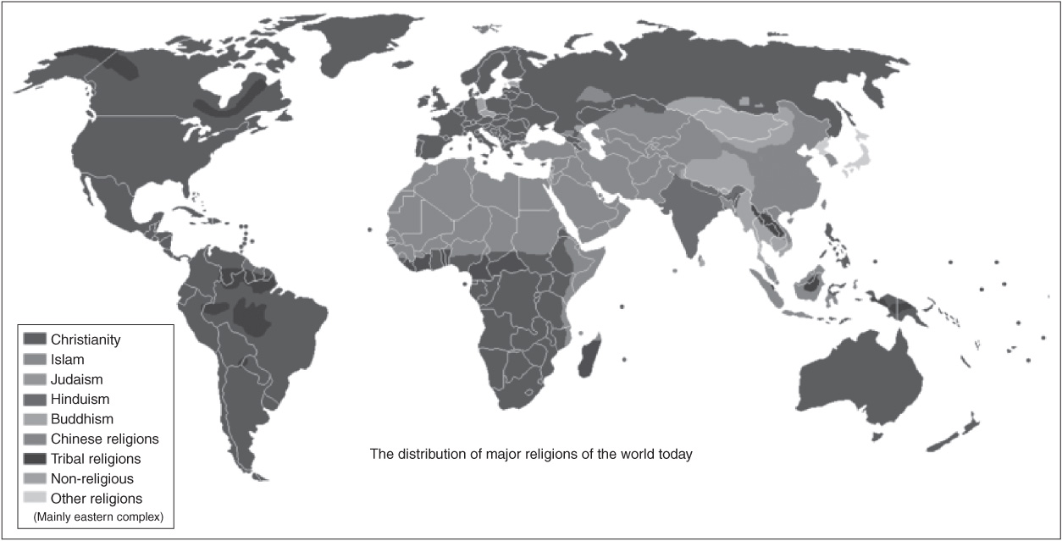
Figure 2 The Diffusion of major religions of the world today. Source: The Green Editor, Wikimedia Commons, 2008.
The six major world religions are Christianity, Judaism, Buddhism, Hinduism, Islam, and East Asian ethnic religions. Of course, there are many more religions practiced in the world today (Sikhism, Voodoo, Rastafarianism, Baha’i, etc.), but the first six mentioned are the ones you need to know for the AP exam.
Religions are classified in one of three groups: universalizing, ethnic, or traditional (tribal). A universalizing religionis one in which anyone can become a member. Christianity, Buddhism, and Islam are the three main universalizing religions. Their members actively proselytize, or seek new converts, by sending missionaries throughout the world to spread their beliefs. An ethnic religion is one that is a part of a particular ethnic or political group. Outsiders cannot join because they must be born into this ethnic group to practice the religion, although one can marry into an ethnic religion. Judaism and Hinduism (as practiced in India) are examples of ethnic religions. The third major grouping of world religions is traditional, or tribal religion. Traditional religions are ethnic religions that are practiced by small, local cultural groups. They are typically blended religions that combine the belief system of the ethnic group, tribe, or village, with animism and, perhaps, imposed religions. In Indonesia, for example, with its multilayered cultural landscape showing a rich sequent occupance (the process by which a landscape is gradually modified by a succession of occupying groups), there are numerous tribal religions being practiced but they are each classified under one of the many major religious groups and most show syncretism.
There are some other religious belief systems that you should also know for the AP exam. Animism, the belief that spirits (including ancestral) live within objects such as animals, rivers, rocks, trees, and mountains, is practiced in Malaysia, Africa, Australia, and by most indigenous groups throughout the world. Shamanism is a form of tribal, or traditional, religion that reveres a particular person, the shaman, as one with special healing or magic powers. Secularism is the rejection of all religious beliefs and is spreading rapidly in certain areas of the world such as Europe. For example, France and Italy possess large Roman Catholic majorities yet are secular countries where very few people attend church regularly. Secularism is on the rise in Europe. The European Union’s European Court of Human Rights forbids any religious symbols such as crucifixes, crosses, etc. on public school walls and calls them a violation of religious and educational freedom.
In the table below, you can see the approximate percentage of the world’s population who ascribe to each of the world’s major religions. Make sure you know which religions have the most adherents and where they live for the exam.
MAJOR RELIGION | PERCENTAGE OF WORLD POPULATION
Christianity | 33.32%
Roman Catholic | 16.99%
Protestant | 5.78%
Orthodox | 3.53%
Anglican | 1.25%
Islam | 21.01%
Hindu | 13.26%
Buddhism | 5.84%
Sikh | 0.35%
Jews | 0.23%
Other religion | 11.90%
Non-religious | 11.77%
Atheist | 2.32% (2007 est.)
Source: CIA World Factbook, 2010
Hinduism is the oldest major world religion; it arose in the Indus River Valley in Pakistan. This polytheistic (many gods) religion spread by contagious diffusion into the Indian subcontinent displacing native religions. Later, Indian traders spread Hinduism into Southeast Asia and the Indonesian island of Bali. Hinduism spread elsewhere in the world by relocation diffusion as devout Hindus moved for jobs and education. Today over 80 percent of the world’s Hindu population lives in India. One must be born into this belief system of hundreds of gods and multitudes of rituals to participate. Its caste system (social structure) strongly influences Indian society and traditionally dictates a person’s job, social standing, and even the foods some eats and clothing a person wears. The cultural landscapes of South and Southeast Asia are rich with displays of the ornate, colorful Hindu temples and shrines. Figure 3 is a good example of the elaborate carvings of gods that adorn Hindu shrines and temples. This is one of several towers that comprise a typical Hindu temple.
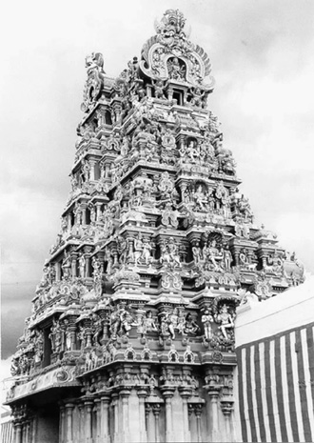
Figure 3 A Gujarat (ornamental tower) at the Hindu temple entrance in Madurai, India.
Judaism emerged slightly later than Hinduism, around 3000 to 4000 years ago, in the Mesopotamian culture hearth in Southwest Asia (the Middle East). Judaism is the oldest of the three main monotheistic (one God) world religions. Christianity and, later, Islam, were direct offshoots of Judaism; they also are monotheistic and share a Mesopotamian birthplace. All three regard Jerusalem as a sacred city. Judaism is an ethnic religion in which members are bound by a strict set of rules and dictates that include dietary restrictions. Religious persecution led to a diaspora (dispersion) of Jews throughout the world, but their homeland is Israel. The Jewish cultural landscape is understated compared to most other religious forms of architecture. Jewish temples are simple buildings, and their cemeteries are equally unremarkable.
Christianity began with the birth of Jesus, a Jewish carpenter, whom Christians believe is the Messiah promised by God. Christianity is a proselytizing religion because Jesus proclaimed God’s love and salvation to everyone, not just the Jewish people. The expansion of the Roman Empire throughout Europe spread Christianity throughout most of Europe by expansion and hierarchical diffusion. Later, relocation diffusion brought the faith to the New World at the hands of Spanish priests and conquistadores. The Protestant Reformation in Europe during the fifteenth and sixteenth centuries occurred as a rebellion against the excesses of the Catholic Church. The spread of the British Empire carried Protestantism into South and East Asia and the Pacific Islands, but India, China, and Japan proved resistant because of strong ethnic and cultural beliefs. Today, South Korea has a majority population of Protestants, but it is an exception in East Asia. Protestant missionaries spread their religious beliefs to Sub-Saharan Africa and Latin America, but traditional religions maintain dominance in much of Sub-Saharan Africa, and Catholicism has deep roots in Latin American culture. The cultural landscape throughout the world is greatly influenced by the diversity of Christian religious architecture. Cathedrals, Spanish missions, Protestant churches, and monasteries are some of the types to be found today.
Islam, the last of the three main monotheistic religions to be birthed, is based on the teachings of Mohammed, a prophet who followed in the footsteps of Abraham, Moses, and David. The Koran is the sacred book of Islam, and Muslims adhere closely to the strict tenets of the religion as stated in this course. The Five Pillars of Islam are (1) repetition of the Muslim creed, (2) prayer five times daily, (3) observance of Ramadan (a month of fasting), (4) almsgiving, and (5) a pilgrimage to Mecca before one’s death. Islam spread rapidly by expansion diffusion throughout Southwest Asia and into India after Mohammed’s death in A.D. 632. The Ottoman Empire helped disseminate Islam in Eastern Europe (Bosnia, Kosovo, Albania) as well. The Muslims conquered and ruled Spain for nearly 700 years until the Spanish, during the Christian Reconquista, regained control of Spain and expelled all Muslims in 1492. Islam spread by relocation diffusion into Southeast Asia, Sub-Saharan Africa, and the Western Hemisphere through trade and human migration. The two main branches of Islam are Sunni and Shi’ite with Sunni having 80 to 85 percent of the adherents to Islam. The cultural landscape of Islam revolves around the mosque—a center of worship that varies from a very simple, plain structure to one that is quite ornate and elaborate in design and decoration. Figure 4 depicts the Dome of the Rock in Jerusalem. This structure is the oldest Islamic structure still in existence today and is considered part of the sacred heritage of both Judaism and Islam.
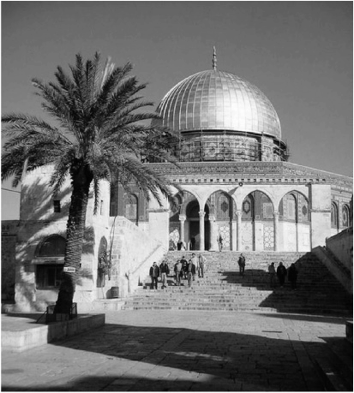
Figure 4 The Dome of the Rock is the oldest Islamic structure in existence in the world today. The site is sacred to both Jews and Muslims.
Buddhism is a non-theistic (no god) religion (some say it is a philosophy) that does not believe in worshipping gods but rather in seeking and discovering the truth for one’s self. Buddhism began in the sixth century B.C.E in present-day Nepal (then part of India). It is based on the meditations and teachings of Buddha (Siddhartha Gautama), the Enlightened One, an Indian prince who spent his life pondering the mysteries of life, death, and suffering. There are two main branches of Buddhism—Theravada (the oldest surviving branch) and Mahayana. Theravada is widely practiced in Sri Lanka and Southeast Asia while Mahayana (which includes Tibetan and Zen Buddhism) is found throughout East Asia. Contagious diffusion spread Buddhism throughout India. Monks and missionaries carried Buddhism to other parts of Asia. Buddhism slowly became reabsorbed into Hinduism, and it competed unsuccessfully with Islam in northern India. Buddhist temples, or pagodas, and stupas (shrines), as well as monasteries where Buddhist monks pray, meditate, and seek enlightenment color the cultural landscape in most parts of Asia. Statues of Buddha such as the one shown in Figure 5 are located throughout the cultural landscape of Asia today.
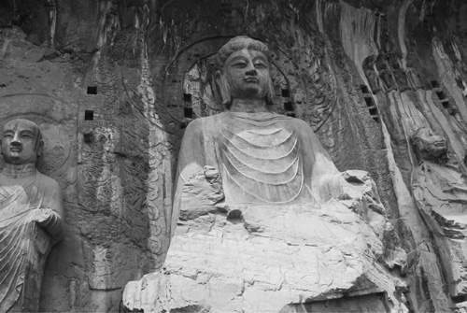
Figure 5 Buddha in Louyang, China (Longman Grotto).

East Asian Ethnic Religions
Buddhism merged with ethnic religions when it arrived in Asia. In Japan, the syncretism of Shintoism (traditional religion based on nature and ancestor worship) and Buddhism formed a special type of Buddhism. In China, Confucianism (system of ethics and family behavior) and Taoism (a philosophy based on living a peaceful life in tune with nature) blended with Buddhism to form a syncretic religion that combined elements of all three belief systems.

Ethnicity
Key Idea:
An ethnic group is a population that shares common roots based on culture, religion, race, language, or nationality. Race is not the same as ethnicity. Race refers to a group of people with a common biological ancestor. The members of a race have distinguishing physical characteristics that make them look different from members of other races. Since we all share a common ancestor, these racial differences have clearly evolved as humans spread out over the Earth and adapted to the different environments they encountered. Ethnocentrism is the belief that one’s own ethnic group is superior to all others.
Ethnicity is a very spatial concept. Ethnic groups have long migrated to other locations in search of a better future for themselves and their families. Geographer Wilbur Zelinsky used the term first effective settlement to refer to the first group—or charter group—of settlers to establish a new and lasting culture and society in an area. For example, the chief charter group to colonize the United States came from England, Ireland, Scotland, and Wales.
Ethnic homeland areas are areas that contain an ethnic group that seeks autonomy or self-rule. The Croatians, Slovenes, and Bosnians of Eastern Europe, and the Basques, Welsh, and Bretons of Western Europe are examples of ethnic minorities with their own homelands and very specific ethnic territories. An ethnic island is a small ethnic settlement centered in the middle of a larger group of the population. Ethnic islands of Germans exist in the Hill Country of South Central Texas and throughout much of western Ohio and eastern Illinois. Scotch-Irish ethnic islands are found throughout the Appalachian and Ozark Mountain regions of the United States. The cultural landscapes are imprinted with the architecture and symbolism of their rich cultural backgrounds. Ethnic enclaves are small areas of cities that are inhabited by a minority cultural group. Most large cities have ethnic enclaves and the toponyms (place names) may hint at the ethnicity of the original settlers even though the neighborhoods may not be strictly ethnic anymore. Chinatown, Polish Hill, and Little Saigon are just a few easily guessed ethnic enclaves but there are many more with toponyms that do not hint at the strongholds of immigrant solidarity that once occupied them. In Western Europe, ethnic enclaves of Muslims from North Africa live in highly segregated neighborhoods where they deliberately restrict contact with the host society (dominant culture group receiving minority group) as much as possible. When a charter group neighborhood reaches a critical number of minority inhabitants, the tipping point is reached and the charter group quickly leaves the neighborhood. A ghetto is an ethnic enclave where the residents are either voluntarily or forced to live segregated (separated) by race, religion, or ethnicity in a voluntary or sometimes, forced, manner.

Gender Roles
Men and women have different roles based on their culture. Throughout the world, cultures assign roles to people based on their gender (male or female). In Sub-Saharan Africa, a woman’s traditional role is to care for the old, the young, and the sick, while working in the fields to grow food, gathering firewood for cooking use, and fetching water. The man’s role is to converse with other men at length and work in fields growing cash crops or perhaps work at a job in the city for family income. Young women in many developing countries are expected to work to add to the family income, and many leave their homes and travel to other countries. As recently as the 1940s, big sisters in the United States worked in factories or offices to provide college funds for a younger brother. Gender roles change very slowly and usually with great difficulty. Societies construct identities for men and women based on the society’s cultural norms. “The woman’s place is in the home” is still a prevailing attitude in most regions of the world today. She may also have a place in the full-time workplace, however, and the multitude of roles she fills often is a source of family and societal stress.
Popular and Folk Culture
Popular culture (pop culture) refers to the ever-changing cultural norms associated with a large, diverse group of people who are very influenced by mass media, mass production, and mass merchandising. Examples of pop culture include McDonald’s, Michael Jackson, and Wii. Pop culture is widely distributed throughout the Earth because of the means of dissemination—the mass media.
Folk culture refers to a homogenous group of people with a strong family structure who follow a simple, traditional lifestyle of self-sufficiency and independence from the society’s cultural mainstream. The Old Order Amish are a folk culture in the United States (see Figure 1). Folk culture tends to be highly localized and clustered with little interaction with the main cultural group. Their material culture—physical items of culture such as furniture and clothing—differs greatly from that of mainstream American culture. Their nonmaterial culture—the intangible mentifacts and sociofacts such as customs and social behaviors—also differs greatly from those of most Americans.
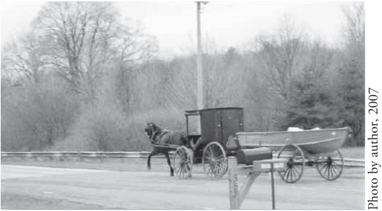
Figure 1 Old Order Amish going fishing in Pennsylvania

Cultural Landscapes and Identity
The cultural landscape is made up of the structures placed on the physical landscape by human activities or, how people arrange the physical space around them. It includes any change to the natural landscape such as roads, fields, cities, houses, bridges, etc. Sequent occupance is the concept that successive societies leave their cultural imprints on a place, each contributing to the cumulative cultural landscape. For example, the cultural landscape of Bolivia includes imprints from the early Incan civilization, and from the Spanish colonists who conquered them, and finally from the period after independence. Remnants of each of these successive cultures make up the cultural landscape of Bolivia today.
Key Idea:
Land survey methods for parceling out land to its occupants differ according to the charter group’s ethnicity in the United States and Canada. The English settlers to the original 13 colonies used the nucleated-village-and-outlying-farmlands method used in their native England. A central village (town) with a commons and meetinghouse was surrounded by farmlands worked by the villagers. From Pennsylvania south, the land was allocated by royal land grant. Natural boundaries such as rivers, trees, and large rocks marked land boundaries. This metes-and-bounds system led to numerous disputes whenever a boundary tree was uprooted by a storm! After independence from England, the United States adopted a rectangular-survey system with rectangular grid divisions to divide new land settlements. The French charter group in the Mississippi and St. Lawrence River valleys used the French long-lot system to give each settler access to river frontage and fertile alluvial soil while extending the long lots outward several acres to give them additional grazing and farm lands. Spanish colonists adopted the long-lot survey system wherever they settled, too.
In the United States, the chief settlement pattern of isolated farms scattered throughout the countryside has been based on the rectangular land survey system. The French and Spanish long lots encouraged settlers to live close together along the rivers or main roads. The towns and villages of the English charter group found in New England were adopted by utopian religious communities including the Mormons. Because of the extensive blending of cultures and assimilation of immigrants in the United States, the ethnic regions are less pronounced than in other world regions. For example, Basque houses are easy to pick out because of their dark green shutters, and blue, thatched-roofed Croatian homes are easy to identify in the Croatian countryside.
The types of housing built reflect the cultural identities of those who live there and also depend on environmental constraints. House construction materials (wood, brick, stone, mud, palm thatch, etc.) reflect the natural resources in the area and the climate and precipitation patterns. For example, houses in northern Europe typically have steeply slanted roofs to allow snow to slide off easily during long, cold winter months. In the regions of North America where cold, snowy winters prevail, northern European immigrants built similar houses. In the Yucatan Peninsula, Maya villagers use palm thatch roofing because it is easy to obtain and will withstand the frequent tropical storms by allowing violent winds to pass through unhindered. Although mass construction and pop culture are slowly destroying the regional diversity in US housing, you can still see the New England salt box, the Charleston single house (see Figure 2), and the shotgun house of the Deep South.
Figure 2 Charleston single house

Symbolic Landscapes and Sense of Place
Vernacular regions are popular regions named for the way people perceive them. For example, most people in the United States think of the Midwest as the region occupying the center of the country—a broad, rolling heartland of plains, grains, and livestock where people have solid, family values and a hard work ethic. When you say the South, they think of the states in the southeastern portion of the country and think about sunshine, tobacco and cotton, grits, and a slower way of life. Vernacular regions are based on a sense of place that people develop based on popular media images, books, and historical and cultural differences between regions.
Geographer D. W. Meinig believed that there were three symbolic landscapes in the United States, and he arranged them chronologically and historically. First in chronological order, Meinig described the New England village with its central village green, Protestant church, and meeting house. This landscape of religion and community laid the very foundations of American democracy from the seventeenth through the nineteenth century. Throughout the nineteenth century, Main Street represented the second symbolic landscape with its courthouse, banks, and retail establishments serving as the heartbeat of the Northeast and Midwest towns as they grew economically. The third symbolic landscape, Meinig believed, was the suburb of Southern California. He felt this defined the twentieth century with the family car, single-family dwelling, and the white picket fence with racial and class tensions left behind in the city.
Sense of place is the special perception we have of a certain place based on our feelings, emotions, and associations with that place. Placelessness is the loss of a place’s unique flavor and identity because of the standardizing influence of popular culture and globalization. As Walmarts and other “big-box” stores move into communities, the mom-and-pop small businesses are slowly phased out. On a global scale, the uniform nature of pop culture is smoothing out the cultural individuality between groups and results in a different material and nonmaterial culture from the folk and ethnic ones that were first in place.

Impact of Culture on the Environment
Both popular and folk cultures have an impact on the physical environment. Popular culture is usually imposed on the environment in a uniform fashion while folk culture seems to evolve naturally out of the physical surroundings of the culture group. For example, fast-food restaurants impose a “like image” on the built environment (the material culture of an environment) that is easily recognizable no matter what country you are visiting. McDonald’s “golden arches” are present in every country in the world, and even though the menu is culturally modified to suit the host society, the architecture is fairly uniform. The negative impact of culture on the environment is increasingly evident as whales are overfished because of cultural food preferences, and fur-bearing animals are overharvested for their valuable furs. Both popular and folk culture can pollute the natural environment. Pop culture creates a lot of waste that is not always biodegradable (able to decompose) such as Styrofoam containers and plastics. Folk cultures can also harm the natural environment by soil overuse, erosion, and overhunting some species of animals.

Rapid Review
Culture is a combination of material artifacts, values, and political traditions. Language, religion, and ethnicity are cultural values. Human geography is interested in how these values are distributed and diffused spatially throughout the various regions of the world.

