Blank Central America Map
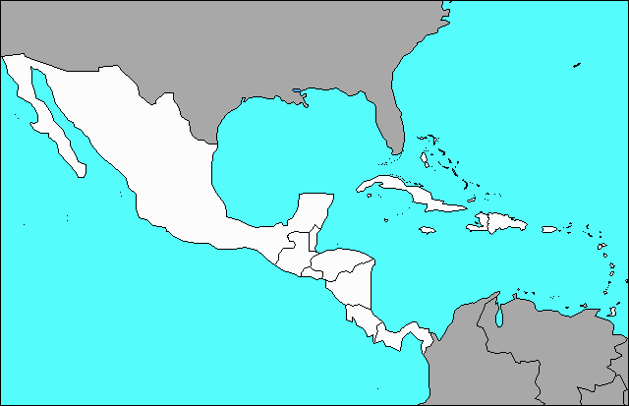
Bahamas El Salvador . Mexico Belize Guatemala Panama Costa Rica Honduras Cuba Puerto Rico Haiti Nicaragua Dominican Republic Jamaica

