Name _____________________________________ Date ____________ Class ____

WORLD HISTORY/CHAPTERS 4 & 8 / EARLY CIVILIZATIONS OF INDIA& CHINA
VOCAB WORDS | DEFINITIONS
Subcontinent | A large landmass that juts out from a continent
Monsoon
Caste
Citadel
Rajas
Dynastic Cycle
Feudalism
Moksha
Reincarnation
Karma
Dharma
Ahimsa
Nirvana
Yoga
Middle Way
Dissent
Court
Golden Age | A period of great cultural achievement
Mandate of Heaven
Dynastic Cycle
Civil Service
Philosophy
Filial Piety | RESPECT FOR ONE’S PARENTS!!!
Acupuncture
Ch. 3 SECTION 1 | CITIES OF THE INDUS VALLEY
Geography of the Indian Subcontinent | - India is a large landmass that is part of a content called a ______________________________ and includes three major geographic regions  - Includes today’s countries of India, Pakistan, Bangladesh, Sir Lanka, Nepal, Bhutan  - It has three major rivers: Indus, Ganges and Brahmaputra  - Heavy rains add to its fertility with seasonal winds called ______________ bringing rain  2. Mountain ranges include:
Indus Valley  Civilization | - Earliest civilization a mystery/emerging in Pakistan about 2500BC  - This civilization flourished for about ______ _ years then _______________ without a trace  - We know little about this large civilization  - It was first discovered in the 1920’s
Well Planned Cities  of Harappa & Mohenjo-Daro | - The most striking feature was it was so ________________________  - Houses even had ________________________ with baths, drains and water chutes that led into _____________________  - They had a well organized ____________________________  - ______________________ leaders, perhaps priest –kings and tens of thousands of ___________________________
Farming and Trade | - Most people are _________________ and they grew a wide variety of crops  - Some people were ________________________ of cotton, cloth, grain copper etc  - Contact with Sumer may have stimulated them to develop their own system of writing
Decline and  Disappearance | - In 1750 BC we see a decline in the quality of life in this region…Why?  - damage to local environment 2. ________________________  3. ________________________ 4. ________________________
Vedic Period:  The Aryan Civilization | - Aryans (term meaning noble) were among many Indo-Europeans (refers to a related family of languages in Europe and Asia) to migrate here seeking water and pastures  - Most of what we know comes from the ____________, a collection of ____________, ___________________ and other religious teachings  - Aryan priests memorized and recited the ___________ for a 1,000 years before they were _____________ __________  - Aryan warriors were nomadic herders who valued ________ and even when they settled into farming wealth was still measured in _________
Aryan Society | - Divided people by occupation: had four classes of people or _____________  - Three basic groups were  1. ___________________ 3. _________________________  2. ___________________ later 4. Sudras who were __________  - Later class divisions reflected the social and economic roles more than ____________________ differences between Aryans and not Aryans  - As these changes occurred they gave rise to a more complex system of _________________ or social groups into which people are born and which they cannot change
Aryan Religious  Beliefs | - ___________________ worshiping gods and goddesses that embodied natural forces such as sky, ________________, storm, and fire  - Sacrifices of ________________and _________________ were offered  - Over time some began believing in a single god called _____________ that resided in all things
Expansion &  Change | - Aryan tribes were led by chiefs called __________________  - They were skilled war leaders and elected by an assembly of warriors  - He ruled with the advice of a ______________ of elders
From Nomads to  Farmers | - They gradually gave up their nomadic ways and settled into ________  - By 500 BC a new Indian civilization emerged consisting of many ______________________  - Because of the blending of the cultures the people shared a common ___________ rooted with both _____________ and ___________traditions  - Their written language was called __________
Epic Literature | - Aryans preserved a strong oral tradition, memorizing and reciting hymns and epic poems
 | - HINDUISM
The Beliefs of  Hinduism | - Hinduism, which claims about 800,000 million practitioners worldwide, is unique among humanity’s major religions in that it cannot be traced to any specific individual or historical event  - Scholars believe that Hinduism arose about 3,5000 years ago out of interactions between Aryans and Indus Valley people
Beliefs  Beliefs continued | - Hindu means ___________________________  - Because Hinduism arose from no single person or institution, it is seen an eternal & unchanging in its essence. Believers regard it as having existed forever
Many Gods –  or One?  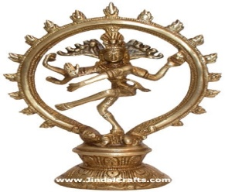 | - Key feature: all the universe is part of the unchanging, all powerful spiritual force called Brahman  - Because Brahman is too complex and powerful a concept for most to understand they worship a variety of gods that give concrete form to Brahman  - Each represents aspects of Brahman each god may take on many forms & has its own family
Sacred Texts | - Over several Thousand years Hindu teachings have been recorded in sacred texts such as the _______________ and ______________
The Goal of Life | - To Hindus, every person has an essential self or ____________ which is another name for ____________________  - The ultimate goal of existence is to achieve _____________ or union with Brahman  - To do this one must free themselves from _____________ _________ that separate them from brahma.  - Usually it takes many life times to achieve ____________________  - The Hindus believe in _____________________ or the rebirth of the soul in another bodily form which allows people to continue working toward moksha through several lifetimes
Karma and  Dharma | - In each existence Hindus believe a person can come closer to achieving moksha by obeying the law of _____________________ which refers to all actions of a person's life that affect their fate in the next life  - All existences is ranked  - __________________ come closest to the Brahman then ____________, _________________, and ________________________________  - If you live a virtuous life you can be reborn at a higher existence but if you do evil then you will acquire _________ __________ and be reborn into suffering  - Hinduism stresses the importance of ______________ or ones religious and moral duties and they vary according to class, occupation, gender or age. By obeying ones _______________ a person acquires merit for the next life.  - To Hindus, all people and things are aspects of Brahman and should therefore be respected. And try to follow a path of __________________ or nonviolence  - People may also meditate or silently reflect upon the world and nature  - To help meditate some also practice a series of physical and mental exercise called __________ to help teach people how to focus their bodies and minds  - Some may go on Pilgrimages to sacred places like the Ganges River which they believe will purify them and remove bad karma
 | - BUDDHISM
Buddhism:  How it began  Early Life | - _________________________________: the founder of Buddhism  - born about 566 BC to a high cast family.  - A prophet predicted he would become a wandering ______ _______  - To prevent this, his father his father kept him in the palace walls surrounded by comfort and luxury.
The Search  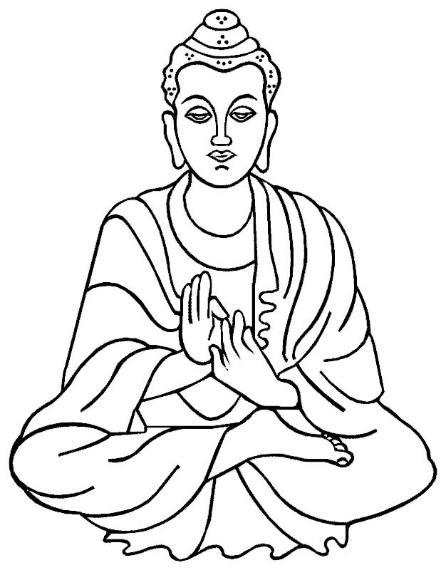 | - Gautama rode outside the palace walls seeing for the first time a sick person, an old person & a dead person  - For the first time he became aware of _______________  - Disturbed, he left the palace setting out to discover the realm of life where there is neither suffering nor death  - He wondered for years, seeking answers, fasting and _____________  - Determined to understand the mystery of ______________ he meditated for48 days Gautama rose and was now the ____________or ____________
The Four Noble  Truths | - Four Noble Truths stand at the heart of Buddhism  1. All life is full of ___________________ and ________________  2. The cause of suffering is the desire for that are illusions and negative deeds and mindsets such as hatred and desire_  3. The only cure for suffering is to overcome desire  4. The way to overcome desire is to follow the ______________ _____ ___________________________  - You must understand the Four Noble Truths and follow the Eight Fold Path along with living a moral life, avoiding evil words and actions  - The Eight Fold Path advises people to follow a __________________ ______________ or to live in moderation  - Through meditation a person may achieve “____________________”  - One’s final goal is achieving ______________________________
The Eight  Fold Path | 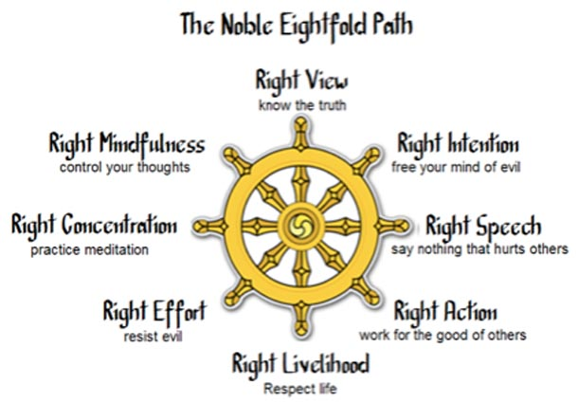
Buddhism & Hinduism  Shared Traditions | - Both grew out of the traditions as _________________________  - Both stressed non ______________________________  - Both accepted the laws of ______, dharma and the cycle of rebirth
Differences | - Buddhism rejected priests, formal rituals and the many ___________ of Hinduism. Buddha urged each person to seek enlightenment through meditation  - Buddhism rejects the ______________ offering hope of nirvana to all
Sacred Texts | - After Buddha's death his followers collected his teachings into a sacred text called the __________________ or ______________
Spread of  Buddhism | - Buddha attracted many disciples who set up monasteries to study meditation and centers of learning will spread into Asia but decline in India
Two Sects | - As missionaries spread Buddhism across India & Asia two major sects developed  - ________________________Buddhism: closely followed the Buddha’s original teachings, it required a life devoted to hard ____________ with only the most dedicated able to maybe reach ______________________  - ________________________Buddhism sect made Buddhism easier for ordinary people to follow. They pictured him and other holy beings as _______ ___. People turned to these gods for ________ The afterlife as a filled with _____________________
 | POWERFUL EMPIRES OF INDIA
The Maurya Empire | - Had schools and libraries and splendid palaces and temples
Chandragupta | - Chandragupta first gained power in the _________________ and conquered northern India  - The dynasty maintained order through a well organized ____________ building roads and harbors and collected taxes and manage factories  - Chandragupta's rule was effective but ___________ with secret police who reported crimes and __________________ any differing or opposing ideas  - Had specially trained _______________ to guard his palace
Asoka | - The most honored Maurya emperor was Chandragupta's grandson ________  - After a bloody war, horrified by the slaughter, over _______ dead, he turned his back of further ____________ and converted to _________ and rejected _____________ and resolved to rule by _____________  - He became a _______________ and sent out ____________ or people sent on a religious mission to spread _________________________  - His rule brought _____________ and ________________ to the land and helped to _____________ the diverse people of the empire
Golden Age of  the Guptas | - The most powerful Indian state was the _______________ who united much of India  - They organized strong central _________________________ that promoted ______________________ and __________________  - This was considered the ________________ or period of great cultural achievements and was a time of peace and prosperity
Advances in  Learning | - Students were educated in ____________ _____________ but learning was not limited to religion  - Advances in ______________________ with devising a simple system of _______________ we still use today called __________________ numerals because it was ____________ who carried them from _____________ to the ______________________  - Originated the concept of _________ and developed the ___________ with numbers based on ______  - They performed simple __________________ and ______________ people against __________________
 | INDIAN SOCIETY AND CULTURE
Complex Caste  System | - Many rules and customs influence Indian society  - Society was dived into four occupational classes with Non-Aryan's considered ______________ and held the __________
Many Castes | - Many additional castes and _________________ evolved as invaders were absorbed into the society  - By modern times there were hundreds of _____________ and thousands of _____________________
Complex Rules | - Castes were closely linked to the Hindu beliefs with people in different castes were different _____________________________  - The high caste ________________ were purer and closer to ____________  - To ensure purity there were rules to govern every aspect of life and one may not __________________ outside ones caste or __________ with other outside the caste  - The lowest rank was the _________________ who were restricted the impure jobs and were forced to live apart from everyone else
Effects | - Despite inequalities the caste ensured a stable ___________ _______  - People knew they could not change their status in life but could reach a higher state in a future life by fulfilling the duties of their ________ _____________
 | EARLY CIVILIZATION OF CHINA
Geographic  Barriers | * An isolated civilization made up of long distances and physical barriers  contributing to the belief that China was the center of the earth  - West & Southwest are mountain ranges:____________________ ____________________________________  2. To the north is the _____________ desert  3. To the east is the _____________________________________  * fertile soil, temperate climates contributed to it’s growth & development
River of Sorrows | - The Huang H or Yellow River got its name from the Loes or fine windblown yellow soil  - Called the River of Sorrows because the loess settles on the river bottom which raises the ______________ causing it to flood and devastate the area
 | SHANG DYNASTY
Shang Dynasty  Begins | Shang Dominate China from about 1650 to 1027 BCE. During which Chinese civilization takes shape
Government | - Ruled by strong kings surrounded by a __________________ or gathering of wealthy nobles who performed rituals intended to strengthen the kingdom and keep it safe  - Kings appointed governors to rule distant regions  - Largely an agricultural society with farmers called up to fight when needed
Religious Beliefs  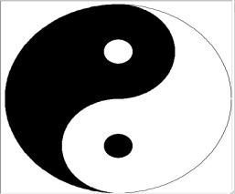 | - Maintained a complex beliefs with many gods and nature spirits but also believe in ancestor veneration, ancestors can talk to gods for you  - Chinese believed the universe reflected a delicate balance between two forces ________________ and _________________  - _______________ was linked to the earth, darkness and female forces  - ______________________ stood for heaven light and male forces  - A well balanced universe depended on maintaining balance between ____________________ and ________
The Difficult Study of Writing  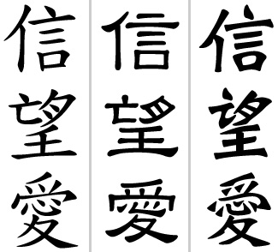 | - Written Chinese took shape almost 4,000 years ago  - Chinese system of writing used both _________________________ and ______________________, signs that expressed thoughts or ideas  - It evolved to include tens of thousands of characters  - Each character represented a ______________ or ______________ and was made up of a number of different strokes  - Chinese writing remains one of the most difficult languages to learn having up to __________________ characters while English or Arabic contain only a couple of dozen representing basic sounds  - People in different parts of China often could not understand each other but they did all use the same
 | THE ZHOU DYNASTY
The Zhou Dynasty begins | - The Zhou people overthrew the Shang in 1027 BC and set up a dynasty lasting until 256 BC
The Mandate  from Heaven | - ___________________________________________ or divine right to rule  - Because of the cruelty of the Shang king it was declared that because he treated the people so bad the gods sent ruin on him  - The Mandate of Heaven was passed the ________________ who treated the multitude of people well  - Dynastic Cycle was the _________________________________________  - Floods, famine and other catastrophes were signs that a ____________ had lost the favor of ___________  - This would result in new leaders seizing power and setting up new dynasties
Feudal State | - Zhou rewarded their supporters by granting the control over different regions  - ______________________ was a system of government in which local lords governed their own lands but owed military service and support to the ruler
Economic Growth | - Iron working arrived about ____________ enabling farmers to _____  - Commerce expanded too  - Chinese began using _______________________ for the first time making ______________easier  - Economic expansion led to an increase in ___________________  - Feudal nobles expanded their territories and encouraged __________ to settle in the _________
Chinese Achievements | - Astronomers studied movements of the _________ helping them to develop an accurate ___________ with 365 1/2 days  - By 1,000BC the Chinese discovered how to make _____________from the cocoons of _______________________________  - Only ________________________ could afford robes make from silk  - Under the ______________the Chinese made the first ______
 | PHILOSOPHY AND RELIGION IN CHINA
Wisdom of  Confucius  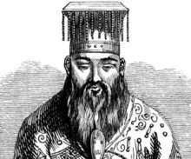 | - _________________________ was born 551 BC to a noble but poor family  - Was a brilliant scholar & tried to become an adviser to a local ruler but couldn’t find a permanent position so he turned to teaching  - His reputation for wisdom grew and attracted many students  - His sayings were collected by his students in the _____________________  - He took little interest in religious matters  - He developed _____________________ or system if ideas concerned with worldly goals .Especially how to ensure ____________ _
Five Relationships | - Confucius taught that harmony resulted when people accepted their place in society  - He stresses maintaining Social Order or order in society  - Except for friendship, none of these relationships is equal, (father/son, ruler/subject)  - Everyone had ____________________ and responsibilities  - Correct behavior would bring order and stability  - Confucius put _____________ ____________Or respect for parents above all other duties  - Other duties include ______________,
Government | - Rulers had responsibility to provide _______________________  - In return, people would be ___________ and _____________ subjects  - The best ruler was a ____________________ one who led people by good ____________  - Government officials should be well
The Spread of  Confucianism | - After his death Confucius ideas influenced every area of Chinese life from the choosing of scholars and _____________________ to reverence for _______________  - Close to a _________ of the world’s population came under its influence
Harsh Ideas  of Legalism | - A harsh philosophy grew from the teachings of ______________, who died 233 BC called _____________________________  - He felt the nature of man was ______________ And goodness was acquired  - Felt that ______________was the motive for most actions and caused most of the _________________  - The only way to achieve order was to pass strict _____________ and impose harsh ______________ not goodness was a ruler’s greatest virtue  - Many feudal rulers chose ____________ as the best way to keep order  Legalists ideas forced people to work on government projects and  punished those who don’t do their duties
Daoism:  The Unspoken Way | - Founder of Daoism was _________________or ____________  - Concerned was with living in _______________ with ______________ and rejected ______________ and strife with many turning away from society and living as hermits, ____________ or __________
Government | - Daoists view government as _________________ and therefore cause many problems  - Best government is one that
 | STRONG RULERS UNITE CHINA
Shi Huangdi | - He spent 20 years conquering most of the warring states in Zhou China to end its divisions  - He centralized power with help of ____________ advisers and built a strong authoritarian _____________ of the Qin dynasty
Unity Imposed | - Emperor Shi Huangdi abolished_____________________________  - He replaced feudal states with 36 _________ _________  - He sent inspectors to ___________ on local officials and report back to him  - Still peasants had to pay high ______________ to support armies and _________________  - To promote unity he standardized ____________ and _____________ , and replaced Zhou coins with ______________________ coins  - Writing became uniform and workers repaired and extended _______, canals to strengthen transportation
Crackdown  on Dissent | - Shi Huangdi moved harshly against critics  - They were ____________, ____________ or killed. He also had a ruthless campaign of _____________ burning and ordered destruction of all works of literature and ______________ burned, only books on______________ and______________ were allowed
The Great Wall  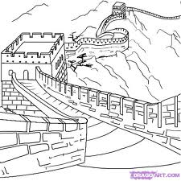 | - Shi Huangdi’s most remarkable & costly achievement was the ______ __________________________________  - It took hundreds of thousands of labors years to build the _______ foot height wall topped with a wide brick _________________  - The wall was thousands of miles long and while it did not keep out invaders it did become an important symbol to Chinese people
The Han Dynasty | - As emperor _____________ took the title of ____________________  - He continued efforts to unify ____________, lowered taxes and eased some of the harsh _____________ polices thus creating a strong foundation for the ___________ dynasty
Emperor Wudi | - Most famous Han Emperor was __________  - He strengthened the government and the ______________ as well as chose Confucian men of wisdom for officials  - He improved ___________________ and ______________  - Wudi imposed a government ______________ or complete control of a product or business by one person or group, on iron and _____  - Wudi followed a policy of ______________ by increasing the amount of territory under Chinese rule and encouraging settlers, soldiers and traders to spread Chinese culture
Silk Road  to the West | - Wudi opened up a trade route linking China with the west that would become known as the _________________________________  - Eventually the road would stretch for __________miles linking China to the ________________ ________________
Civil Service  Examination  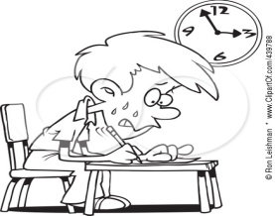 | - Han emperors made ____________________ the Belief system of the state  - Han emperors adopted the idea that government officials should win positions by ___________________ rather than through family background  - To find the most qualified officials, they set up system of _________ but to pass candidates had to study _______________________  - Typically only those who could afford years of study could hope to succeed  - Because of filial piety and the superiority of men ____________ were kept from taking the exam so government jobs were forbidden to ____________  - The civil service exam put well trained men into every level of the government
Collapse of the  Han Empire | - Over time the Han dynasty declined, the emperors could no longer control powerful ____________________________ or local military rulers  - Roads and canals fell into disrepair, heavy taxes pushed peasants into ____________________________  - Finally in 220 AD the Han emperor was overthrown and broke into several_________________ and invaders poured over the
Science | - The Han period was one the _____________________________ of Chinese civilization when they made many advances in many fields  - Han scientists wrote texts on _____________, zoology,_____________etc  - Astronomers observed measured movements of stars, planets enabling an improved calendar & timekeeping devices
Medicine | - Physicians diagnosed diseases, experimented with herbal remedies  - ___________________ was when doctors inserted needles under the skin a specific points to relieve pain or treat some illnesses. Restores balance of and
Technology | - In its time, Han China was the most technologically advanced civilization in the world  - Some advances were  - Paper 5.__________________  - advanced methods of shipbuilding 6.__________________  - invented the _______________ to steer 7.__________________  - bronze and iron ________________ 8._________________
Looking Ahead | The Han united China and created an empire about the same size as the _______  - They established a system of government that would survive until 1912

Confucius Sayings
- I hear and I forget. I see and I remember. I do and I understand. ________________________________________________________________________________________________________________________________________________
- If you enjoy what you do, you will never work another day in your life. ________________________________________________________________________________________________________________________________________________
- Our greatest glory is not in never failing but in rising every time we fall. ________________________________________________________________________________________________________________________________________________
- A fool despises good counsel, but a wise man takes it to hart. ______________________ ________________________________________________________________________
- Silence is a friend who will never betray. ______________________________________ _______________________________________________________________________
- The journey of a thousand miles begins with a single step _______________________ _______________________ ________________________________________________
- Without learning the wise become foolish by learning the foolish become wise _______________________________________________________________________________________________________________________________________________

Advancements in India | Advancements in China
- ______________________________  - ______________________________  - ______________________________  - ______________________________  - ______________________________ | - _______________________________  - _______________________________  - _______________________________  - _______________________________  - _______________________________

 | Hinduism | Buddhism
Founder
Goal Of Life
Sacred texts
Basic Beliefs | ____________________________  ____________________________  ____________________________  ____________________________  ____________________________  ____________________________  ____________________________  ____________________________ | _______________________________  _______________________________  _______________________________  _______________________________  ________________________________  _______________________________  ________________________________  ________________________________

Mandala (Sanskrit: lit, circle) is a spiritual and ritual symbol in Indian religions, representing the universe. In common use, mandala has become a generic term for any diagram, chart or geometric pattern that represents the cosmos metaphysically or symbolically; a microcosm of the universe. Buddhism, mandalas have been developed into sand painting

