Industry and Development

Introduction:
As countries have evolved since the start of the Industrial Revolution, increased industrialization has been an indicator of a higher level of development. However, in recent years industrialization has reached countries in Asia, Latin America and Africa, but the development in the standard of living has not followed. It is better to view industrialization and development as two separate entities that has a spatial relationship. Industry may bring in jobs and outside revenue, but the question is who makes the money from such an arrangement? In a country like China there are billions of dollars in international investments, but there are regions of China where people have never seen a television or car. Another question is which is better? Is life improved with the introduction of these modern luxuries, or does it just create additional problems?
Essential Questions:
- What is the difference between development and industry?
- How did the Industrial Revolution change the world?
- How are theories of locational interdependence applied throughout the world?
- How do levels of development and industrialization differ around the world?
- What are the unintended side effects of development and industrialization?
- How does the development of opportunities for women differ from that of men?
Development can have any number of definitions, so the United Nations created the Human Development Index based on specific healthcare, education and economic indicators. According to these specific measurements, countries such as Norway, Australia and Sweden have the highest levels of development and countries such as Afghanistan, Zimbabwe and Mozambique are among the lowest. Do these numbers match up to the industrialization level within those nations? Almost always. Countries with post-industrial economies, those in which most people are in service sector jobs, are ranked towards the top of the HDI. Countries with industrial or pre-industrial economies, where people either work in industrial or agricultural jobs, are on the lower end of the HDI ranking

Lesson 1: Development Around the World
Intro to Development
- Development is a term used to explain the standard of living in any particular location or country. In order to be considered developed, a country must provide for and support the social, educational, economic and human rights of their citizens.
- The concept of industrialization, or the change in economic activities from basic goods to mass-produced goods (through the use of machinery and technology), is directly correlated to development
  - Countries that are pre-industrial are normally not highly developed and those that have moved past manufacturing (post-industrial or service-based) are highly developed.
  - You will recall from earlier units, that economic activities are divided into sectors:
    - Primary (raw materials directly from the earth), Secondary (industry and manufacturing) and Tertiary (service-based) are the main sectors of economy
      - In service-based countries with very developed international economies, there are sub-sections of the third economic sector - Quaternary (non-tangible business service jobs) and Quinary (management level positions within consumer services)
Categorizing Countries of the World
- MDCs (More Developed) vs. LDCs (Less Developed or Developing Nations)
  - Some Newly Industrializing Countries (mostly Asia and Latin America - Mexico, Brazil, Vietnam and the Philippines) are going through compressed modernity) are going through compressed modernity
    - Moving from agriculture to industry at a great speed due to democracies, growing economies and aid from non-government institutions
    - They are aided by the lessons of countries that went through the stages of development before them
- Wallerstein's World-System Theory (Capitalist World Economy Model) created a core-periphery model in the 1970s that compared countries to each other based on their importance and power internationally
  - The power can be economic, military, social, etc.
    - Core - Europe, Japan, US , Canada, Australia, New Zealand (includes the major cities of the world)
    - Semi-periphery - Chile, Brazil, India, China, Indonesia
    - Periphery - Sub-Saharan Africa, some South American and Asian nations

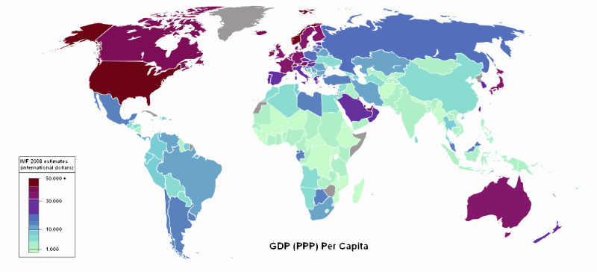
Indicators of Development
- UN Human Development Index (HDI) compares three indicators to rank countries around the world (a perfect score does not exist, but would be a 1.0)
- Standard of Living (the measure of wealth a person enjoys):
  - Gross Domestic Product (GDP) (value of a country's total output of goods and services within the borders of that country in one year) divided by the total population (per capita)
  - Gross National Product (GNP) is the value of all goods for a country's companies in one year internationally and domestically
  - Gross National Income (GNI) is the GNP + exports – imports, this shows the economic balance of trade
  - Gini coefficient – a measurement that shows the differences between the rich and poor within a country
  - Economic sectors - In MDCs people are mostly employed in the tertiary (service) sector and in LDCs they are mostly in the primary (agricultural) sector
  - Productivity (value compared to labor) is higher in MDCs and the value added (basic goods or crops taken through technological process to add value to the object) are much higher
    - Raw materials are more accessible (water, minerals, oil)
    - Availability of consumer goods (non-essentials)
    - An increased amount of expendable income, money left after the bills are paid
  - Access to Education:
    - Literacy rate (percentage of a population that can read and write)
    - Years of schooling
    - Student/teacher ratios (these numbers are much higher in LDCs)
  - Healthcare and Longevity:
    - Life expectancy
    - Infant mortality is an important factor to determine the growth of a nation (this is much higher in LDCs)
    - Rates of Natural Increase (RNI) are higher in LDCs
    - Crude death rates are different because they are similar in MDCs and LDCs
      - LDCs due to lack of medicine and education
      - MDCs due to large elderly population
  - Gender Equity is an important measure that does not necessary follow the patterns of MDC/LDC (there is a separate measurement for gender equity)
    - Women have less educational opportunities than men in most LDCs and some MDCs
  - The highest levels of HDI are located in Oceania, North America and Western Europe – regions such as Latin America and East Asia are considered above average and areas such as South Asia and Sub-Saharan Africa have lower scores

Lesson 2: Gender Development
The United Nations has created two main measures for gender inequity (GII and GDI)
  - The Gil has become the only active measurement for gender used by the United Nations
- Gender Inequality Index
  - Gender Inequality Index (GII) measures the opportunities provided to women
    - The term inequality is used because no country in the world has a completely equal society for women
    - There is not a country with a perfect score, but that number would be zero, meaning no difference between the treatment of the genders
  - There are three indicators for the GII:
    - Empowerment (the ability of women to improve their own life politically and economically)
    - Percentage of seats held by women in the legislature (giving women the chance to enact change)
      - 25% in Northern Europe, 10% in MDCs and 5% in LDCs
    - Percentage of women who have completed high school
      - Very high 90%s in MDCs and 80% in LDCs
    - Labor market (the opportunity for women to find gainful employment outside the home)
      - Female participation rate in the labor force (giving women the ability to earn and contribute to the economy)
        - 75% in MDCs and 65% in LDCs
          - Interestingly in the lowest ranked LDCs (Sub-Saharan African countries) more women work outside the home than other LDCs (at the same rate as MDCs)
    - Reproductive (access to healthcare and reproductive services)
      - Maternal mortality rate (number of women who die in child birth – per 100,000 births)
        - 15/100,000 in MDCs and 140/100,000 in LDCs
      - Adolescent fertility rate (number of births to women aged 14 to 19 – per 1,000 women)
        - On average, the earlier a woman has children, the less likely she is to receive further education
        - 20/1,000 in MDCs and 60/1,000 in LDCs
- Gender-Related Development Index (GDI)
- Gender-Related Development Index used the same indicators as the HDI (a perfect score does not exist, but would be a 1.0)
  - Standard of living, access to education, and healthcare and longevity
  - It measures the level of development overall and then the level of women compared to men
  - A high score means high development and a small difference between genders and a low score means low development and a large difference between genders
  - Since 1970 the gap has been closing
    - Reduced by ¾ in LDCs and ¼ in MDCs
- Some national scores include the US and Canada have scores the 90%, China in the 70%, India in the 60% and Kenya in the 50%
GDI Indicators
- Average income gap (and GDP ) in MDCs is at a lower percentage then in LDCs - although it seems higher because of the amount (30% or about $15,000)
  - (US women make .78 cents on the dollar that men make - $46,000 average income)
  - (Niger women make .50 cents on the dollar that men make - $240 average income)
- Education gaps are higher in LDCs
  - 99/100 girls in secondary school in MDCs - 60/100 in LDCs
  - Literacy rates are universally high in North America/Western Europe/Oceania
    - Universally a little bit lower in Latin American and Asia
    - The Middle East and Sub-Saharan Africa have the largest gaps in literacy between boys and girls
      - These areas also have the largest difference in female/male school enrollment
    - Life Expectancy is the only measure in which women have the advantage and the difference is greater in MDCs (women live 5-6 years longer on average) than in LDCs (women live 1-2 years longer)
      - Any LDC country with the same life expectancy for men and women will not have good healthcare and will have high maternal mortality rates
United Nations Millennium Development Goals
- In 2000, the United Nations agreed upon eight goals, which all members would work to achieve by 2015:
  - Eradicate extreme poverty and hunger
  - Achieve universal primary education
  - Promote gender equality and empower women
  - Reduce child mortality
  - Improve maternal health
  - Combat HIV/AIDS, malaria, and other diseases
  - Ensure environmental stability
  - Develop a global partnership for development

Lesson 3: Development in the LDCs
Development in the LDCs
- LDCs are desperately attempting to catch up, but the development gap is widening with MDCS continuing to develop at a faster rate
  - There is uneven development between and also within countries of the world
- Some geographers and economists argue that the world will continue to keep the LDC nations down ( structuralist theories ) because they cannot catch up to the resources or abilities of MDCS
  - This idea falls in-line with the dependency theory, which suggests that LDCs will remain dependent on foreign investment and economic deals that benefit MDCs
  - Some geographers argue that this is neo-colonialism, meaning that although the core countries no longer have the periphery countries as official colonies, they still use them in the same ways
- Others believe that development is a process open to all nations (liberal development theories) LDCs need to choose a path to success through two main methods - International trade or Self-Sufficiency

Development through Self-Sufficiency (Balanced Growth)
- The Self-Sufficiency approach was used by China, India, Eastern European and African Countries
  - This model suggests that money should be spent evenly in all sectors so that all people and industries feel valued
    - Development through International TradeThe growth may not be dramatic, but it will be equitable
  - Urban and rural areas will grow at the same speed and poverty will be diminished rather than a small percentage of the population becoming wealthy
  - Businesses are kept national or even local to protect them from international competition
  - Limits on imports and increased tariffs to stop international trade
    - Quotas on imports
    - Licensing required for import companies
    - High tariffs to make imports more expensive than domestic products
- India used self-sufficiency by requiring complicated licensing for imports, limiting exports, increasing tariffs and supporting Indian products made for the Indian people (government incentives for following their guidelines)
- Problems with Self-Sufficiency
  - Businesses are inefficient on the global scale and have been protected by government policies that will eventually hurt business
  - Bureaucracy (government control and "red tape") has to be huge and complex - this can lead to corruption and ineffective rules and regulations
Development through International Trade
- In International Trade development countries identify the resource or manufactured program that they have in abundance (or can make in abundance) and which other countries want (supply and demand)
  - The country should focus all of its financial resources into one area and then when money comes in it can be spread to other areas
  - This is most successful in a country that has a comparative advantage over others, meaning it has the ability or resources to make goods and provide services at a lower cost or higher rate of efficiency compared to other locations
- Rostow's Development Model (Modernization Model)
  - Rostow's Stages of Development Model - proposed stages of development followed by several emerging countries in the 1960s (Middle East, East Asia & SE Asia)
  - Stages work in a similar fashion to the DTM (every country is in one of the stages)
  - MDCs are in Stages 4 or 5 and LDCs in Stages 1 through 3 although all nations have moved through the previous stages in their history
    - The model was based on the success of previous LDCs in Eastern European and Japan and the LDCs have access to raw materials which gives them the chance to move through Rostow's Model
- Rostow's Stages
- Stage 1 (Traditional Society) is a primary sector economy with low technology and no money spent on the growth of the country
- Stage 2 (Pre-Take Off) occurs when a country is investing in infrastructure and has increasing technological knowledge
- Stage 3 (Take Off) occurs when there is a shift to limited industry and exports of goods and products
- Stage 4 (Drive to Maturity) is a country with high skills and education, where technology has diffused throughout the country and industry produces goods across the economic sectors
- Stage 5 (High Mass Consumption) is the final stage, when a country has high levels of technology and education and creates specialized, consumer goods and products
- Examples of countries that have followed the International Trade Model (Rostow's Development Model)
  - Persian Gulf Countries (SW Asia) have used petroleum resources to advance quickly through the stages (although cultural religious practice do not always match up to other MDCs)
- The "Four Asian Tigers" (also known as the "Four Dragons")
- South Korea, Singapore, Taiwan and Hong Kong (not British owned)
- These nations learned from Japan (Taiwan and South Korea) and Britain (Hong Kong) and used a focus on one area of produced goods (mostly high-tech) that the world needed/wanted
  - These countries, paired with China and Japan, have helped to establish the Pacific Rim economic region as one of the most powerful regions in the world
- These new industrial countries (NIC) establish rapid growth very quickly
- Problems with International Trade (Rostow's Model)
  - LDCs might suffer if the resource/good they have loses its value
  - Markets have to expand to allow LDCs to have areas to sell (if growth isn't enough you have to compete and take markets from other countries)
  - Funds might not be able to be shared with other areas - instead of equitable distribution money has to be put right back into the production and money will still have to be spent on imports in other areas
- The International Trade approach has been the accepted method since the growth of world production increased dramatically in the 1990s (India has changed its industry to focus on international trade)
Financing Development
- The World Trade Organization (WTO) was created in 1995 by the vast majority of countries of the world
- WTO negotiates reduced tariff and quota
- WTO enforced rules and contracts
- Some feel that the WTO is too powerful and secretive
- LDCs have to obtain funding before they can grow and improve, by improving infrastructure
- Without roads, water, hospitals etc it is difficult for industry to function or grow
- They may get loans from two large world organizations, the World Bank and the International Monetary Fund (loan about $50 billion a year to LDCs)
- Loans may also come from commercial banks (close to $3 trillion dollars in loans to LDCs)
  - Loans can be effective, but about half of the infrastructure projects either fail or go over budget
- Also, most countries can only afford the interest on their loans so they can not receive additional funding
  - Some African, SE Asian, Eastern European and Latin American nations have more debt than income
- This over lending (both domestically and internationally) contributed to a weakened economy around the world
  - Banks were either failing or implementing more regulations for lending money
- Some LDCs have been able to receive structural adjustment plans, which change the loan itself as long as the nation follows new conditions (higher taxes, less government spending, controlled inflation, etc)
- Countries can also gain money from investment by transnational (multinational) corporations (have headquarters in one nation, but other also other locations around the world)
  - These corporations build factories to create parts or find resources in one nation to then be shipped to another
  - These corporations may also be a combination of smaller companies ( conglomerate corporations )
- Can also involve outsourcing which is going outside your country to get one part of your business done which is going outside of your own company (and usually outside your country) to get one part of your business done
  - Making parts in Malaysia, sending telecommunications to India, etc
- Investing usually follows the core-periphery model
  - Most investments from MDCs (US, Western Europe & Japan) are sent to other MDCs in order to protect the investment
- MDC/LDC tend to fall into the North-South Gap (the core nations are in the northern hemisphere and the peripheral nations are in the southern hemisphere)
  - This leads to the question of fair trade (ensuring workers equality through oversight and rules) or free trade (allow companies to use capitalist policies to make decisions)
- These areas will attempt to entice multinational corporations through foreign direct investment and will establish special economic zones (tax breaks, environmental easements, etc.)
- There is a push for sustainable development worldwide, which would focus on addressing social and environmental issues, while growing economically

Lesson 4: Industry
Introduction to Industry
- Industrialization is the growth of manufacturing activity, which normally goes along with the decrease of agricultural involvement (but not production due to agricultural innovations)
- The Industrial Revolution marked the beginning of rapid change towards the secondary sector, but production did exist before that time
- People would make foods, clothing, etc. in the home, a cottage industry
- Most were located near cities and natural resources
The Industrial Revolution
- The Industrial Revolution began in England in the 1750s
- England was the perfect location because of the natural resources and waterways
- Machines replaced human labor and new forms of energy were discovered
  - Coal was the first energy source so major cities were founded around the coal fields in NE England, Manchester and Liverpool
- These processes led to the creation of factories, cleared industrial space and workers

Results of the Industrial Revolution
- The Industrial Revolution created improved infrastructure , specifically in transportation
- New technology not only improved industry, but it also created machines to increase farming productivity
- Early factories were located near the market places in large cities, but the use of coal allowed these buildings to move to large open spaces
- By early 1800s the ideas had reached other western European nations and America
- Rich coal deposits in Ohio and Pennsylvania, Ukraine (Russia) and Ruhr region (Germany)
- Along with the other ideas of technology. - the assembly line was perfected by Henry Ford

Changes in Transportation
- Industry and manufacturing requires low cost, reliable transportation in order to reach markets and customers
  - The transportation innovations of this time period (as well as current innovations) have added to the changes in time-space compression internationally
  - When transporting goods the two main considerations are distance and weight (and an increase in either or both is an increase in cost)
    - Trucks are an efficient method of transportation and are the most used method currently
      - Goods can be moved relatively quickly and there is high flexibility because of the many routes that can be taken – there are drawbacks in the form of pollution, high fossil fuel usage, and maintenance fees
    - Trains are very efficient and cost effective
      - Heavy and high freight items can be moved over great distances, however, there is little flexibility because of limited tracks and this type of transportation requires a break-of-bulk, meaning the goods must be moved to another form of transportation to finish the route (i.e. trucks)
    - Airplanes are the fastest transportation option and can offer the only option to truly isolated locations
      - They provide high flexibility, but are limited in the weight that they can carry, are very expensive and require break-of-bulkchanges
    - Pipelines are the ideal method for moving gas or liquid products
      - The use of pipelines are very efficient and safe, however, the usefulness is limited to gas and liquids only, there is no flexibility, the pipelines are expensive to build and are the source of demonstrations and disagreements about placement
    - Ships are the most energy efficient and cost effective method for transportation
      - Ships can overcome the obstacles of oceans, however, they also represent the slowest method and require break-of-bulkchanges if a company is not located directly on a port

Locational Theories for Industrialization
- There are several theories regarding the placement of industry, factories and plants
  - Geographers attempted to create models to answer these questions as the impacts and effects of the Industrial Revolution became more widespread
Weber's Least Cost Theory
- Alfred Weber - German economist who created the Least Cost theory regarding industrial locations in the early 1900s
- Based on the following assumptions:
  - Similar to von Thunen but focused on industry
  - The cost of transportation is a direct function of weight and distance: the greater the distance, the greater the cost; the greater the weight the greater the cos
  - Most raw materials are localized (found in certain locations) o Markets are in fixed locations
  - Labor only exists in fixed locations
  - Physical, political and cultural geography is all the same
    - Isotropic plain (physically, politically, culturally uniform)
  - Aim is to minimize costs and maximize profits
- Assuming these factors, Weber believed the location of industry will be decided by transportation costs (weight and distance)
Weber's - Transportation
- Transportation: the site chosen must entail the lowest possible cost of A) moving raw materials to the factory, and B) finished products to the market.
- Need to consider situation factors (relative location) to be nearer to either the markets or the resources based on:
  - Weight-loss processing (bulk-reducing) – in this case you have very heavy resources, and a product that weighs less than the resources when it is complete, so you would locate by the resources (material orientation)
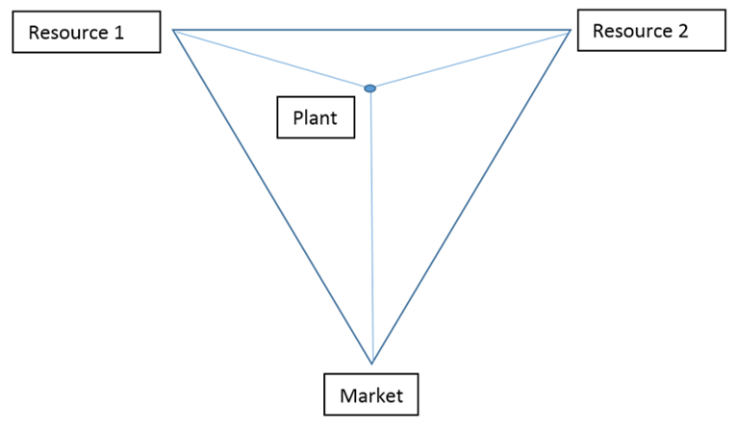

- Weight-gain processing ( bulk-gaining ) in this case you have resources that are lighter than the finished product, so they would locate by the market (market orientation)
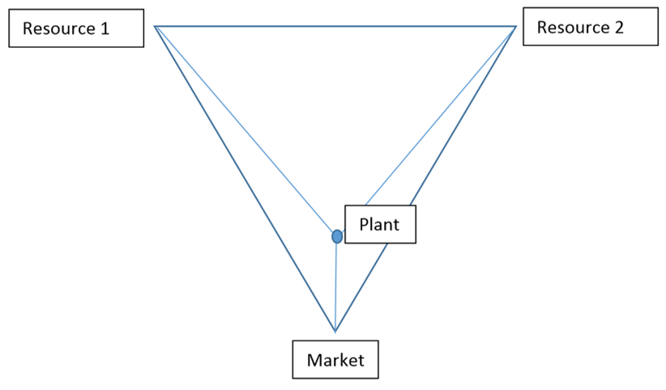
- There are some industries have spatially-fixed costs that stay the same no matter where they are located, normally lightweight expensive products
  - These are known as footloose industries because they are not tied to location
- Brick Bunny industries have one very heavy resource and one very light, so the plan would be located closer to the heavier resource
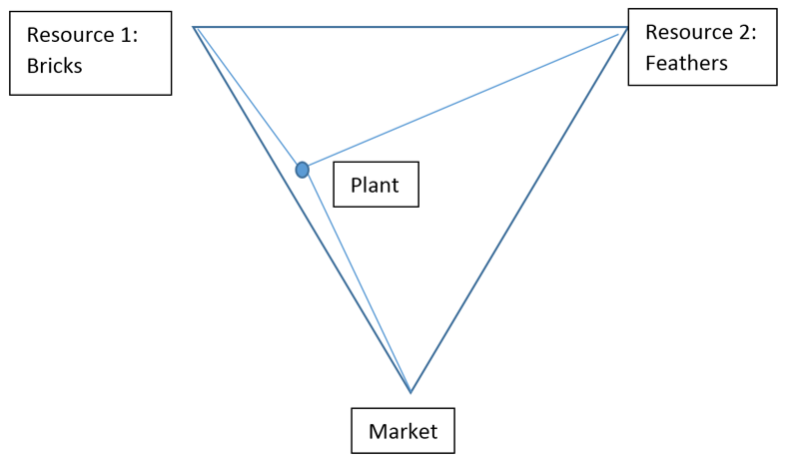

Other Characteristics of Weber's Model
- Labor: higher labor costs reduce profits, so a factory might do better farther from raw materials and markets if cheap labor is available
- Includes availability of industrial capital (money) to buy machinery, technology and labor
- In the long run the lower cost of labor will balance the higher cost of transportation, (or land or capital), substitution principle meaning one cost replaces another
- Agglomeration : when a large number of enterprises cluster (agglomerate) in the same area for mutual advantage, they can provide assistance to each other through shared talents, services, and facilities
- Costs can be shared - power, resources, infrastructure
- Can benefit industry and customers as well
- If agglomeration becomes negative (pollution, decreased revenues, traffic) the industries might leave, deglomeration
  - Silicon Valley in CA is an example of a high-tech corridor
- Can also create ancillary activities that support the major industry (food, retail, energy)
  - o The pull of one agglomeration can hurt other areas by draining talent (backwash effect – leaving only the undereducated or unskilled workers in an area )
- Criticisms of Weber's Least Cost Theory:
  - Did not account for variation over time (changing labor & land costs - substitution principle )
  - Model determined one point (site) as most profitable, it might have be the same over a larger area
  - Didn't take into account taxation policies and changes in consumer demand
Theory of Locational Interdependence - Hotelling
- Companies may also want to ensure they get a share of the business in one location (think of fast food restaurants and gas stations) - locational interdependence
- Harold Hotelling created the theory in 1929 which stated that you cannot understand the location of one industry, without understanding the locations of others
- This model looks at revenue (profit) as opposed to cost (Weber)
  - Market area analysis model concerned with profit maximization, not cost minimization
- The location that generates the greatest profit will be preferred and the greatest profit comes from the most customers
  - This can be determined by identifying production costs at various locations, and then taking into account the size of the market area that each location is able to control
  - Producers/suppliers will monopolize as many consumers as possible - they seek spatial monopoly (locational interdependence )
- Hotelling's Assumptions:
  - production costs are uniform
  - product selection is uniform
  - demand is uniform
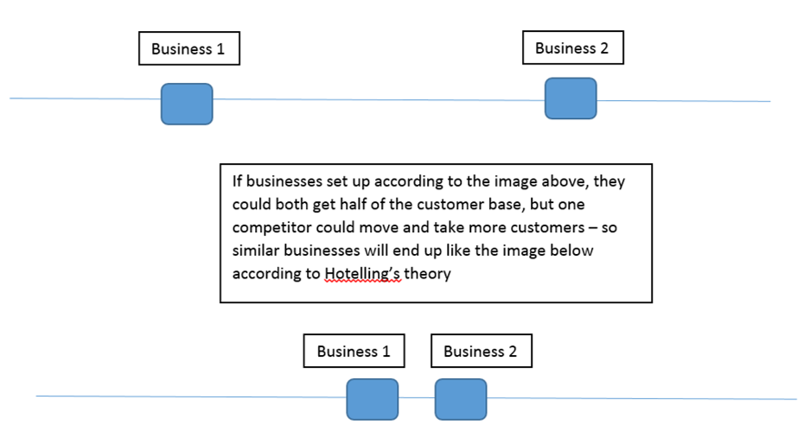

Profit Maximization - Losch
- August Lösch (1906-1945) was a German economist focused on market area analysis
- According to Losch's Profit Maximization , the correct location of a firm lies where the net profit is greatest
- It is difficult to pinpoint a single "best" location since it is possible to replace a declining amount of one input (labor) by another (automated technology) or increase transportation cost while reducing land rent ( Substitution Principle)
  - With substitution, a number of different points may appear as optimal locations

- The series of connected points is the Spatial Margin of Profitability -define the area within which profitable operation is possible
  - Location anywhere within the margin assures some profit
  - Includes spatial influence of consumer demand and production costs into his model

- Losch's Assumptions:
  - isotropic plain
  - population evenly distributed
  - identical preferences among population
  - consumer paid cost of shipping product (as distance rose, so did cost)
  - people acted economically rationally
  - new production plants could enter market if profitable
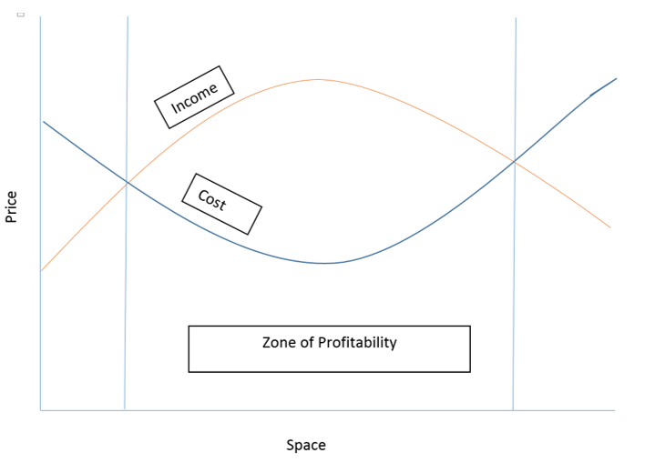

Lesson 5: Global Industrialization
Industry Around the World
- Modern Industry
  - 75% of industry is located in primary industrial regions :
    - West and Central Europe (England, Germany, France, Ireland and northern Italy)
    - Eastern Europe (Russia and Ukraine
    - North America (mostly NE)
    - East Asia (Japan, South Korea, Taiwan and China)
  - Secondary industrial regions
    - Latin America (Venezuela, Argentina and Brazil)
    - South Africa and Nigeria
    - India
    - Malaysia, Vietnam, Philippines, Thailand ("Baby Tigers" )
United States
- Regionalization is created by characteristics that differentiate areas from each other:
  - Can be by city:
    - NYC financial, Hartford (CT) insurance, San Francisco shipping and technology, Houston energy
  - Can also be by state:
    - North American Manufacturing Region (Boston - NYC - Philadelphia - Baltimore - Pennsylvania and Great Lakes)
      - The Middle Atlantic - megalopolis (NYC, Philadelphia, Delaware, Baltimore) with a focus on ports
      - Great Lakes region (MI, IL, IN, OH, NY, PA) also into Canada - manufacturing, steel, autos (Detroit), marketplaces and transportation (Chicago)
        - Deindustrizliation (shift away from manufacturing) has hit the Rust Belt hard, but is still home to some industrialization
      - New England - textile industry because of labor and water
Changing Economies
- Geographers expect that new countries will come to control manufacturing, especially as Europe and the US move toward the service industries
  - The BRICS are expected to control global manufacturing in the 21st century
    - Brazil, Russia, India, China and South Africa

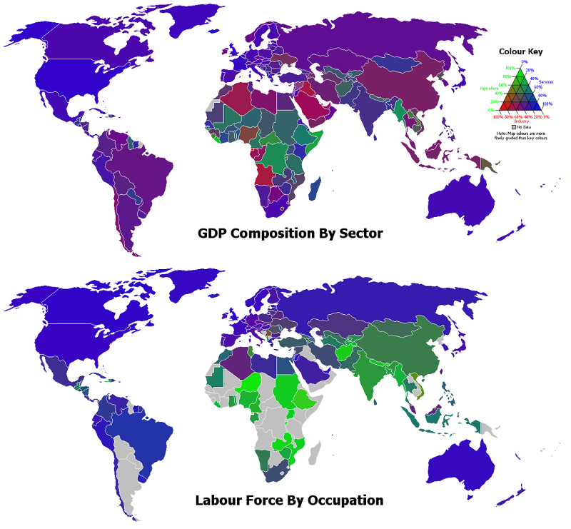
Globalization
- Industry has reached new levels of globalizaton (interconnectedness of the world) and created a new international division of labor (global division of labor) with industrial jobs going to the LDCS due to lower costs
  - Brands such as McDonalds, Starbucks, At&t, Nike, GM
  - Multinational companies are focusing on low cost production in LDCs and high profits in MDCs
  - Outsourcing allows a company to relocate some or all of its production to cheaper locations
  - Offshore companies do the vast majority of their business (production) outside of their home nation country in order to benefit from more lenient taxes and economic regulations
    - Panama, Luxembourg, Switzerland, Bahamas, etc.
    - Many companies form conglomerations or trading blocs to ensure continued power ( NAFTA, EU, Pacific Rim Economic Region)
Modern Changes
- In the USA movement has been seen to the southern US because of anti-union sentiments ( right to work laws ), cheaper land and labor
- The EU has encouraged the spread of European industry to less wealthy areas and eastern European nations have benefited from the fall of communism
- But the most obvious shift had been to areas with more resources for increasing production
  - China(highest production), Mexico, Brazil
    - This has led to deindustrialization in areas such as the American Midwest ( Rust Belt ) and central England
Special Economic Zones
- LDCs welcome outside industry, foreign direct investment, by creating special economic zones ( export-processing zones ) with incentives for companies such as lower taxes or environmental easements
  - Some money comes from organizations such as the World Bank or IMF or private company loans
    - Failed loans can lead to structural adjustment plans that require the nation to create international business incentives to keep the loan
    - Some nations also privatize or sell public industries to private companies (such as utilities or phone companies)
    - Some nongovernmental organizations (NGO) such as try to help people in nations on the periphery
Maquiladoras
- Mexico established maquiladora zones on its northern border with the USA
  - These zones offer cheap labor, tax breaks and shipment back to the US tariff free
- These factories ( maquiladoras ) attract out-of-work farmers and laborers, but the overpopulation has created problems
- These factories have been supported by the reduced restrictions on tariffs, and flow of products due to NAFTA

