Name __________________________________________________ Period____ Date_______
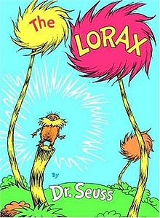
The Lorax
The Lorax is a creature that once lived in a beautiful paradise, populated
by animals and trees. When Mr. Once-Ler comes along and starts cutting
down trees to make the profitable Thneeds.
https://www.youtube.com/watch?v=8V06ZOQuo0k

- Who is telling this story?

- What was the job of the Lorax?

- What did the Once-ler make?

- Why did the Once-ler cut down the Truffula trees?

- Why do the Brown Bar-ba-loots have to leave?

- Name at least 3 problems the Thneed factory caused for the local environment.

- What is a “Thneed”?

- After the last Truffula Tree was gone and The Lorax left what did the town look like?

- The Lorax is often called a “cautionary “tale. Explain why

- Is the story relevant today? Why or why not?

