AP Human Geography UNIT 5 AGRICULTURE NOTES

Introduction:
Farming in the Southeast is a cherished and honored profession. But how do we get food that is not grown locally and how do some areas survive with very little agricultural land? Rural land use varies from county to county, state to state and country to country. The most important factor is the climate and soil types. But what about the religion, educational level or technological skill of the people in that region? Each of these cultural and social dynamics greatly impacts the agricultural production in the area. For example, the Middle East does not have pig or hog farms, why not? First, there is climate to consider and secondly, the Islamic faith doesn't allow the consumption of pork. Why is there enough food produced in America to feed over 300 million people easily, but people in other regions are starving? The technological advancements of the region, farm equipment or genetically modified seeds for example, might not be available. Food is necessary to keep us alive, but we don't spend a great amount of time considering where it will come from.
The number of farmers in more developed countries is rapidly declining, but the agricultural production in those same countries is increasing. The secret to this inconsistency is technology. With the advent of the Third Agricultural Revolution (the Green Revolution) technology allowed for the engineering of certain seeds and fertilizers that allow crops to grow stronger and with less water. The introduction of feed lots, hormones and antibiotics has allowed industrial farms to raise larger animals on a quicker schedule and with less space. However, even with these breakthroughs in production, the less developed countries of the world have over 50% of their population involved in the agricultural sector and production has remained relatively stable. These countries and individuals do not have access to the same tools and innovations compared to more developed countries.

Essential Questions:
- How did permanent farming settlements begin to form?
- How does farming and rural land use differ within regions?
- How does von Thunen's Agricultural Land Use Model explain rural land use?
- What are the effects of the Green Revolution on global agriculture?
- What is the difference between the Green Revolution and the Green Movement?
- How has industrial farming grown and diffused?

Lesson 1: Introduction to Agriculture
Intro to Agriculture
- Agriculture and the Revolutions
  - Agriculture - is the purposeful growing of plants and raising animals for sustenance or economic gains
    - Part of the primary economic sector, which means it is pulled directly from the Earth (i.e. fishing, mining, farming)
  - Agriculture developed when human groups stopped being hunters-and-gatherers and domesticated animals and cultivated crops
  - Today there are less than 250,000 hunters-and-gatherers in the world
    - Isolated regions of Africa, Australia and the Arctic
  - Animals had roles in religion and as pets before domestication began
  - Neolithic Revolution (Agricultural Revolution) occurred 10,000 years ago
    - Increased carrying capacities for cultures which led to increased populations
    - Permanent settlements and more food production led to increased social differences and job specialization
  - The first large civilizations developed along the river valleys, but agricultural innovation occurred around the world independent of other areas (including East and Southeast Asia, India, Latin America, northern Africa and the Middle East)
Carl Sauer identified two early forms of cultivation (production of food by preparing the land to grow crops)
  - Vegetative planting - direct cloning (i.e. taking the plant with you or cutting off a piece to replant)
  - Seed agriculture - annual growth from planting seeds
- The variety of hearths supports possibilism, meaning that humans can modify their environments

Agricultural Crop and Animal Domestication Hearth
- Southwest Asia - barley, wheat, lentils, olives
  - Also an important center for animal domestication (cattle, goats, pigs and sheep)
- East Asia - rice and millet
- South Asia - rice
- Sub-Saharan Africa - sorghum and yams
- Southeast Asia - root crops, taro, bananas (dogs, pigs and chickens)
- Central and South America - squash, beans, cotton, potato, corn (turkeys, llamas and alpacas)
- Western Africa - yams and palm oil (cattle, sheep and goats)

- Second Agricultural Revolution
  - Second Agricultural Revolution - Europe in the 17th century
    - Before the Industrial Revolution (these two revolutions were dependent upon each other – the increased food production supported population growth and because less farmers were needed people flocked to cities to work in factories)
      - new innovations (fertilizers, plow collars, etc) - less farms could make more food
  - Farmers moved towards the enclosure system (land that had been treated as "common" and used by non-land owners was enclosed by the wealthy owners to create large, individual farms)
  - Innovations like the seed drill, cotton gin, crop rotation , tractors, reapers and threshers continued to drive crop production
- Third Agricultural Revolution
  - Green Revolution (Third Agricultural Revolution) -1960s -70s create enough food to feed the world (starting with higher yield seed and chemical fertilizers)
    - Focused on stronger crops, more fertilizers, better technology, etc.
  - This has led to Biotechnology (Genetically Modified Foods) - scientific creation or genetic engineering of crops
    - Some opponents believe the focus should be on sustainable crops and techniques (ones that protect or even restore the environment) this movement is organic and known as the Green Movement
    - Sustainability is focused on responsible land use, less chemicals and a focus on mixed land use and livestock model of agriculture
  - The Green Revolution and GMOS were supposed to help feed the world, however, farmers need to buy the expensive seeds and machines in order to take advantage of the increased output and there are environmental and health concerns
  - The move towards corporate and industrial farming has strengthened the importance of transnational corporations (multinational corporations) which produce crops in different countries (often periphery countries) for sale in different locations (often core countries)
- Pros: more food, fertilizers increase productivity, new methods of irrigation, agribusiness increasing globalization
  - Blue Revolution is the movement to engineer fish that will produce more nutrients, this can be accomplished in conjunction with aquaculture (breeding and harvesting of marine life is a controlled environment)
- Cons: Poor nations suffer more (cannot afford tech or crops), overuse of land /sea, lack of water, lack of balance with crops
  - Green Revolution and GMOS have not helped the area they were created for (Sub-Saharan Africa)

Farming Around the World
- LDC vs MDC
  - Most farmers - LDCs and they are subsistence farmers
    - They farm for their own food
    - Almost 50% of population involved in farming
    - Traditional and local methods
    - Less land can be farmed (due to a lack of mechanization)
    - Less output per person
    - This type of farming is labor-intensive (using man power to produce output)
  - Farmers in the MDCs are commercial farmers
    - Food to sell
    - Less than 5% of the population
    - Large farms over 400 acres
      - 4% of farms in the US account for ½ of the crops
      - Half of all farmers in the US generate less than $10,000 yearly
    - Use of technology (tractors, combines, GPS ), transportation (railroads and trucks) and scientific advancements (fertilizers and pesticides)
    - This type of farming is capital-intensive (use cash to buy machinery to increase output)

Mapping Climate and Agriculture
- Wladimir Koppen created a map that illustrated the main climate zones an biomes globally (this map has been revised several times since 1900)
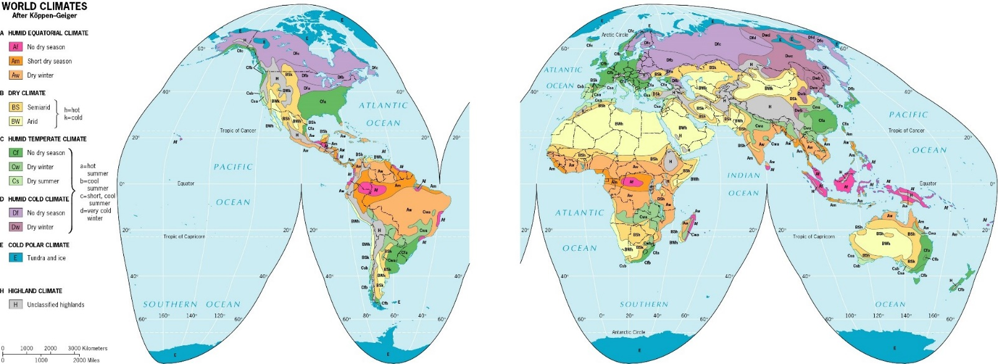
- Derwent Whittlesley went a step further and used the climate zones to create a map that shows the eleven zones for agriculture (and one zone where agriculture does not occur)
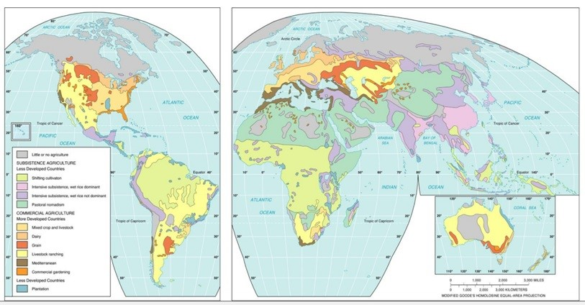

Lesson 2: Agriculture in the LDC's

Shifting Cultivation
- Shifting cultivation the constant changing of land use
  - Common in areas with high temperature and high rainfall
  - ¼ of world's land area
  - South America, Africa, SE Asia
- People tend to live in small villages with farming land near by
- Traditionally the land was owned by the entire community, but there is starting to be more private ownership
- Uses slash-and-burn agriculture to clear vegetation and waste (the cleared land is known as swidden )
  - Once the fields have been planted several times the nutrients will be gone and the field will be left fallow (empty) for at least several years
- Methods are very traditional and labor-intensive ( intertillage – cultivating the land between rows of crops to plant other seeds)

Crops in Shifting Cultivation
- Shifting style is known as cultivation because it lacks the technology and updates of true agriculture
- Swidden will vary from region to region, but they will not resemble the rectangular shape of MDCs
  - The land belongs to the village, so elders will decide which area will be the food of one family and that might be a different crop than the other portions
- Crops vary, but include:
  - Rice, maize, manoic (root that provides carbs for large pop. of the world), millet (grain), sorghum (grain), yams, sugarcane, plantains, etc

Pastoral Nomadism
- Pastoral nomadism is domesticating and breeding ( animal husbandry ) animals in areas where agriculture is difficult
  - Arid (dry) climates
  - North Africa, Central Asia, Middle East
    - Bedouins (Africa) and Masai (Kenya/Tanzania) ‏
  - 1/5 of world's land area
- Small groups move as they tend to their herds, may be split into herding units
  - Animals provide milk, hides, hair - but are not usually eaten (mostly grains)
- Groups might trade for food or leave women in a set location to farm or farm in an area during a specific season before moving

Animals for Pastoral Nomads
- Due to the amount of area covered by these groups, pastoral nomadism is a type of extensive agriculture (spread out over a large area)
- Animals are chosen based on cultural preference and environmental compatibility
  - Camels (arid terrain), goats (eat anything), horses (flat steepe region), sheep (valuable but highest maintenance) ‏
- Certain groups will use transhumance , or migrating from mountains to pastures (grazing areas) during different seasons

Intensive Agriculture
- Intensive subsistence agriculture is used to feed billions of people in LDCs
  - This is the most common form of agriculture in Asia
- Requires intensive farming in the sense that every inch of land must be used to ensure that enough food is grown to feed a family
  - Grazing, paths and roads are all kept to a minimum to avoid wasting any agricultural opportunity
  - Also this work is labor intensive , as almost all of it is done by hand
- Intensive Subsistence Agriculture with Wet Rice
  - Intensive subsistence farming with wet rice involves growing rice seedlings and then moving them to a flooded field ( sawah / paddy ) ‏
    - Asia's most important crop
    - SE Asia, China and India
      - Flat land near rivers are ideal, but monsoons can provide water elsewhere and terracing can create flat terrain
  - The work is time and labor consuming, done by hand
  - In order to get the most from the land, some regions (with warm winters) use double-cropping, growing rice in the wet season and grain in the dry season

Growing Rice
- The field must be plowed, flooded (controlled with canals to avoid too much or too little water), the seeds must be cultivated on dry land and submerged in water
Intensive Subsistence Agriculture (Not Rice) ‏
- In Asian areas with harsher climate and less water, it is impossible to grow enough rice
  - Interior India and NE China
- The traditional and labor powered methods are the same, but crops differ
  - Grains such as wheat and barley are the most important
    - Millet, oats, corn, sorghum and soybeans
- People in these areas often attempt crop rotation (switching crops in one location in different seasons) to ensure that there is enough food and not a loss of nutrients in the fields

Pros and Cons of Agricultural Methods in the LDCs
- Shifting Cultivation
  - Ineffective and land-consuming but environmentally friendly (in small doses) but would contribute to deforestation and global warming (burning) at large scales
- Pastoral Nomadism
  - Disliked by government who would like to use the land for their own purposes but seems to be an effective form of farming in areas with little water - used to be the main source of movement across difficult terrains but replaced by transportation and technology
- Intensive Subsistence Farming
  - Provides the majority of the planet with food but was ineffectual for years in East and Southeast Asia due to communes (shared Communist farms)

Lesson 3: Agriculture in the MDCs
Commercial Agriculture in the MDCs (And one in the LDCs)
Changes in Farming
- MDCs (specifically the US and Canada) produce enough food to feed the region and sell surplus to the rest of the world
  - Although the number of farms are shrinking in the US, the land possessed for farming is growing (about 1B acres)
  - The number of farmers in MDCs have declined dramatically over the last century because of higher paying jobs in cities, low incomes for farmers and less opportunities to survive by farming
- Farms around the world are facing the loss of prime agricultural land (best farmland) because of urban sprawl (growth of metropolitan areas)

Mixed Crop and Livestock Farming
- Common in the US and Europe
- A mixture of farming and raising animals
  - Most of the crops are used to feed the animals then manure is used to fertilize the fields
  - Most land goes to the crops, but most of the money comes from animal products (beef, milk, eggs)
  - The crops are rotated through two seasons, but animals are year-long (these also reflect the time of year these items can be sold)
- Farmers plan their crop rotations years in advance to get the most nutrients for each crop

Crop-Rotation
- The earliest crop rotation system, the two-field rotation, was used in Europe as early as 400ad
  - This involved a cereal grain ( staple grain ) in one field while another was left fallow - the next season the fields were switched
    - Oats, wheat, rye and barley
- As the centuries progressed crops increased in field usage (Three-field, four-field)
  - Also includes a fallow field or a rest crop
  - Wheat and barley - flour and beer
  - Wheat stalks - animal bedding
  - Roots, clover and rest crops - animal feed

Mixed Crop and Livestock Farming
- Corn is the most often produced crop in the US
  - Used for human and animal consumption
  - The Corn Belt is the major region (Ohio to the Dakotas)
    - Corn subsidies are available from the US government in order to support farmers and control the amount of any given agricultural commodity
    - Many small and family farms are threatened by rising costs and completion from corporate farms
- Soybeans are the second most important crop in the US (mixed commercial)
  - Produce both human and animal food
  - Tofu (soybean milk) in Asia and soybean oil in the US are major food

Dairy Farming
- Common near urban areas in US, Canada, Europe, Russia, Australia and New Zealand
  - Produce the majority of milk worldwide - sold to wholesalers and retailers to reach consumers
  - Increases in income and technology (railroads and refrigeration) made milk common
  - The vast majority of dairy producers used to be clustered in developed countries, but this is changing (China is the world's largest dairy producer)
- Dairy farms need to be near to markets because it is perishable ( milkshed is the area around a market that can be reached before spoiling)
  - Modern milksheds are 300 miles
- The distance still influences the products, the farther the farm the more the focus on other products (cheese, butter, evaporated/condensed/dried milk)
  - I.e. NE farms focus on milk but Wisconsin focuses on cheese and New Zealand avoids fresh milk due to distance
- Dairy farming is facing ongoing issues:
  - Labor-intensive requirements (milking)
  - Cost of feed (and machines if possible)
  - Lower profits worldwide

Grain Farming
- Grain is the seed from different types of grasses
  - Wheat, corn, oats, barley, rice, millet, etc.
- Grain represents the major crop on most farms, these are staple crops (can be the base for feeding an entire civilization)
  - On grain farms the purpose is not to produce food for animals, but food to sell for humans
- Wheat is most important (in grain farming) because of its uses (bread), ease of transport and profitability
- The US is the largest commercial producer of grain
  - All locations are found in areas that are too dry for mixed crop and livestock

Areas of Grain Farming in the US
- Most US grain comes from winter and spring wheat
- Most wheat farms are large and heavily reliant upon machinery
  - The reaper was the first machine to cut the grain
  - The combine has replaced the reaper because it can reap, thresh and clean the grain
- The workload on a grain farm depends on the season of planting
- Wheat is the largest export crop worldwide, with about 50% coming from the US and Canada ( large-scale grain farms )
  - The North American prairie states are such big producers that they are known as the "World's Breadbasket"

Livestock Ranching
- Ranching is a type of extensive agriculture that uses large semi-arid lands (not ideal for farming) to raise animals
  - Located in the US, South America, Australia, South Africa, New Zealand
- Cattle first arrived in the US through the Columbian Exchange (Old World to New World and vice versa)
  - American settlers in Texas were taught how to ranch by immigrants from Spain and Portugal
- The largest cattle markets were located in Chicago and herds were moved on foot and then on cattle cars (railroads)
- In the West, ranchers allowed their cattle to graze at will and were only forced to buy and enclose their land when other farmers moved into the area (semi-nomadic extensive farming changed to fixed farming on a more intensive scale)
  - Longhorns were the original US cattle, but they were replaced by European varieties (better meat) once transportation allowed for fixed locations (didn't have to move the herds long distance to graze or find water)
- Crop farming has slowly replaced cattle ranches and now animals are usually sent to indoor facilities to be fattened quicker (through the use of feedlots and corn feed)
  - Feedlots are small contained areas for animals, where they are fattened quickly – this can allow for just-in-time delivery of goods for freshness

Mediterranean Agriculture
- Common in area bordering the Mediterranean Sea (needs to have dry summers and cool, moist winters)
  - Southern Europe, Northern Africa, western Asia
- But also in areas with Mediterranean climates
  - California, South America, South Africa, Australia
  - All areas border a sea (or ocean) which bring moisture and help moderate the winter temperatures and balance out the summer temperatures and the land is hilly or mountainous
- Some farmers use transhumance to raise animals (sheep and goats) in the region, but the focus is mainly on crops
- Horticulture (fruits, veggies and flowers) and trees are the basis for Mediterranean agriculture
  - Olives (for oils) and grapes (for wines) are widely produced in nations bordering the Mediterranean Sea
  - Grains are also important (bread and pasta)
- Winter wheat is rotated with cash crops
  - The largest exception is California, which focused on horticulture
    - The loss of prime agricultural land to urban areas (Los Angeles) had required large scale irrigation of arid land in the region

Commercial Gardening and Fruit Farming
- Common in the SE United States because of the warm temps and water
  - This is known as truck farming because of the demand from a number of different markets (used to be bartering but now it is selling)
  - Traditionally these were large farms in the Southeast that would then sell their goods to colder climates
- Crops focus on fruits and vegetables that can be produced cheaply due to migrant workers (working on suitcase farms ) and then sold to corporations to process and sell ( agribusiness )
  - New England has copied the idea and started specialty farming , which doesn't produce a lot, but has a high demand items (fruits, veggies and nurseries)

Plantation Farming
- The only type of large scale commercial farming found in the LDCs ( periphery )
  - The farms are usually located in the tropics (Central and South America and the Caribbean) and owned by Europeans or Americans and sold in the MDCs ( core )
- Plantations are large farms with a focus on one or two crops
  - Cotton, sugarcane, coffee, rubber, tobacco, cocoa, jute, bananas, coconuts and palm oil
    - Asia focuses on jute and palm oil; while Latin America produces bananas, sugarcane and coffee
    - Plantations are usually in isolated locations, so workers must be found, transported and housed on the farm
  - Plantations focus on cash crops (these are in high demand and easy to sell, but are also nutritionally important) or luxury crops(nonessential and non-sustenance, not for survival, but can be sold for a very high price)

Global Concerns
- More land being cleared and being farmed in an intensive manner creates harsh landscapes:
  - Erosion - loss of soil (through wind, rain, etc)
  - Overgrazing of grassland can lead to dry lands – leads to erosion and desertification
  - Soil Changes - More farming equals less nutrients
  - Loss of natural vegetation - Introducing new crops can lead to overpowering of traditional ones
  - Increased chemicals - Fertilizers and pesticides change the soil
  - Loss of prime agricultural land (to urban sprawl)
  - Desertification - land changing to desert-like conditions

Worldwide Production
- Biggest factors are climate (including soil and relief) and money
  - US leads in corn (for livestock, humans and ethanol) and produces a lot of soybeans and wheat
  - South America produces sugarcane (for food consumption, but mostly for ethanol)
  - Eastern Europe produces wheat for human consumption
    - All nations in the EU have strict guidelines for food production and land use - so a lot food is produced organically (very few GM crops)
  - Africa produces millet and sorghum
  - Asia focuses on rice (food / barter for animal products)
    - China has a planned economy (due to communism) and has wheat in northern areas and rice in southern areas
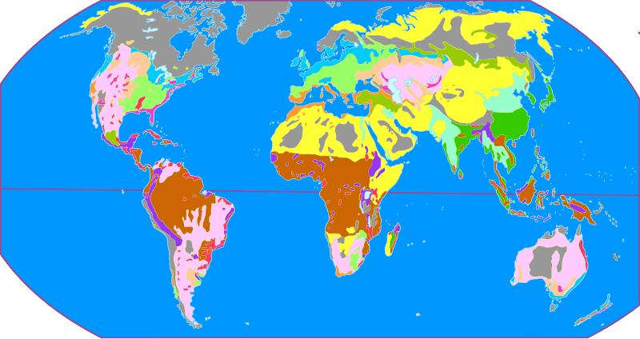

Lesson 4: Agricultural Models
Agricultural Sectors
- Primary sector - pulling raw material from the earth (mining, agriculture, animal domestication, forestry)
- Secondary sector - transforming raw materials into manufactured goods (processing, refining, metallurgy)
- Tertiary sector - Services (construction, trade, finance, retail, transportation)
- Quaternary sector - Jobs in service (non-tangible retail - internet, tax services)
- Quinary sector- Management (administration, government)
- Farming is primary, but agribusiness encompassed all four sectors (includes growing, canning, packaging, marketing, transporting and selling)

Von Thunen's Land Use Model
- Johann von Thunen, was a German geographer in the early 19th century who noticed that crops and land use changed, even if the climate and terrain were the same
- He created the model of agricultural land-use
  - Market gardening and dairy farming were closet to the marketplace (central city) because they are expensive to transport and spoil quickly
  - Forestry was next because logs are heavy to move
  - Field crops (wheat, corn) were next because crops could sustain travel (light and did not spoil)
  - Animal grazing because of the space available (although feedlots are now making use of less space)
- The first rings were intensive (because the land is more expensive) and the fourth was extensive
Von Thunen's Assumptions
- Von Thunen assumed that:
  - There was one market with a central location
  - The area outside was uninhabited forestland and there were no other close markets
  - The land was flat, uniform and there were no barriers on the way to the only market available
  - There was only one mode of transportation
  - That all farmers were rational
  - Main two factors are costs of rent and costs of transportation (cost to distance relationship)
    - The closer the land is to the market, the more limited it is, so the more it costs (bid-rent curve)

Problems with Von Thunen
- This model does a good job illustrating the functioning of local market
  - The model can be altered to account for transportation networks and competing markets (will change the shape and size of zones)
- Von Thunen did believe that climate and topography (rivers, arid, etc) could change the pattern
  - But he did not consider things such as cultural choices and religious implications in farming
- With the globalization of agriculture, the von Thunen model becomes nearly obsolete as local food economies are replaced by large-scale agricultural production
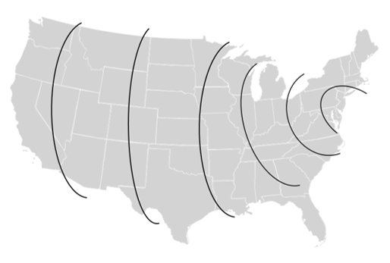
Von Thunen in modern times - there are parts of the model that can still be applied in the US

Changes in Farming
- Originally farming was extensive agriculture , meaning it was widespread, but now the focus is on intensive agriculture, or getting greater production from smaller areas
  - Capital-intensive uses machinery and tools with little human labor
  - Labor-intensive uses human hands
- Farming is not the only component of agribusiness
  - Farming, processing, packaging, storing, distribution and retailing (and the technology and science behind new ideas)
  - More than 20% of the US population is involved in agribusiness
  - Agribusiness is involvement in the entire commodity chain (all the resources and processes needed to go from crop to grocery store)

Land Use Patterns in the United States
- • You will recall from earlier units that most of the land in the US is divided up using three land survey systems (in distinct regions of the US)
  - Metes and Bounds – the English land survey system is most prevalent along the Eastern Seaboard (i.e. original 13 colonies)
    - This system used landmarks and well known natural landforms to divide up land (rivers, mountains, forests, etc.)
  - Long Lot – the French land survey system is used in Louisiana, Texas and other areas influenced by French colonists
    - This system created more narrow lots that gave all landowners accessed to certain landforms (i.e. rivers)
  - Township and Range – the American system was used in the western states
    - This systems used precise measurements to create large farmsteads and clear ownership

