AP Human Geography Support Document Units 1 -5
Exam Website Link | Your Login | Your Access Code
Unit 1: Thinking Geographically: Key Terms
Theories!
Environmental Determinism: The believe that the environment determines where and how humans settle (i.e. nomadic groups who live on the land in dry or tropical regions)

Possibilism: While the environment does play a role in how people live, people have the ability to adapt and change it . (i.e. building cities in the desert of Dubai)

Regions:
Formal Region: described by having unifying cultural or physical characteristics (i.e. countries and groups of countries
Functional Region The area must also have a center of activity (a node), with outside areas connected. (i.e. pizza delivery service area)
Perceptual Region characterized by a population's sense of identity and opinion towards a place (i.e. the south is a region where everyone wears cowboy hats)

Scale of Analysis: Local, National, Regional, Global

Unit 2: Population and Migration
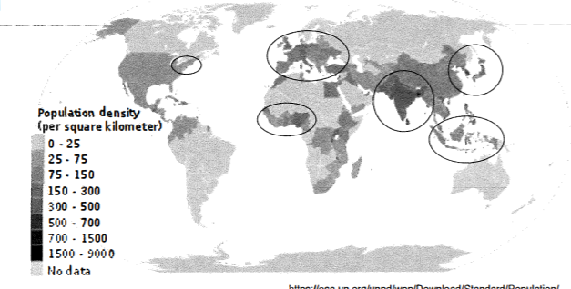  Where do people settle?  Fertile Soil (near rivers)  Oceans (Trade)  Climate  Economy  Government  Culture | How do we measure human settlement?  1. Arithmetic Density: The number of people in a given space  2.Psyicological Density: The amount of arable land that can be used for agriculture  3. Agricultural Density : The number of farmers for amount of arable land  Places with less arable land and high population will have high Physiological Density  LDCs will have higher agricultural densities than MDCs, since most are involved in subsistence farming and work is not being done by machines as in MDCs (USA) | Global Population Clusters and Population Densities

How do we describe populations using demographic terms?  LDCs : Lower life expectancy, gender equality, education and higher birth rates, death rates, infant mortality rate, and youth dependency  MDCs: Higher life expectancy, gender equality, elderly dependency, levels education and lower death rates, birth rates, infant mortality  Theories on population Growth:  Malthus: belief that we would run out of food for growing population. There would be population checks like war, famine, disease.  Boserup: As population grew, there would be more technology and food for population (as was true with GMOs, and higher yielding seeds in the green revolution)  How do states control population growth?  Pro Natal Policies: Encourages people to have children, usually economic incentives population is declining (DTM 5,) aging population, not enough people to fill jobs.  Anti Natal Policies: Discourages people from having children because of strain on resources: Government programs (one child policy,) education on family planning or economic incentives | 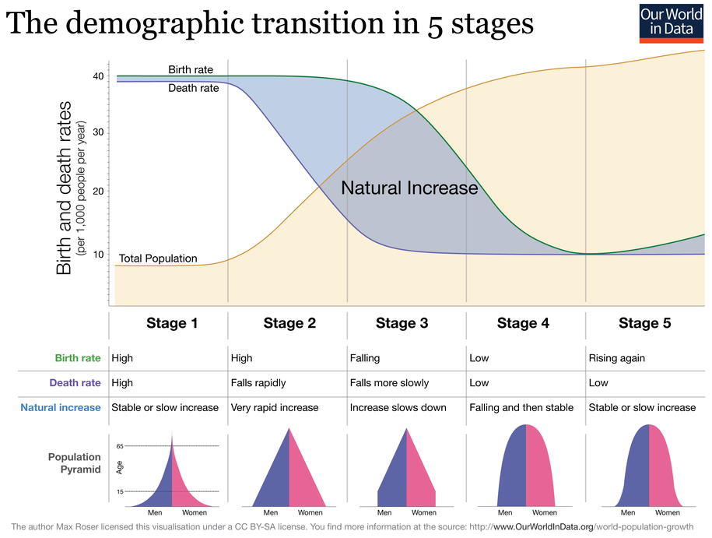  Epidemiological shift: infectious to chronic diseases from LDC to MDC
Why do people migrate? Types of Migrations and Migration Trends
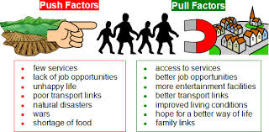  Forced  People move for fear of life or natural disaster  Voluntary People move by choice | Migration Trends::  - Largest Global Migration: Rural to Urban for jobs!  - Many travel within country/short distance  - Most international migrations are done in Steps (step migration)  Refugees: People who have been forced from their homes due to year of life (Usually due to conflict or persecution, i.e. Syria, Sudan)  Internally Displaced people: people who are forced to leave their homes, but are displaced within their country  Asylum Seeker: People who have left their home country seeking refugee status in another country  Remittances: Money migrants send back to their home country
Unit 3: Culture and Diffusion of Languages and Religion
Religion and Diffusion  Religion Type Hearth Diffusion  Christianity Universal-izing Israel Hierarchical through colonization, relocation through migration  Islam Universalizing Saudia Arabia Hierarchical through conquest, relocation through migration  Buddhism Universalizing NE India Contagious as teachings spread to Asia and relocation  Judaism Ethnic Israel Relocation Diffusion (migration)  Hinduism Ethnic India Relocation Diffusion (migration) | Language and Diffusion  Lingua Franca - A language used by people who don't speak the same language to communicate for trade or business.  - Many languages spread through relocation diffusion as people move, hierarchical diffusion through colonization (i.e. French and English in West Africa), contagiously as language become popular (global spread of English)  - As popular languages spread, there is language loss  - Languages diffusion can lead to the creation of Pidgin Languages (a combination of languages to form a simplified language,) and Creole Languages, (a combination of languages to form a more complex language
Types of Diffusion  Relocation-culture does not expand, rather moves as people migrate. Hierarchical- spread of an idea from someone of influence or power (i.e. fashion trends or through force as with colonization  Contagious-spreading rapidly through contact, i.e. diseseas, viral videos Stimulus-idea spread but end result changes (i.e veggie mac in India) | Culture Key Terms  Ethnocentrism-the belief that ones own culture is better than others, often leading to conflict (yugoslavia, holocaust)  Globalization-the process of the earth becoming more connected due to increased technology, transport, and communication  Placelessness-loss of unique characteristics of a place; as pop culture spread, local culture is often destroyed  Cultural Landscape the imprints human leave on the land  Sequent Occupance-over time many culture occupy the same space and leave their imprint
Unit IV: Political Patterns and Process
Types of States  State-political unit with defined boundaries, population, sovereignty  Nation-group of people with a shared identify/culture/ethnicity  Nation-State-a state made up mostly one nation/cultural group (i.e Japan)  Stateless Nation- When a nation does not have control of a state( Kurdistan, Palestine)  Multinational State- a state composed of many different ethnic groups (U.S.)  Types of International Boundaries  Antecedent- boundary that existed before human settlement (US/Canada) Relic-boundary that used to exist (Berlin Wall)  Subsequent (boundary that was created with human settlement NE US colonization Superimposed- boundary imposed by outside force (African states, colonization)  Law of the Sea  A states territory extends 200 nm of its shoreline giving it Exclusive Economic Zones to the resources in the waters. Where boundaries overlap, resources must be shared.  Can often lead to conflict: Example, South China Sea; 7 countries competing for control of trade passages and access to mineral and oil resources in the water. | Internal Boundaries  Gerrymandering: Manipulating voting district boundaries to make people favor one political party over another  Reapportionment Reassigning legislative seats among districts after census so they each represent the same # of people  Redistricting Redrawing voting district lines according to population.  Census/Pop count ( every 10 yr) ➜ Reapportionment➜ redistricting➜possible gerrymandering  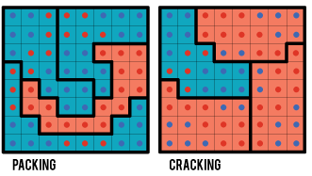

Forces that Unite and Divide States  Centripetal-forces that unite people within a state (equality, shared language, good governance)  Centrifugal-forces that divide people within a state (cultural diversity/many language & regions, poor government, poverty. Leads to conflict within states.  Devolution The shift of power from a centralized government to a subunit within that central government  ProsGovernment becomes closer to its people  CONS Could lead to a desire for independence & Loss of sovereignty and eventual conflict | Conflict Among States  Balkanization-region that has broken up in to smaller units due to ethnic conflict (Former Yugoslavia)  Shatterbelts-deeply divided areas on the verge of conflict or collapse (Eastern Europe in the 1990s)  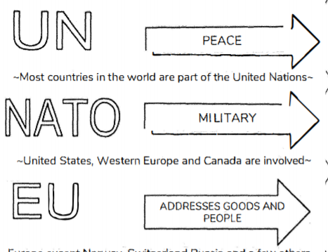  Ethnic Cleansing/Genocide- When an entire group of people is targeted due to their ethnicity (Sudan, Rwanda, Yugoslavia, Holocaust)  Cooperation Among States: Supranationalism: 3 or more states joining together to work for a common political, economic, or military purpose.
Unit 5: Agriculture Patterns and Processes
Agricultural Revolutions  1st (Neolithic) 2nd Ag Revolution Green Revolution  Shift to sedentary Industrial Revolution High Yield Seeds, GMOs  Pros and Cons of the Green Revolution  Pros: saved many from starvation Asia, high yields of grains Cons-pesticides pollute environment, loss of soil fertility, did not reach Africa | The global System of Agriculture  Subsistence Farming-food grown for survival, family, usually many people involved and in LDCs  Commercial Farming-farming done on a large scale to be sold for profit w/machines & in MDCs  Agribusiness-the business of producing and selling crops  Commodity Chain-the links that connect production to distribution of goods in ag.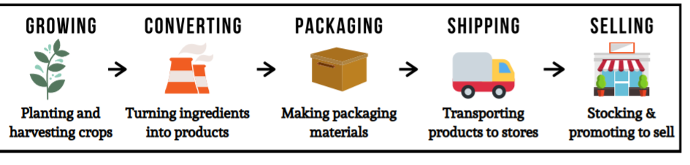
Agricultural Regions:
Intensive:lots of labor/machines & high yields Extensive: low labor, large land,& low yields
Major Agricultural Concerns:
Use of pesticides, GMOs -> loss of biodiversity, destruction of soil and water, air pollution
Agribussiness-> food deserts (areas in cities where people do not have access to fresh food because of low income)
Women make up almost 1/2 the agriculture force but have little equality, (esp in LDCs) do not own land and often unable to access capital

Sustainability in Agriculture:
Organic Crops (no chemicals used,)
Eat Local (reduce gas used in transport)
Fair Trade (ensuring fair wages for workers)
Micro-Loans: Given mostly to women for small businesses and agriculture to lift out of poverty

Pastoral Nomadism | Subsistence | Drylands (SW Asia, North Africa) | ext
Shifting Cultivation | Subsistence | Tropics (Latin America, Central Africa) | ext
Grain | Commercial | Cold and Mid Latitudes (US, Europe) | int
Dairy | Commercial | Cold and Mid Lat (US, Europe, Canada) | int
Mediterranean | Commercial | Wam ( S Europe, Cali, Chile, S. Africa) | int
Livestock | Commercial | Drylands( West US, Argentina, Cen. Asia) | int
Plantation (LDC) | Commercial | Tropical (sub-Sahara Africa, SE Asia, Latin America) | int
Land Use and Survey Patterns
Von Thunen-before refrigeration, perishable closer
To the market area, grains and livestock further away
French Long-Lot: (Quebec, Louisiana)
Farms divided into linear sections perpendicular to river
Metes and Bounds- British system to divide land based on physical features
Township and Range: Under Jefferson in the US, divided new lands in to square parcels
FRQ Command Prompts and Examples
Verbs | Definition, Example Prompt, and Abbreviated Sample Answer | Helpful Hints for Success
Describe | Provide the relevant characteristics of a specified topic. | 3-4 DETAILED sentences with specifics.  Scale matters: State, region, global… stick to the scale in Q
Prompt: “Describe the changing demographic structure of Japan since 1990.”
Answer: “The demographic structure of Japan has changed as the birth rate has decreased and life expectancy has increased since 1990. This has resulted in a more topheavy pop pyramid with many elderly people and relatively few children. As a result, working age...”
Explain | Provide information about how or why a relationship, process, pattern, position, or outcome occurs, using evidence and/or reasoning. | Paragraph  Use “because” and “for example”  Qs are often looking for you to explain cause/effect relationship
Prompt: Explain why deforestation has been increasing in tropical regions.
Answer: “Deforestation is occurring in tropical regions because commercial farmers in the region need more land as consumer demand increases and there is widespread use of unsustainable farming practices such as slash-and-burn agriculture. (then back up claim with evidence and reasoning)

Compare | Provide a description or explanation of similarities and/or differences.  Notice that you have to describe or explain the differences and/or similarities. | Paragraph  Useful words: both, whereas  Never say A is ___ and B is not. You must elaborate on both A and B.
Prompt: Compare the theories of environmental determinism and possibilism.
Answer: Both are philosophies that focus on human-environmental interaction and aim to explain the degree to which humans are shaped by their environment. Whereas environmental determinism asserts that developmental and cultural differences are attributable to differences in physical landscape, possibilism...

Descriptors, Meaning and Examples

Descriptor | Definition and Interpretation | Example
Social | - Think cultural, language, ethnicity, religion, generational, societal norms, health, education  - How is this trend/event/change affecting the ways in which people interact and live | “Explain one social consequence of suburbanization.”
Political | - Relating to the government, sovereignty, territoriality, states, nations, nation states, ect.  - think governments, policies, parties, legislations, organizations, alliances | “Describe how political reforms have promoted democracy in Sub-Saharan Africa since the 1960s.”
Economic | - That which pertains to financial (monetary) value. Resource allocation and jobs are often the focus.  - Think jobs, money, business, trade | “Explain two economic changes resulting from supranationalism in Europe.”
Environmental | - That which describes the natural world and the impact of human activity on its condition (or vice versa).  - think anything physical earth, landforms, bodies of water, conservation, resources | “Identify and explain one environmental consequence of green energy technology.”  “Identify and explain one environmental consequence of climate change on human settlement patterns.”
Demographic | - Relating to the structure of human populations.  - think population statistics like birth rate, ages, genders, population characteristic | “Explain the demographic changes that developing countries have been experiencing in recent decades.”
Spatial | - Describing the relationship or geographic features within a space or between multiple locations.  - Think, pattern, scale (global, national local,) distance, direction, clustering, dispersed | “Explain the spatial arrangement of dairy farms in the northeastern United States.”  “Compare the spatial distribution of Starbucks and Dunkin Donuts in New Jersey.”

