World History One Pager
Your One Pager should be thought of as a review of the unit we are on, something you could use to help you remember key elements from the unit for both for the test and to reference for the final exam. This will be weighted as quiz grade so my expectations are high for quality work, you should want this for yourself as well. Remember the more detailed it is the more helpful it is for you.
The requirements for the One Pager is as follows
- This must be done by hand, you may not use printed material and your name and class period should be on the back. Also, no duplications, for example if you use a person for your significant people then you can’t use them for your questions, each section is a standalone item and cannot be used twice.
- This must be done in color, it may not be done in pencil or in a single color and must cover the entire page as well as demonstrate effort (10 points)
- It must include the title of the unit and the general time period (5 points)
- A minimum of two pictures of something significant from this unit (10 points)
- A minimum of two significant people from the unit and what they are known for. This is a description not just that they ruled over a territory, or led an army but what they did that made them a significant historical figure. (10 points)
- Two vocabulary words and their definitions (10 points)
- Two questions and the correct answers to them. This cannot be information already used on the One Pager (10 points)
- Two significant events and why they were important. (10 points)
- A brief overview of this time period, what was it about, this should be at least 4 sentences. (15 points)
- A Map of the territory included in the Unit (10 points)
- Two Cultural Achievements, what the achievement was and why was it an achievement. (You may have your two pictures be of cultural achievements) (10 points)

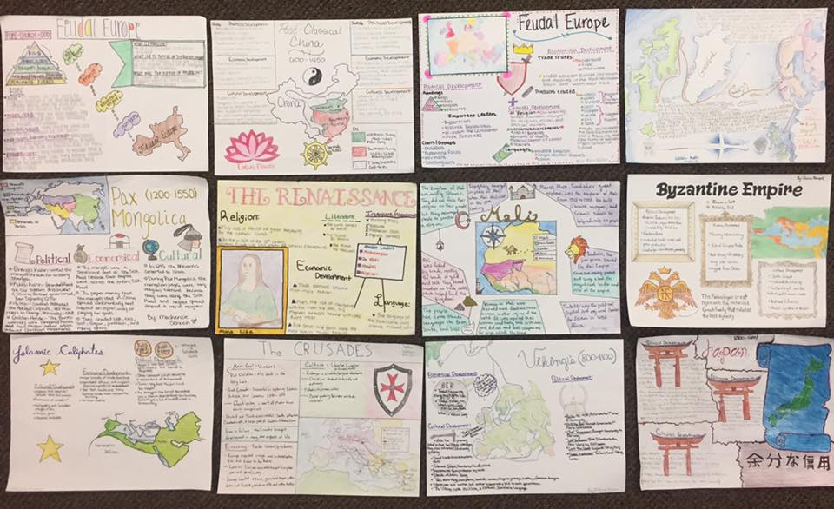
World History One Pager of the Renaissance and Reformation
Your One Pager should be thought of as a review of the unit we are on, something you could use to help you remember key elements from the unit for both for the test and to reference for the final exam. This will be weighted as quiz grade so my expectations are high for quality work, you should want this for yourself as well. Remember the more detailed it is the more helpful it is for you.
The requirements for the One Pager:
- This must be done by hand, you may not use printed material and your name and class period should be on the back. Also, no duplications, for example if you use a person for your significant people then you can’t use them for your questions, each section is a standalone item and cannot be used twice.
- This must be done in multiple colors, it may not be done in pencil or in a single color and must cover the entire page as well as demonstrate effort (10 points)
- It must include the title of the unit and the general time period (5 points)
- Your full name and class period written on the BACK of the page (5 points)
- A minimum of Three pictures of something significant from this unit (15 points)
- A minimum of two significant people from the unit and what they are known for. This is a description not just that they ruled over a territory, or led an army but what they did that made them a significant historical figure. (10 points)
- Two vocabulary words and their definitions (10 points)
- Two test questions and the correct answers to them. This cannot be information already used on the One Pager (10 points)
- Two significant events and why they were important. (10 points)
- A brief overview of this time period, what was it about, this should be at least 4 sentences. (15 points)
- Two Cultural Achievements, what the achievement was and why was it an achievement. (You may have your two pictures be of cultural achievements) (10 points)

